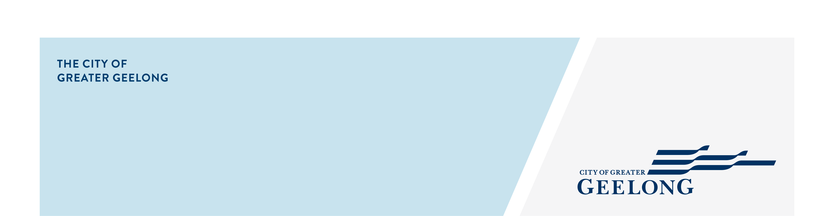
Aldershot reserve

playground renewal
community engagement summary
Feedback on the Aldershot Reserve Playground Renewal consultation has closed, thank you to everyone who provided feedback, your contribution is valued and appreciated.
This stage of community engagement was to seek your ideas and priorities on how we should build your playground, and an understanding of what type of play equipment you would like to see in your new playground.
There were two on-site engagements where a dotmocracy activity (voting using dots) was used at both the pop-up consultations and school workshop. The activity involved the community prioritising what type of playground equipment they liked by placing dots on a range of playground equipment images.

Community feedback is a vital part of our planning. Your feedback will be used to inform the draft concept plan of the playground.
Over the course of this consultation period the City reached the following achievements:
29 DAYS
of engagement
13th November 2023 – 11th December 2023 (Stage 1)


701
Contributions were received via multiple tools.

1278
Visitors to the Have Your Say Page.

2
Community on site drop-in sessions were held, with 47community members attending.
1
School workshop was held involving 120 school children.



237
Online surveys were completed.
28
Ideas received from children.
436
Fund it tool surveys completed.


SOCIAL MEDIA
30,372
Reach/Impressions
315
Actions (Clicks, reactions,
shares, comments etc.)
People following the project.
41

Next Steps
Phase 1 community engagement is closed for evaluation and review. We will be reviewing your responses and this data will be informing the draft concept plan of the playground. A further engagement report will be released detailing further analysis of the feedback received.
Following development of draft plans there will be a further engagement opportunity for the community to review and provide feedback on the draft concept plans. This is anticipated to take place in early 2024. We look forward to your input.

