community engagement summary


Mercer and gheringhap
streetscape Masterplan
February 2022
Mercer Street and Gheringhap Street Streetscape Masterplan will provide a holistic vision to guide the transformation of these thoroughfares into places for the future. It will consider factors such as footpath improvements, potential improvements to intersections, landscaping and microclimate improvements, outdoor dining, public art, cycling and improved safety and accessibility. The project aims to contribute to the area’s character and sense of identity, as well as supporting greening of the city and our focus on design excellence. It is aligned with Revitalising Central Geelong Partnership and will contribute to current and completed projects such as Malop St Green Spine and the Arts and Cultural Precinct Masterplan. The Masterplan will take into account Wurriki Nyal, the City’s new civic precinct.
The City undertook community engagement on the Masterplan over 22 days from 1 December to 22 December 2021. We asked the community to complete a survey and/or leave comments via an online map. This first round of engagement sought to capture community aspirations and priorities to inform the Draft Masterplan.
More than 330 people made submissions through the online engagement tools.
A summary of the community engagement process is provided below.
People following the HYS project page
44
NEWS

3
Print adverts in local newspapers
22 DAYS
of engagement

647
Letters sent to raise awareness of the project




SOCIAL MEDIA
20,472
Reach/Impressions
952
Actions (Clicks, reactions,
shares, comments etc.)

311 online surveys on the Have Your Say Page completed
88 posts via the online map on the
Have Your Say Page

What we heard
Thank you to everyone who provided feedback during the first stage of the community engagement.
Survey
The following outlines some of what we heard from you and what you believe are most important improvements.




Most important street improvements
1. More even footpaths
2. More pedestrian friendly crossings
3. Wider footpaths
Most important footpath improvements
1. More trees and landscaping
2. Better street lighting
3. More rubbish and recycling bins

Malop St
and Lt Malop St
were most frequently noted by participants
when asked to imagine how streets within the study area should look in the future.
39%
of participants noted that they wanted more historical information about the city.
History promotion (indigenous and colonial), as well as protection of built heritage was specifically noted.

64%
of participants said that ‘more trees and landscaping’ was important to them.

Social Map
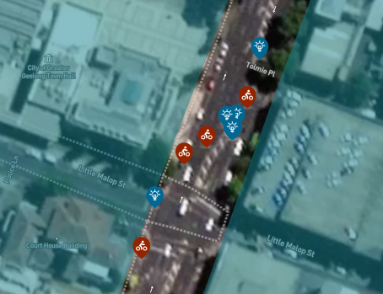
- 22% of responses related to ‘Cycling’ and focused on improving bike safety,
- 17% of responses related to ‘Landscape’ particularly the provision of more trees, and
- 16% of responses related to ‘Footpaths’ and focused on street crossing improvements.

Next Steps
Draft Masterplan
This input will be considered during the development of the Draft Masterplan over the coming months. Once the Draft Masterplan is complete, it will be released for another round of engagement where the community will have the opportunity to provide further feedback on what is proposed.

Better Bike Connections
We wish to note that several comments received during the engagement period were in relation to the separate Building Better Bike Connections project. This feedback has been sent to the relevant project manager to be considered. Direct feedback in relation to Building Better Bike Connections project can be provided via this webpage: Better bike connections - City of Greater Geelong (geelongaustralia.com.au)

The Mercer and Gheringhap Streetscape Masterplan process will consider bike lanes as a concept along with other factors such as footpath improvements, potential improvements to intersections, landscaping and microclimate improvements, outdoor dining, public art, and improved safety and accessibility.

Keep in the loop
If you would like to receive future updates about the Masterplan click here to ‘follow’ the project via our HYS page.

