The City Of
Greater Geelong

Rippleside inclusive playspace

Engagement Summary report

  - August 2020

Introduction
The Rippleside Inclusive Playspace will be a unique place where people of all ages and abilities will be able to play alongside each other in an engaging and beautiful setting. It will incorporate multi-sensory and nature play elements and play opportunities for physical, creative, social and passive play.
The City has partnered with Variety – the Children’s Charity for this exciting project. In addition to an on-line ‘Have Your Say’ survey, Council officers, in partnership with Variety, undertook a number of on-line meetings and workshops with stakeholders from organisations supporting people living with disabilities and access experts
This report presents the outcomes from the second round of consultation for this project. The first round of engagement was conducted in November 2019 and provided us with information about the types of elements and experiences that were most important to the community. The second round was to present the draft concept design for comment.
Engagement PURPOSE
The purpose of this engagement was to share the draft concept designs with the community and raise awareness of the project.
The draft playspace concept has been created with the data from previous engagement, Universal Design and inclusive design principles.
We wanted to hear what the community thought about this draft and understand their feedback.

Method
Due to COVID19 face to face engagement was not an option for this piece of engagement.
The draft concept plans were available for the community to view and leave their comments between 20th July 2020 to 30th August 2020.
Have your Say Project Page
The Have Your Say platform was the main engagement tool. https://yoursay.geelongaustralia.com.au/RSIPS
The draft plans were available for viewing and an interactive “social map” tool was also available where the community could add markers/comments/reactions directly to the plans. Responders could also leave written comments in a box provided rather than on the interactive plans.
The Have Your Say page also had links to past engagement findings, news articles and to Variety’s Play Space project page.
Workshops
Variety -the Children’s Charity, conducted on-line workshops with BCYF (Barwon Child Youth & Family, a not-for-profit community organisation supporting children, young people and their families),parents from Hamlyn Views (Specialist School) and the Access and Inclusion Advisory Committee (a community group providing advice on universal access and inclusion for all).

Communications
Social Media
The engagement was also promoted via Social media, Facebook, Instagram and Twitter.

Concept plans on-site at Rippleside Park
The plans were displayed on site at Rippleside Park (next to the existing playground) with an explanation on how to respond via webpage or written submission.

Printed Media
Media releases were published and picked up by the local press including the Geelong Advertiser.
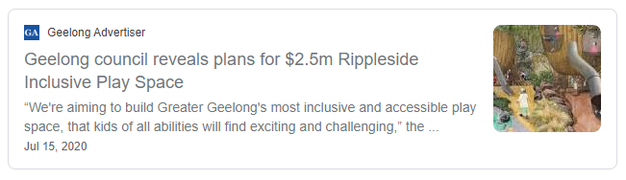

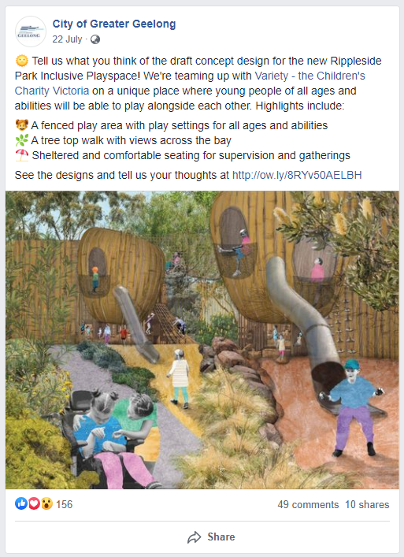
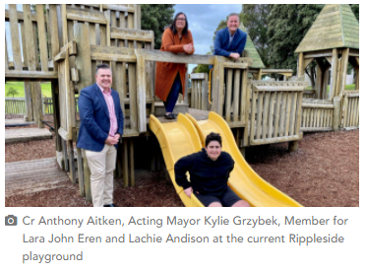

Findings
Have Your Say Findings

feedback recieved
No formal questionnaire was undertaken but an open-ended opportunity for the community to leave their thoughts, comments and suggestions.
46 comments were made during this time. 33 comments were received in the feedback form and 13 comments were added to the ‘social Map’ (a tool where you could add a point to the plans and add a comment)
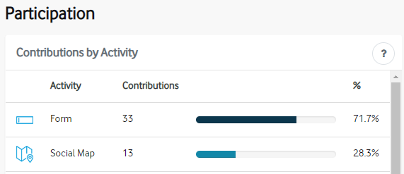

The Have Your Say Web Page received 1,816 views.
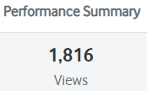

Most of the feedback provided suggestions around design and elements they would like to see included in the plans.
Comments around retaining the existing equipment were made and returning the named fence pickets back to those who sponsored them was also mentioned.
Most of the feedback was positive

Key findings
The sentiment from the feedback form was in the majority positive (14). Neutral (6) Negative (3) and Mixed (5) and n/a (5) were the other recorded sentiments.

The sentiment from comments associated with the Social Map were Positive (10) and Neutral (3)

Quote
“I have a son with Autism who always runs off. If this play space was surrounded by a large fence with multiple latch gates that would be awesome! Not many parks in Geelong have fences to help keep kids safe from absconding.”

The table below shows that the most frequent type of feedback was design suggestions followed by positive support.

Theme | Count
Provide design suggestion - ie types of art, play activities & equipment, signage and access | 31
Supports elements of the plan - ie fencing, natural elements, types of equipment and plantings | 16
General Comments - ie comments relating to existing equipment, scale of playground within the park and dogs. | 8
Opposes elements of the plan - ie nature play and stylised equipment. | 3
Please note some responses had more than one suggestion

Quotes
“I am concerned about the playgrounds proximity to the car park and road”

“Rippleside is such a big park, I think the playground should spread out more”

“I have concerns that the design does not fit within the existing footprint.”

“The plan looks fantastic. It will be such an amazing addition to Geelong.”

“There is nothing wrong with the old playground”

“This looks like an imaginative & stimulating experience for all children”

“I think the new park is going to be awesome. I was involved in the kids consultation and I think my ideas are shown here”

Online Workshop Findings

Due to COVID19 face to face meetings were not an option for this piece of engagement.

BCYF (Barwon Child Youth & Family, a not-for-profit community organisation supporting children, young people and their families).

The Inclusive Play Manager from Variety conducted an on-line meeting with BCYF and three families who are users of the BCYF services and who had children living with disabilities.

The feedback received was
- Importance of fencing
- Would like to keep named fence picket from the old (current) playspace
- Lots of swings please

Variety also attended a board meeting of BCYF. The concept plans were presented and were received with great support.

Hamlyn Views School (Specialist School) was asked for their comments and they believe it is a much-needed space for the Geelong community. Many parents find it very hard to find a suitable space that is not only accommodating but safe, especially as many are single parent families, sometimes with multiple children that have never been able to take their children to a playground without the help of informal supports or a support worker.

Access and Inclusion Advisory Committee to the City of Greater Geelong, provide a role providing advice on universal access and inclusion for all.

The Inclusive Play Manager from Variety, along with Social Planning and Investment Officers presented current concept design for the Inclusive Play Space. The overall feedback from the Committee was very positive.

The following points were made by the Committee for consideration:

- Ensure all weather path surfaces for wheelchairs and mobility devices.

- Ensure compliant gradients and suitable landings are provided.

- Consider monitoring and security measures.

- Provide places for children on the autism spectrum: consider hidey holes and quiet places.

- Consider dedicated Recharge points for wheelchairs and mobility devises.

- Upgrade toilets to reflect the standard of the proposed playground and consider permanent installation of a Changing Places facility.

Participants of all the workshop meetings were referred to Councils Have Your Say website to contribute further comments

Social Media Findings

1,762 engagements were received through the COGG Facebook, Instagram and Twitter accounts

Total posts: 7
3 Facebook
3 Instagram
1 Twitter

Total reach: 27,980

All responses to the social media were either “thumbs up”, “surprise” or “love” emoji reactions



Quotes from Social media;

“Looks great. Please support local manufacture for this project - we have the capabilities! #Keepitlocal Queens Park playground refurbishment included climbing ropes sourced from Europe!”

“Some nice scented plants/ foliage would be good especially for disabled children”

“Something like this would be amazing https://ultimateplay.com.au/riverbend-park-opening-launceston-tasmania/?fbclid=IwAR2gcyMKD1ThAx6-cCT5TE4RLQbjYvBqCi8QZgPJksyzjq1adKOhx3KI1aQ”

Variety the Children’s Charity and BCYF also shared the engagement page and link on their social pages

Feedback via written correspondence
Feedback was received from a local community group with the following points via email
- “In principle we support the concept of the integrated playground proposal
- Do not accept the size – over twice the existing footprint
- The proximity of the playground to the road [safety concerns]
- [fear] The loss of further green space to car parking and expanded toilet facilities “

Conclusion

The majority of responses had a positive sentiment supporting the concept plans. Many design considerations were also received through this engagement.
Full responses to questions will be provided to the landscape architects to make design inclusions incorporating the feedback on specific design features.

This report will be used to brief Councillors and stakeholders on the outcomes of the engagement.
Engagement findings will be presented to all Councillors at the Council Meeting 27 April 2021.
If the draft concept and its footprint are endorsed by Council the landscape designers will be given the approval to proceed to finalising the concept plans and detailed design phase.
The Have Your Say webpage will be updated to summarise the engagement outcomes.

Appendix A – Survey hardcopy
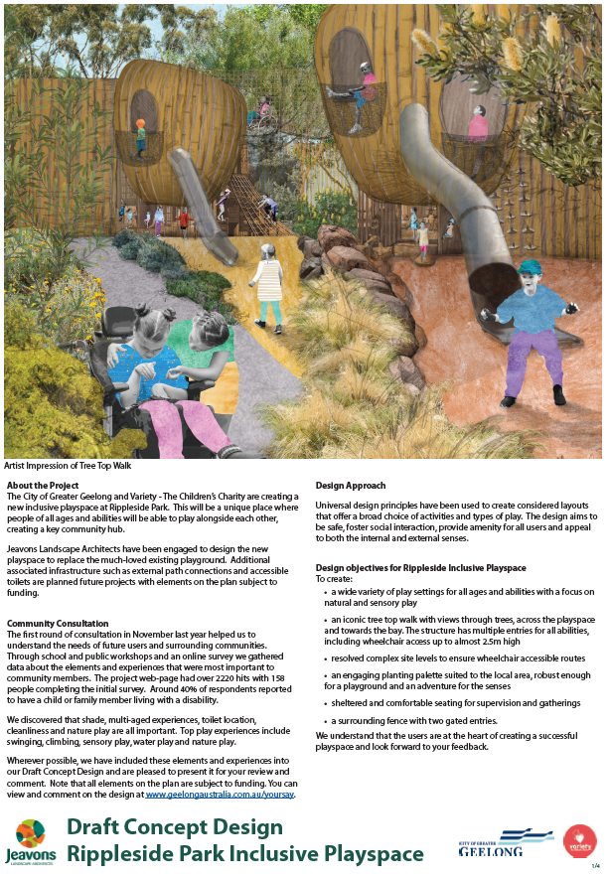
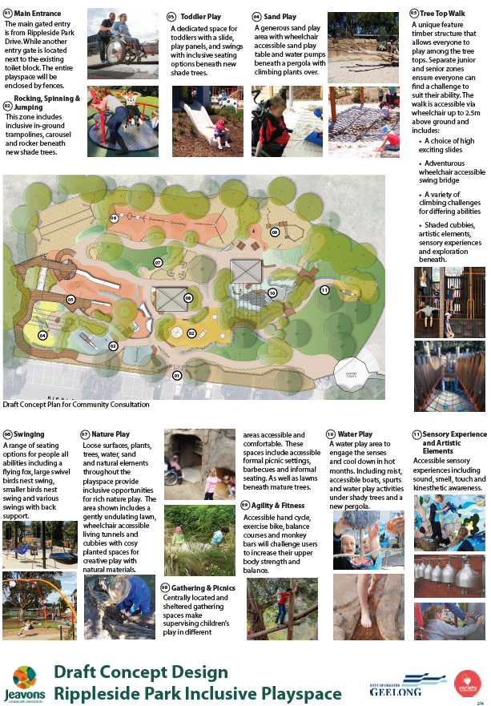
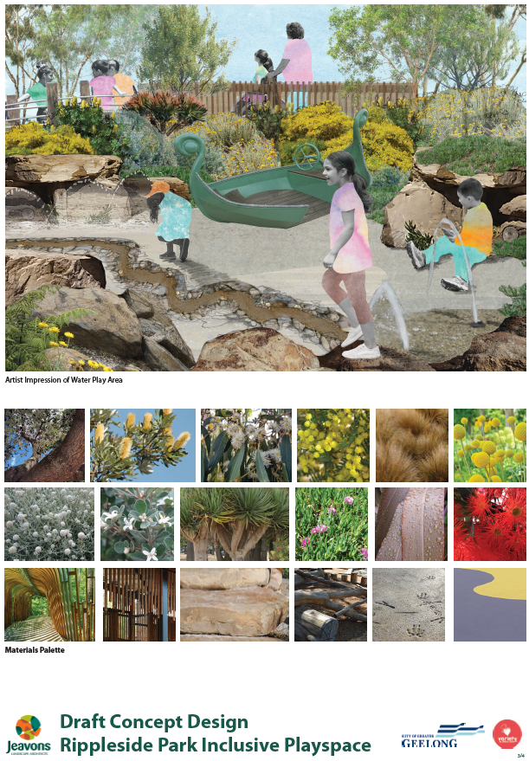

Appendix B – Printed media articles
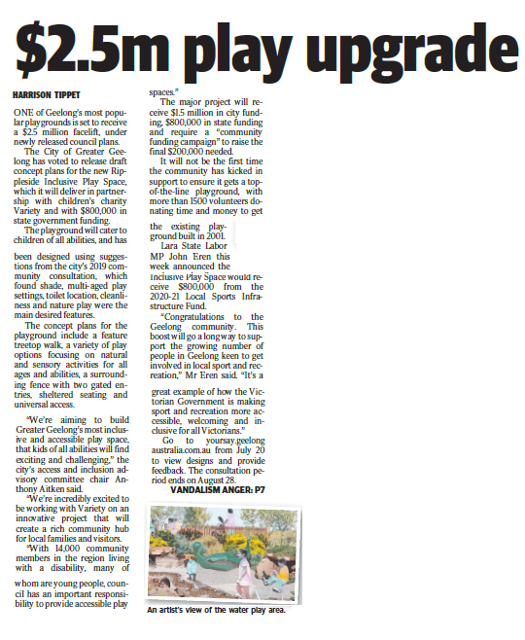
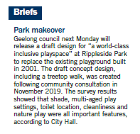
News/press release https://www.geelongaustralia.com.au/news/item/8d82972736c2eaf.aspx
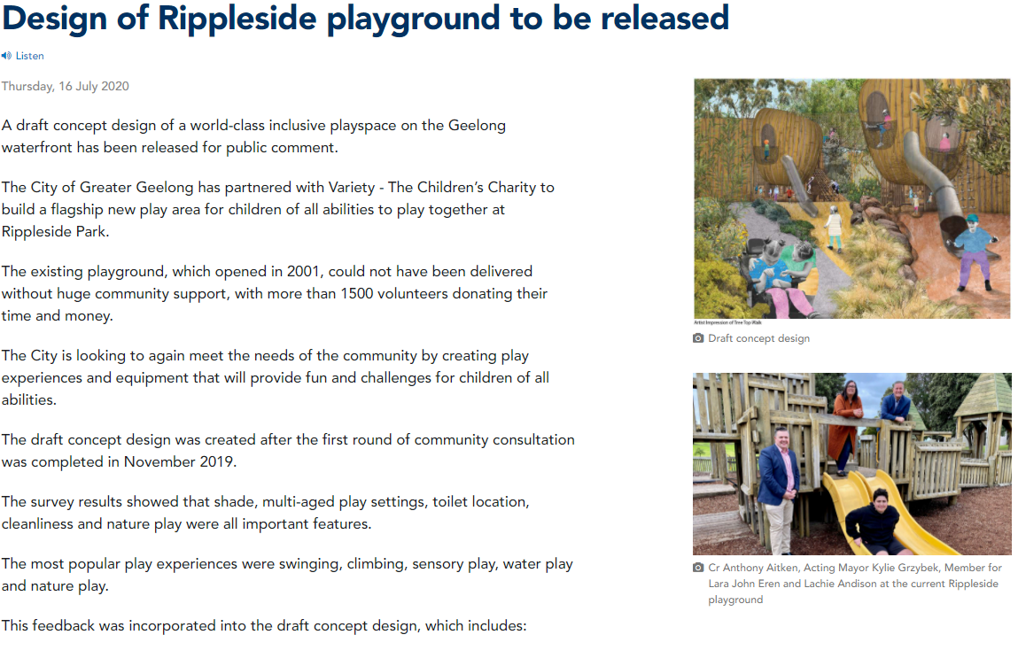
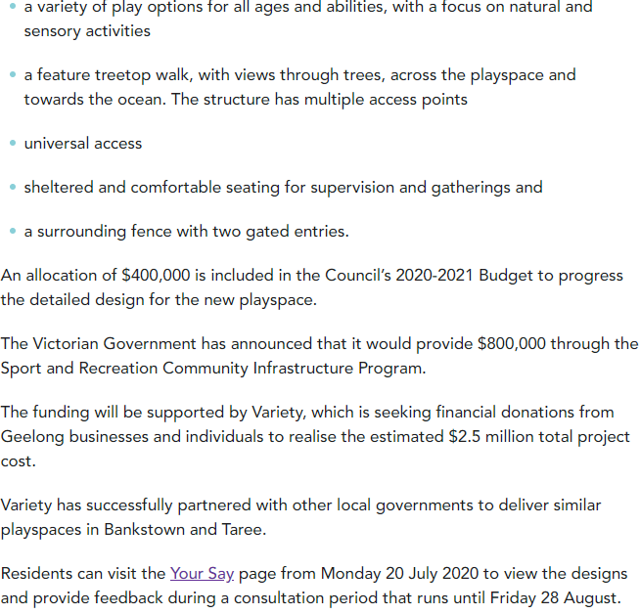

Appendix C – Qualitative Responses
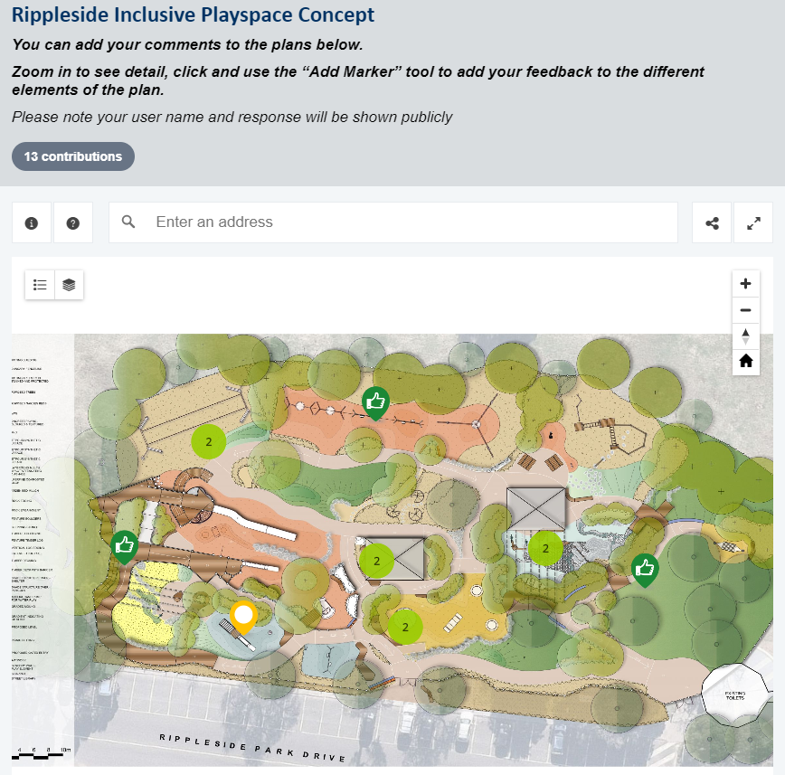
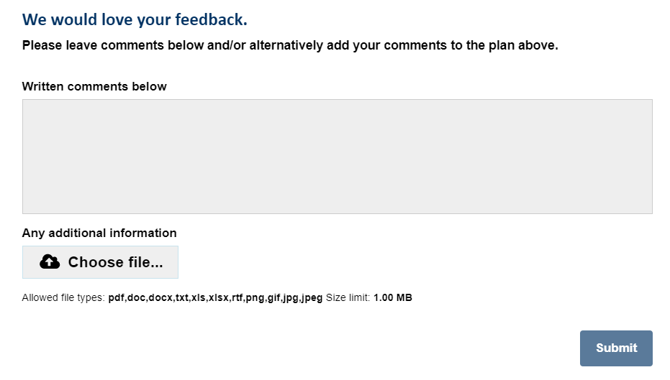


—
CITY OF GREATER GEELONG
PO Box 104
Geelong VIC 3220
P: 03 5272 5272
E: contactus@geelongcity.vic.gov.au
www.geelongaustralia.com.au
CUSTOMER SERVICE CENTRE
Geelong
100 Brougham Street
Geelong VIC 3220
8:00am – 5:00pm
LATEST NEWS:
geelongaustralia
@GreaterGeelong
@CityofGreaterGeelong
@CityofGreaterGeelong
CityofGreatGeelong

