The City Of
Greater Geelong

Geelong Plan for Nature Community Engagement Report

  - 2026

Contents
1 Community Engagement 3
1.1 Summary 3
1.2 How We Engaged 4
1.2.1 What did we do? 4
1.3 Engagement Tools and Techniques 5
1.4 Who We Engaged With 6
1.4.1 Participation 6
2 What we heard and how it shaped the Plan 7
2.1 Key Themes 8
2.2 Connectivity as a Core Priority 9
2.3 Protection of remnant vegetation and habitat 10
2.3.1 Role of Planning and Development Integration 10
2.3.2 Private Land Stewardship 10
2.3.3 Large Old Trees and Canopy Cover 11
2.4 Wadawurrung partnership and cultural knowledge 11
2.5 Community and partnerships – community is essential but needs support 12
2.6 Insects are Important 13
2.7 Urban nature equity and “nature poor” areas 13
2.8 Impact of Light and Noise Pollution 14
2.9 Management of Domestic Animals (Cats and Dogs) 14
2.10 Invasive Species Management 15
2.11 Implementation, Funding and Accountability 16
2.12 Quality of Maps and Future Biodiversity Mapping 17
3 Conclusion/Next Steps 18

Community Engagement
Retaining or improving the biodiversity of living species within the Geelong region is not just a feel-good aspiration (although those people involved will gain much satisfaction). Retaining biodiversity is our obligation to future generations, to Wadawarrung culture and heritage and to the continued existence of the amazing ecosystems that have existed around the Geelong region. Barry Lingham – GFNC
The City prepared a Draft Plan for Nature (the Plan) to set the future direction for biodiversity programs in Greater Geelong. The draft Plan was unanimously endorsed by Council on the 24 March 2026.
The Plan provides Council with a key mechanism to meet an important outcome in Our Council Plan 2025-29; that natural habitat and areas of important biodiversity are identified, protected, connected and restored.
Following this endorsement the City commenced a month of engagement, extending from the 25 March to the 31 April 2026 with face-to-face meetings and a Have Your Say page to collect feedback.
The City would like to thank the over 350 participants and community groups who completed the on-line survey and provided such detailed and thoughtful written submission and the nearly 200 people we spoke to during the engagement process.

Summary
The Plan is well supported in principle, but its success will depend on delivering visible, well-resourced and coordinated actions that lead to measurable improvements in biodiversity outcomes.
Feedback from community members, organisations, agencies and industry representatives demonstrates strong overall support for the Plan. Participants widely recognise the Plan as a comprehensive and timely response to biodiversity decline, and an important step toward improving the region’s ecological health for future generations.
There is broad agreement that the Plan identifies appropriate strategic priorities, particularly in relation to habitat protection, ecological connectivity, community involvement and private landowner engagement. Stakeholders also acknowledge the urgency of biodiversity loss and endorse the Plan’s vision, direction and ambition to protect, restore and connect biodiversity across Greater Geelong.
While support for the Plan in principle is strong and consistent, submissions emphasise that its success will ultimately depend on effective implementation. Key themes across feedback highlight the need for:
- Adequate and sustained funding
- Strong planning controls and policy integration
- Clear delivery mechanisms across Council functions
- Genuine partnerships with traditional owners, community, agencies and stakeholders.
- Visible, on-ground outcomes that demonstrate progress

How We Engaged

What did we do?
The City undertook community engagement from late March through to April 2026 to gather feedback on the Plan, to set a long-term framework to identify, protect, restore and enhance biodiversity across the municipality.
The purpose of this engagement was to:
- Understand community and stakeholder perspectives on the draft Plan
- Identify key priorities, gaps and concerns
- Inform refinement of the Plan prior to finalisation and Council consideration and endorsement.
The engagement sought both quantitative feedback (survey results) and qualitative insights (written submissions and comments) to ensure a comprehensive evidence base.


188
people engaged
in person and community
sessions
295
Contributions
to the survey
165
People following the project
written submissions received
50
days of engagement (stage 2)
37
5
Features in local newspapers


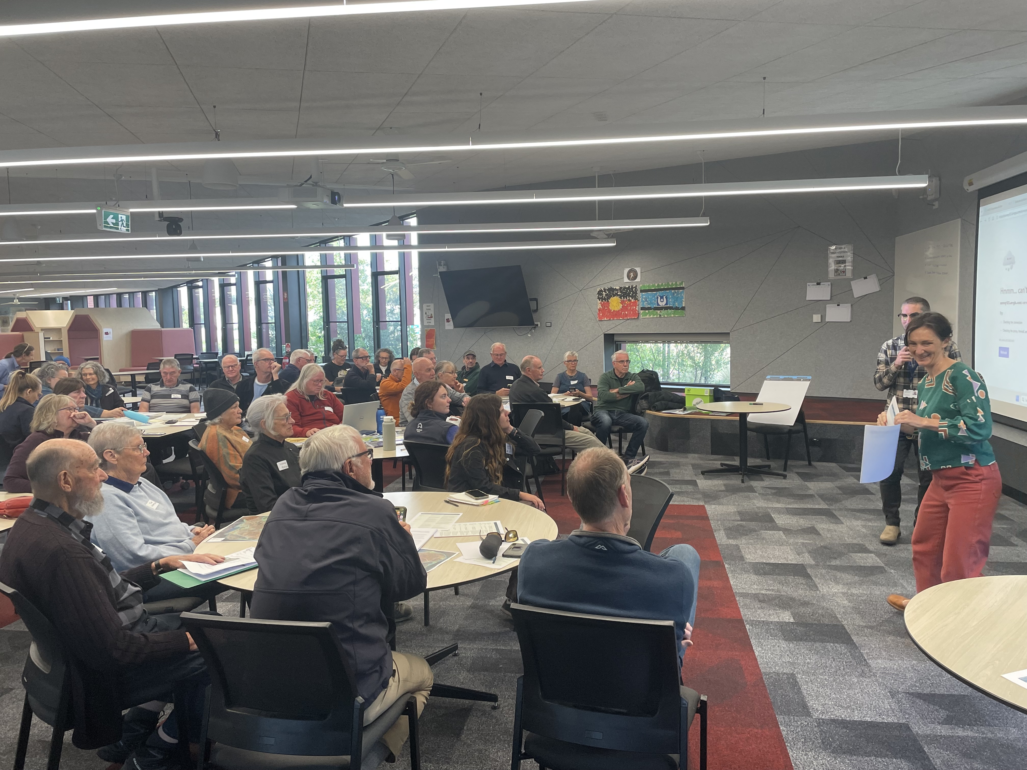
SOCIAL MEDIA
12126
Reach/Impressions
1014
Actions (Clicks, reactions, shares, comments etc.)
Figure 1: Bellarine Community Biolinks Workshop

Engagement Tools and Techniques
A range of engagement tools and techniques were used to provide different types of opportunities for stakeholders and community to have their say. The main tools and techniques are explained in further detail below.
HAVE YOUR SAY ONLINE PORTAL | An online HYS project page was designed to update the Plan’s progress, provide access to the Plan and the Community Engagement Summary Report for review, and to encourage feedback, by completing the survey, making a submission or attending one of the two open house sessions  Geelong's Draft Plan for Nature | Have Your Say
ONLINE SURVEY | The survey was published on the HYS project page to gather feedback about the Plan and if there was anything that should be added or changed.
ONLINE SURVEY NOTIFICATIONS | The community was invited to provide feedback about the Plan on the HYS Project Page.  - Notification to our 165 followers  - Email to our 70 plus community environment groups  - Ocean Grove Voice online story on 6/4/26  - Geelong Independent – online story 7/4/26 and printed in the 10/04/26 edition  - Time News Group – 13/04/2026 in the Geelong Times and Armstrong Creek Times  - Social media posts  - Eight in person and community meetings
DISPLAYS, WORKSHOPS AND PRESENTATIONS X 6 | - Bellarine Catchment Network Update (30) – 25/03/26  - One Planet Living Festival Display (50) - 28/03/26  - Bellarine Biolinks Community Workshop (55) - 10/04/26  - Wadawurrung Traditional Owner Aboriginal Corporation (1) - 15/04/26  - Barwon Heads Discovery Centre Presentation (33) -15/04/26  - Brisbane Ranges Landcare Meeting (14) – 16/04/26
OPEN HOUSE X 2 | Two Open House session were conducted on the 16 April 2026 at Wurriki Nyal. These sessions gave people the opportunity to discuss the Plan with City staff and/or complete a survey.
WRITTEN SUBMISSIONS | 50 written submissions were received - some through the Have Yor Say project page and other directly emailed to the City at ebadmin@geelongcity.vic.gov.au

Who We Engaged With
The Nature Plan needs to be embedded into the Planning Scheme and planning regulations reviewed and formalised in order to have the strength to check future inappropriate development proposals near areas of high biodiversity value, or in locations that would fragment existing or planned biolink corridors, thus impacting on habitat connectivity.

Participation
During late March and April more than 13788 people engaged with the City about the Plan.
Of these 12126 engaged on Instagram and Facebook with 1014 interactions, 345 people completed the survey or made a written submission, 165 people followed the project on the Have Your Say Page and 188 engaged in person through workshops, and our face to face events.
The community were invited to share some demographic data with us, primarily through our HYS page.
Response rate by suburb (responses less than 3 are excluded)
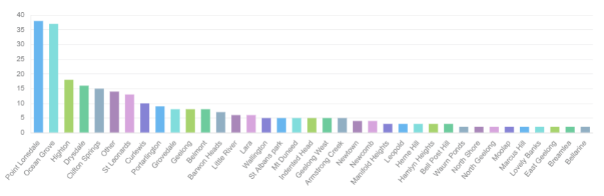

What we heard and how it shaped the Plan
We invited the community to contribute to the development of the Plan for Nature. Participants were asked to provide their views on the following:
- In your opinion, will the Plan have a positive impact on nature across Geelong?
- Would you like to provide further information about your response?
- Is there anything that should be added to or changed in the draft Plan?
- An option to provide a written submission
The feedback expressed a hopeful but cautious outlook on the Plan, acknowledging its comprehensive nature and its alignment with community desires for environmental protection. However, a significant concern raised by many is the perceived lack of concrete implementation, adequate funding and consistent enforcement, especially in light of past Council actions that many have favoured development over environmental preservation. There was a strong desire for measurable outcomes, and a belief the Plan’s success hinges on genuine commitment by the Council to translate aspirations into tangible actions.
In your opinion, will the Plan positively impact nature throughout Geelong?
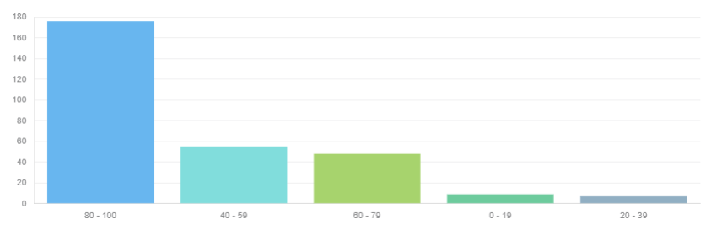
Sentiment diagram
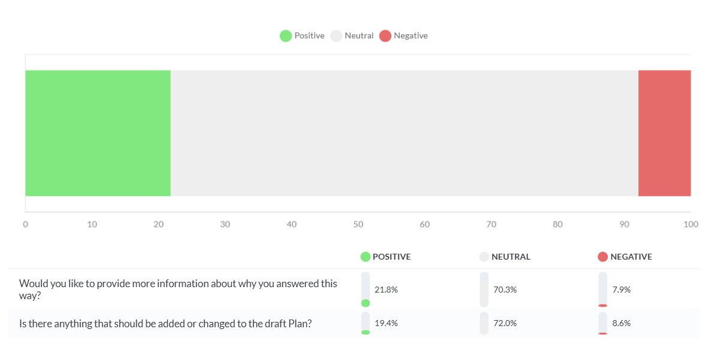

Key Themes
City staff have reviewed and processed all survey responses and submissions received from more than 350 participants. Feedback ranged from high-level commentary to detailed action ideas, along with everything in between.
As a result, many changes have been made to the Plan, across most sections (refer to Table 1 for a summary of these changes).
Many of the detailed ideas provided during the consultation will inform the implementation phase rather than being incorporated directly into the Plan or Action Plan – and we now have a list of incredible ideas.
Notably, no participants commented that the Plan was too long—on the contrary, there was a desire for more detail. One response did note that there were too many actions, which we acknowledge. However, to ensure valuable actions were not lost, we have retained these as supplementary actions and will review their feasibility over the first two years of implementation.
The key themes arising from this engagement are outlined below. Findings from the survey responses and written submissions were strongly aligned and so all sections of the consultation have been grouped together under these key themes
Table 1: Geelong Plan for Nature Sections with Changes – Summary
No. |  | Plan Section | Change
1 |  | Glossary | Additional definitions added
2 |  | Vision | Bringing the Vision to Life
3 |  | How We Engaged | Now references the Community Engagement Plan
4 |  | Drivers for Change | Expanded in response to consultation
5 |  | Landscape | Conditions, threats and opportunities expanded
6 |  | Key Species | Revised to “Key Species and Habitat”. Invertebrates added to Dlilang.  Eastern Yellow Robin replaces Superb Fairy-wren
7 |  | Table 4 | Updated
8 |  | Goal Titles | Expanded to action-oriented statements
9 |  | Goals | Expanded in response to consultation
10 |  | Strategic Objectives | Renamed to “Strategic Outcomes”
11 |  | Targets | Strengthened
12 |  | Biolink Area A3 Map | Replaced with six Biolink Area maps - one per Landscape (see Change 16)
13 |  | Actions | Expanded and updated
14 |  | Implementation and Renewal | Expanded and strengthened
15 |  | Monitoring and Evaluation | Expanded and strengthened
16 |  | Maps | 18 maps in total:  • Maps 1–6: Biolink Areas (updated; replaces A3 Biolink Area map, see Change 12)  • Maps 7–12: Environmental Values (updated)  • Maps 13–18: Protection Measures (updated)
17 |  | Appendix 1 | Updated
18 |  | Appendix 2 | Updated
19 |  | Appendix 3 | Updated
20 |  | Appendix 4 | Updated

Connectivity as a Core Priority
Establishing wildlife corridors is one of the most important actions the City can take. I grew up in Little River, and I would love to see the river restored as a functioning wildlife corridor linking the Brisbane Ranges to the Western Treatment Plant — one of the most significant bird habitats in Australia. This must include restoring environmental flows. My father, a market gardener and farmer, used to take water samples to Barwon Water to check salinity before irrigating his vegetables. He always said that once the Stony Creek Dam was built, flows to the Little River dropped and salinity increased. Yet our family has letters from the 1850s describing people living on the banks of the river and drinking from the river and growing food along its banks. Restoring flows is not just ecological — it is cultural, historical and essential for the health of the entire corridor.
The establishment of landscape-scale wildlife corridors and biolinks was the most consistent and strongly supported theme from the feedback. Participants emphasised that improving ecological connectivity is fundamental to achieving biodiversity outcomes. There was broad recognition that effective conservation requires a landscape-scale approach, rather than a focus on isolated sites, and that corridors should be prioritised across growth areas and both public and private land. Connectivity was widely identified as critical for supporting species movement, maintaining ecosystem health, and enhancing climate resilience.
Feedback also highlighted important nuances in corridor planning. In particular, it was noted that movement pathways for larger fauna, such as kangaroos and wallabies, may not always align with identified biolinks. These species often utilise established movement routes across agricultural land with limited biodiversity value. In addition, roadside corridors were identified as posing risks to wildlife, including increased incidence of road strikes involving native animals. In response, information on large fauna movement and risks associated with roadside biolinks has been strengthened in the Plan.
Within urban and peri-urban areas, there was strong support for prioritising biolinks across both growth and established areas. Submissions emphasised the importance of aligning corridor delivery with capital works, open space planning, and infrastructure investment to ensure integrated and cost-effective implementation.
Consultation also identified additional biolink opportunities. Where these aligned with the biolink criteria, they have been incorporated into the mapping. In the Bellarine Landscape, priority corridors have been aligned with the Distinctive Areas and Landscapes (DAL) framework. The Plan recognises that the biolink network will continue to evolve over time, with further corridors to be added as opportunities arise.
A number of priority biolinks were identified for targeted action which will be further unpacked in the Geelong Biolink Project. These include the coastal corridor from Avalon to Point Impossible, the Little River corridor connecting the Brisbane Ranges to the Western Treatment Plant, and key river and creek systems such as the Barwon River, Moorabool River, Waurn Ponds Creek and Cowies Creek. Other priority areas include the Bellarine Rail Trail, Grassy Point Road, and coastal creeks within the Bellarine Landscape, including Masons Creek and Yarram Creek South.

Protection of remnant vegetation and habitat
Protecting remnant habitats, restoring degraded land and waterways, and reconnecting landscapes through ecological corridors are central to the Plan. Together, these actions provide native plants and animals with the opportunity not only to persist, but to recover and adapt in a changing climate.
There is widespread concern among participants about the ongoing loss of remnant vegetation, habitat and large trees, particularly in the context of urban growth. Feedback consistently emphasise the critical importance of protecting existing high-quality habitats and restoring degraded areas to support biodiversity and strengthen ecological connectivity.
Participants highlighted that existing vegetation is irreplaceable and must be protected, supported by stronger planning controls and enforcement. Protection is expected to extend across both public and private land, including large trees and areas of critical habitat.

Role of Planning and Development Integration
The planning system is widely viewed as the City’s most effective mechanism for protecting biodiversity. Submissions call for stronger integration of biodiversity considerations into planning and development decisions, with a clear focus on preventing habitat loss at the outset rather than relying on offsets. Participants also emphasised the need to better address the cumulative impacts of urban growth and expansion.
There is strong support for embedding nature conservation principles into urban planning and development processes to avoid further habitat loss and fragmentation. This includes strengthening planning controls, protecting existing vegetation, and improving the integration of biodiversity considerations into housing developments and capital works.
Offsets were discussed extensively, with many participants expressing concern that they can undermine local biodiversity outcomes, particularly where offsets are not required to be delivered within the municipality. In response, the Plan strengthens actions relating to the City’s approach to offsets. However, it is acknowledged that offset policy settings are largely determined at the State and Commonwealth level, and that the availability of suitable offsets within the municipality is limited.

Private Land Stewardship
Given that a significant proportion of biodiversity occurs on private land, there is a clear need to support landholders to protect and manage high-value conservation areas. Securing and managing these sites will be essential to achieving long-term biodiversity outcomes across the landscape.
Submissions emphasised the importance of providing targeted incentives, stewardship programs and covenants, along with greater support and guidance for landholders. Clear and accessible pathways for participation in conservation and restoration activities were also identified as important.
The Plan recognises the importance of private land for nature conservation and includes actions to strengthen engagement with private landowners. The City currently delivers targeted incentive programs and works in partnership with Landcare and other regional networks, which play a key role in delivering on-ground outcomes. Strengthening these partnerships and expanding existing programs will be critical to achieving meaningful and lasting change.

Large Old Trees and Canopy Cover
Participants strongly advocate for the protection of large trees across both public and private land, and for increased canopy cover to support biodiversity, urban cooling and liveability outcomes. There is support for adopting more ambitious canopy targets, aligned with leading practice across other councils.
Submissions call for the strongest possible protection of canopy trees, including improved controls on tree removal and enhanced requirements for tree retention on private land.
The Plan prioritises the protection of large, old remnant trees and recognises the broader ecological value of mature trees more generally. Mapping of remnant trees is included and will continue to be refined following adoption of the Plan. Additional tree locations identified during consultation, including River Red Gums and Moonahs not currently mapped, will be incorporated into future mapping programs.
The City’s Urban Forest Strategy (draft) further strengthens tree protection and planting objectives, including the State-mandated target of 30% canopy cover. Actions within the Urban Forest Strategy (draft) complement and support the delivery of outcomes identified in the Plan.

Wadawurrung partnership and cultural knowledge
We would like to learn from the Wadawurrung about their cultural values and perspectives on living sustaining in this landscape and on protecting nature for the future. We would like to work with Wadawurrung Traditional Owners at our regeneration sites to understand and ensure the work is aligned with cultural values. Clifton Springs Curlewis Coastcare Group
Consultation feedback indicates strong support for embedding Wadawurrung knowledge and values throughout the Plan. Participants highlighted the importance of genuine partnership and shared decision-making, including opportunities for co-designed projects, long-term collaboration, and appropriate resourcing to support Traditional Owner–led initiatives.
The Traditional Owner targets and actions outlined in the Plan were developed in partnership with the Wadawurrung Traditional Owners Aboriginal Corporation (WTOAC) through ongoing discussions. In response to feedback, these actions have been further strengthened. Engagement will continue through quarterly meetings with WTOAC to refine and support effective collaboration, including opportunities to enable cultural practices, stories and language across the City’s nature reserves.

Community and partnerships – community is essential but needs support
BLG strongly supports the Draft Plan for Nature and its ambition. Our community is ready to be part of the solution. With clear priorities, adequate resourcing and genuine partnerships, this Plan can help turn that commitment into lasting, positive change for the Bellarine’s natural environment. Bellarine Landcare Group
Consultation feedback consistently highlighted the critical role of community groups, volunteers and partnerships in delivering biodiversity outcomes.
There was strong support for expanding community engagement and education, strengthening Landcare, Coastcare and volunteer networks, and providing sustained funding, coordination and long-term support. However, participants also emphasised that community effort cannot replace adequate Council investment and responsibility.
Community groups and volunteers were widely identified as essential to successful delivery. Participants stressed that these contributions must be supported through appropriate funding, coordination, training and access to resources.
Participants highlighted the importance of moving beyond one-off activities towards more considered ongoing engagement. Building long-term relationships, trust and capacity within the community was seen as critical to achieving lasting environmental outcomes.
There was also strong support for expanding engagement to schools, young people and the broader community. Engagement through schools was identified as a particular priority requiring further strengthening to support early awareness and long-term stewardship.
A clear theme of shared responsibility emerged across submissions. Participants emphasised that caring for nature requires collaboration between Council, Traditional Owners, community groups and private landholders. The Plan was seen as providing a pathway for broader community participation, particularly given the extent of privately owned land across the municipality.
Feedback also highlighted the need for greater community engagement, public awareness and stronger support for volunteer activity. Suggestions included improving the promotion and visibility of environmental initiatives, such as planting programs, litter clean-ups and citizen science activities, alongside providing increased support, education and resources to landholders and community groups to protect and enhance natural areas.
Submissions noted that, with clear priorities, adequate resourcing and genuine partnerships, the Plan has the potential to translate strong community commitment into lasting, positive environmental outcomes. In response to this feedback, the Plan has been updated and strengthened throughout the Plan and associated targets and actions.

Insects are Important
'Measuring biodiversity is a complicated process. As habitat is enhanced, restored or created, the initial changes to biodiversity would be at the indigenous invertebrate level as more insects and other small ecosystem dwellers multiply to take advantage of the vegetation. A good entomologist could use surveys to decipher the numbers of species and individuals from small survey sites. Changes in invertebrate populations are a good measure of biodiversity change, although seasonal factors would have to be taken into account.
Several participants highlighted concerns about a noticeable decline in insect numbers, recognising insects as important indicators of ecosystem health and calling for their more explicit inclusion in the Plan. This feedback reflected both observation and personal concern. One participant noted they now see “approximately one butterfly a month” and, while celebrating each sighting, expressed sadness at how rare these encounters have become. Others similarly observed a broader decline in insect populations over recent years and raised concerns about the implications for ecosystem health. While some acknowledged that insect conservation may be implicitly recognised in the Plan, there was a clear view that it should be more explicitly articulated.
Participants also shared examples from overseas to illustrate alternative land management approaches that support insect populations. One observation referenced German meadowlands and woodland areas, where large sections of open space—including parks, roadsides and nature strips—are left unmown to encourage insect activity. It was noted that, from an Australian perspective, these areas may appear “weedy”, as the plant species that thrive in gardens, lawns, vacant land and railway corridors are often those adapted to disturbed environments. However, from a European perspective, such areas are valued for their ability to support insects and may include a diversity of native herbs and grasses. These approaches were also seen to have practical benefits, including reduced mowing and maintenance costs.
In response to this feedback, invertebrates have now been incorporated into the Plan including an invertebrate community monitoring program supporting the inclusion of key species monitoring within each landscape

Urban nature equity and “nature poor” areas
The plan acknowledges areas that are "nature poor" and states "all residents should be able to experience and benefit from access to nature, regardless of where they live…. but then only provides vague treatment. As an anecdote, in Whittington/Newcomb, we recently experienced Newcomb Central Shopping Centre compliantly remove a significant volume of semi-mature native canopy from their car park. This did not require Council permission and resulted in loss of habitat and shade coverage in a large open asphalt area. It also deeply impacted members of the community who actively valued the integration of this green space into the shopping precinct.
Feedback highlighted strong support for the inclusion of the concept of “nature poor” areas within the Plan. However, participants consistently noted that the term is not clearly defined and lacks supporting detail regarding how these areas will be identified, prioritised and improved over time.
There was a clear expectation that the Plan should more explicitly articulate what constitutes a nature poor area, including whether specific locations—particularly in the northern suburbs—should be identified. Participants also called for the establishment of meaningful targets, minimum access standards, and monitoring approaches to track progress in addressing inequities in access to nature.
Many submissions emphasised the importance of strengthening actions in these areas. This included improving urban biodiversity outcomes through stronger planning controls, increasing canopy cover, and prioritising greening initiatives such as street tree planting, nature strips, gardens and school-based programs and nature stewards programs. Participants also highlighted the need to reduce barriers to participation in key programs, noting that cost, time and access to resources may limit involvement in lower-income areas. More broadly, feedback indicated that while the Plan acknowledges inequity in access to nature, it does not yet clearly demonstrate how this inequity will be addressed or how a broader cross-section of the community will be supported to experience and benefit from nature.
In response, the Plan has been refined to strengthen its focus on urban nature equity and the importance of improving access to nature for all residents, regardless of where they live or their level of ability.
Further work will be undertaken to better define and identify nature poor areas, including consideration of environmental, access and socio-economic factors. While recognising that many of these areas are not located near existing biolinks, the Plan acknowledges the need for complementary approaches to improving nature access in urban environments.
Collaborative actions through this Plan and the City’s new Open Space Strategy (draft) and Urban Forest Strategy (draft) will identify opportunities to improve urban biodiversity outcomes and access to nature in these locations.
The Plan also strengthens its commitment to supporting participation in nature-based programs and initiatives, with consideration to reducing barriers to access for lower-income communities. Further detail on targets, delivery mechanisms and monitoring will be developed through implementation planning to enable the City to track progress in addressing urban nature inequity over time.

Impact of Light and Noise Pollution
There is no mention nor recognition of the impact that Light Pollution is having on Biodiversity. There is no mention of the Federal Governments Guidelines for Reducing Light Pollution for Wildlife, or recognising the work of the Biodiversity Council also working on reducing light pollution.
Consultation feedback highlighted a strong concern that the Plan did not adequately recognise or address the impacts of light pollution on biodiversity. Participants consistently described this as a significant omission, noting that artificial light at night can disrupt migration pathways, alter habitats, and contribute to increased mortality, with some submissions explicitly stating there was “no mention nor recognition” of its effects and calling for clearer acknowledgement of these well documented impacts. Noise pollution was also raised as a related issue, although less prominently, with concerns about its potential to disturb wildlife and degrade habitat quality. In response to this feedback, the Plan has been updated to include more information and an associated action addressing the impacts of light and noise on biodiversity, strengthening the Plan’s approach to managing environmental pressures on species and habitats.

Management of Domestic Animals (Cats and Dogs)
There may be a need to allocate some new off-lead dog zones in new suburbs to cater for the explosion in dog numbers. Dog owners should have targeted campaigns to improve their understanding of their legal obligations and the impacts of dogs on natural areas and wildlife.
Consultation feedback identified strong concern regarding the impacts of domestic animals, particularly cats and dogs, on native wildlife. Participants highlighted predation and disturbance pressures associated with free-roaming cats and off-leash dogs, and there was broad support for stronger controls.
Many submissions called for expanded cat curfews and increased cat containment, including suggestions for a 24-hour curfew. Feedback also emphasised the need for improved compliance with dog leash requirements, particularly in natural areas, with some Participants advocating for restrictions on dog access in highly sensitive locations.
In response to this feedback, the Plan reinforces the importance of responsible pet ownership as a key component of biodiversity protection. The existing municipal cat curfew, requiring cats to be confined from dusk to dawn, will remain in place consistent with the Domestic Animal Management Plan 2026–29.
The City will prioritise behaviour change approaches that support voluntary containment, including reduced registration fees for cats that are contained to their property at all times, and targeted community education to promote the benefits of containment for both pets and wildlife.
Recognising that improved outcomes rely on community awareness and compliance, the City will strengthen education and engagement initiatives to support responsible pet ownership.
The Plan also includes actions to manage the impacts of dogs in high-value biodiversity areas. The City will continue to improve compliance and education, advocate for no dog zones in areas of high ecological sensitivity and strengthen management within Council-managed nature reserves.

Invasive Species Management
Our backyards were once a haven for our tiny native bird species. Their comfortable and safe habitats have been taken over by the voracious Indian Myna.
Consultation feedback highlighted strong concern regarding the increasing presence of invasive species, particularly the Indian Myna bird, which is widely perceived as a significant threat to native wildlife. Participants consistently described the species as aggressive and highly competitive, noting impacts on native birds through displacement from nesting sites and direct harm.
Several submissions identified the management of Indian Mynas as a gap in current biodiversity efforts, with calls for a more proactive and coordinated response. This included requests for Council-led eradication programs, access to trapping resources, and increased public education to support community action.
In response to this feedback, the Plan has been strengthened on invasive species management, including the addition of a new action specifically addressing Indian Mynas. While recognising that control of established invasive species is complex and requires sustained effort, the City will take a more active role in managing impacts within its own natural areas.
The City will also explore opportunities to support coordinated community responses and provide guidance where feasible. This will be supported by engagement with the community to build shared understanding and identify practical and effective pathways forward.

Implementation, Funding and Accountability
A stronger implementation framework. The Plan should include: timelines, responsible departments, performance indicators, public reporting requirements and consequences for non-delivery.
A consistent and strongly expressed theme across submissions is concern that the Plan may remain aspirational without clear and credible delivery mechanisms. While participants broadly support the vision and direction of the Plan, many emphasised the need to shift from strategy to implementation, with a stronger focus on how outcomes will be achieved in practice.
A central issue raised is the lack of clarity around funding and resourcing. Participants frequently noted that, without firm and transparent financial commitments, the Plan risks lacking credibility and may not deliver meaningful on-ground outcomes. There were repeated calls for long-term funding allocations that are proportionate to the scale of the Plan’s ambition, including clearer indications of how investment will be sourced and sustained over time. Some participants suggested that specifying funding commitments—such as a proportion of rates or dedicated budget allocations—would strengthen accountability and demonstrate organisational commitment. The importance of resourcing was also linked to staffing capacity, with participants noting that ongoing personnel and technical capability are essential to effective implementation.
Closely related to this is a perceived gap in the Plan’s implementation framework. Participants highlighted limited detail regarding timelines, sequencing of actions, and allocation of responsibilities. There is a strong expectation that the Plan clearly articulates who is accountable for delivery, how actions will be prioritised, and over what timeframe they will be delivered. This includes embedding biodiversity outcomes across multiple Council functions, such as planning, infrastructure and water management, to ensure a coordinated and integrated approach rather than siloed delivery.
Governance and accountability mechanisms were also identified as an area requiring further strengthening. Submissions emphasised the need for clear roles and responsibilities, supported by robust governance structures to oversee delivery. In particular, stakeholders are seeking more explicit accountability for outcomes, ensuring that commitments made within the Plan are tracked and reported against.
There is also a strong call for comprehensive monitoring, evaluation and reporting frameworks. Participants emphasised the importance of establishing measurable performance indicators and targets to track progress over time. Regular and transparent public reporting was viewed as critical to maintaining community trust and demonstrating progress. Importantly, stakeholders expect that monitoring results will not only report on performance but also inform adaptive management, including adjustments to priorities and future funding allocation.
Finally, several submissions highlighted the importance of strengthening regulatory and policy mechanisms to support delivery. There is a clear view that strategic intent alone will not be sufficient without enforceable planning controls and integration into statutory frameworks. Effective implementation is therefore seen as reliant on a combination of policy, regulation, funding and operational delivery tools.
Overall, stakeholders are seeking a Plan for Nature that is not only visionary, but also practical, funded and accountable—one that provides a clear pathway to achieving tangible biodiversity outcomes.
In response to consultation feedback, the implementation and monitoring sections of the Plan have been strengthened. Effective governance and delivery of the Plan will rely on a combination of long-term and annual monitoring, supported by regular evaluation. This approach will enable actions to be refined, better targeted, and continuously improved over time.
The City is committed to maintaining a robust Monitoring, Evaluation, Reporting and Improvement (MERI) framework to guide implementation and track progress. The shorter-term Action Plan will be reviewed and updated every two years on a rolling basis to ensure it remains responsive and effective. The broader Plan will undergo a major review every 10 years. Progress towards the Plan’s higher-level 10-year strategic outcomes will be evaluated at the end of the Plan’s life in 2036, informing the next iteration of the Plan.

Quality of Maps and Future Biodiversity Mapping
A useful addition to the Plan would be a map showing existing areas under indigenous vegetation. Bellarine Landcare Group has over many years kept records of restored and revegetated sites. Such a map would give a better idea of existing and potential connectivity. A good 45 years of mostly indigenous planting on my own property, for example, is not shown at all.
Many participants were dissatisfied with the quality, scale and usability of maps in the draft Plan. The Biolinks Area Map in particular lacked detail, resolution and clarity, making it difficult to interpret.
Stakeholders also identified gaps in mapping, including missing remnant vegetation, wetlands, large old trees, restoration areas and long-term revegetation sites on private land. There were strong calls for improved landscape-scale mapping, clearer labelling, and additional layers such as indigenous revegetation. Suggestions also included expanding inland biolinks and exploring links with walking and cycling corridors. Some participants acknowledged that producing more detailed mapping would take time.
Mapping has been improved in the final Plan, including reformatting the Biolink Areas into individual A4 maps by landscape. The Plan now includes 18 maps. The City is also progressing interactive online mapping, which will allow users to view and navigate biodiversity data in more detail. Ongoing mapping improvements will prioritise gaps identified through consultation, including additional remnant vegetation, wetlands and significant trees. New layers—such as indigenous revegetation, key species and insect monitoring—will also be progressively incorporated, along with future opportunities to demonstrate improvements to habitat connectivity at a landscape scale.

Conclusion/Next Steps
The Plan has been updated in response to the extensive consultation feedback. It will now proceed to Council for consideration and endorsement at the Council meeting on 28 July 2026.
A summary version of the Plan will be produced, with the full, detailed Plan available on our website.
The City would like to thank the more than 350 participants and community groups who completed the online survey and provided detailed and thoughtful written submissions, as well as the nearly 200 people we spoke with during the engagement process.



