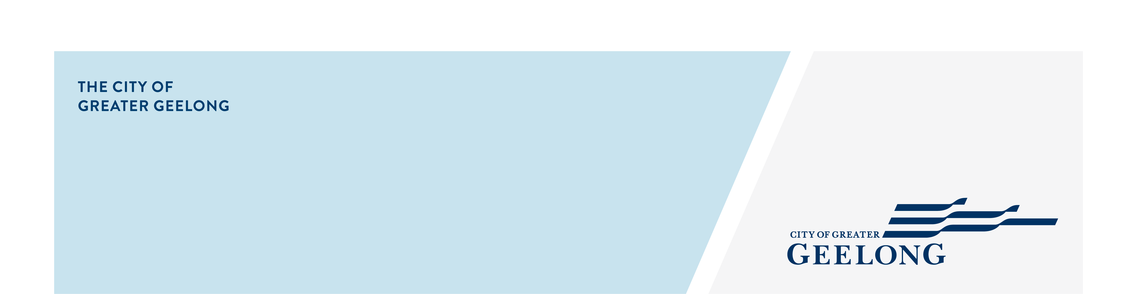
OCEAN GROVE

Stormwater

Management Strategy
community engagement summary

This report provides the findings of the City of Greater Geelong’s Ocean Grove Stormwater Management Strategy Stage 2 engagement process, which was conducted over four weeks from 17 August to 13 September 2026. The purpose of the engagement is being used to confirm the flood modelling and proposed solutions before the final strategy is shared in early 2027.

PROIJECT BACKGROUND

The Ocean Grove Stormwater Study will help the City and relevant authorities to better understand and manage flood risk, stormwater quality impacts, and alternative water supply options in the region. The study forms part of the larger Stormwater Services Strategy which looks to better understand and manage flood risk, stormwater quality, and stormwater reuse.

The study area includes parts of Ocean Grove, Wallington, Marcus Hill, and parts of Point Lonsdale. More information on this study can be found at https://yoursay.geelongaustralia.com.au/OGFS.

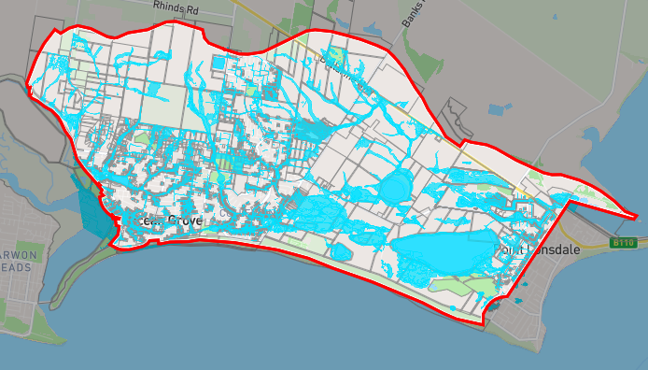
Figure 1: Image of the interactive map
HOW WE ENGAGED
WHAT DID WE DO?
To support this engagement, the dedicated project page on the Have Your Say website was used. This platform allowed community members to access key information about the Ocean Grove Stormwater Management Strategy, including updated flood maps and a preliminary list of potential mitigation options. Community members were invited to review these materials and provide their feedback.

An interactive online map was launched showcasing the new flood modelling results. This tool received 169 individual responses, providing valuable local insights.

In addition to the online engagement, three in-person community drop-in sessions were held. These sessions offered community members the opportunity to learn more about the study, ask questions, and share their views directly with the project team. A total of 69 people attended these sessions, which were well received and featured many thoughtful and constructive conversations.

69
People attended the in-person community sessions
28 DAYS
of engagement (Stage 2)
Suggestions (comments) from the public left online via social map
169

Communications
The engagement survey was widely promoted using social media posts using platforms such as Facebook and Instagram. In addition, we sent letters directly to property owners and residents within the catchment area, including both residential and commercial properties. This ensured that those most directly affected by the study were informed and had the opportunity to participate.

2,645 Letters delivered to community members
1,022
People visited the Have Your Say (HYS) page

People following the project
1221

WHAT WE HEARD

THE FEEDBACK

- 80% of the responses came from community members in Ocean Grove suburb, with others from Point Lonsdale, Swan Bay, and Wallington.

- Approximately one-third (33%) of respondents raised concerns about insufficient drainage infrastructure and maintenance of the existing drainage.

- Approximately 18% of the respondents said they have not witnessed flooding of their property.

- 25% of submissions raised concerns about the Collendina Drain.

- Most participants were supportive of the City’s proposed mitigation approach. Many also encouraged further technical investigations, combining the options, and deeper analysis to strengthen the final recommendations.

- The interactive map attracted a total of 169 comments, with most users sharing personal and localised flooding experiences. These insights are proving valuable in validating the new flood modelling results.

Next Steps

The feedback, experiences, and digital contributions (such as photos and videos) received during this engagement are currently being used to validate the updated flood model for the catchment. In parallel, feedback on mitigation options is being considered as the detailed assessment of potential flood mitigation measures commences.
Looking ahead, there will be one final round of engagement as part of this study:
- Final Strategy Presentation. In this stage, the community will be invited to review the draft Ocean Grove Stormwater Management Strategy report. This is expected to take place in early 2027.

