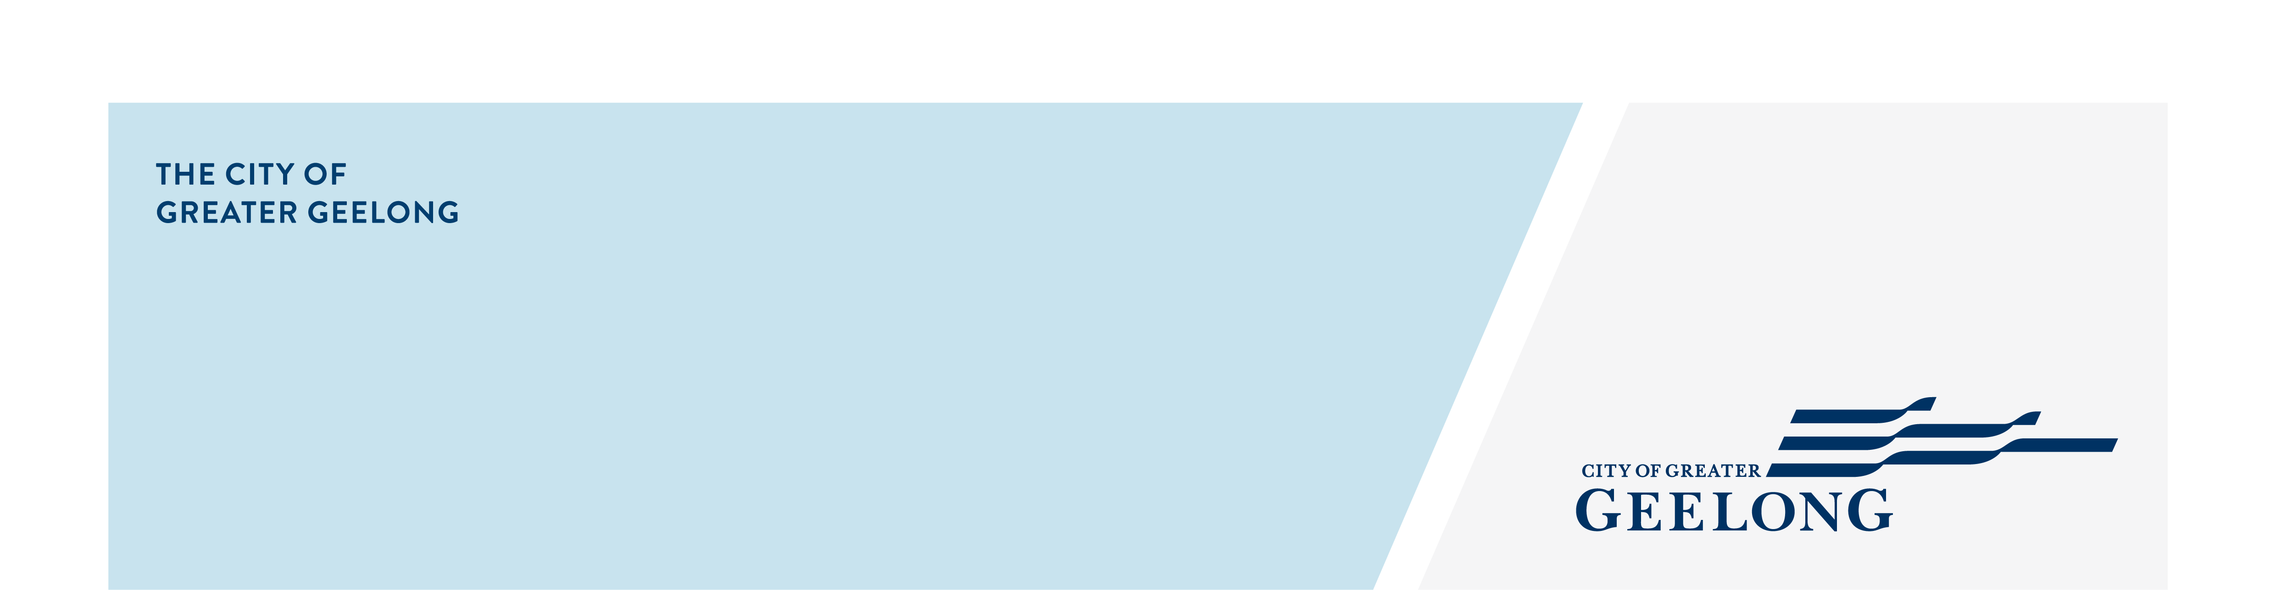
Expressions of interest
Community Strengthening
First NAtions Grants

COMMUNITY ASSESSMENT PANEL 25/26

Thank you for your interest in joining the Community Strengthening
First Nations Grants Community Assessment Panel 25/26.
You will receive confirmation of your application once your Expression of Interest has been received. Shortlisted applicants may be invited to attend an interview. Interviews are 10 minutes in length and conducted online via Teams.
Everyone who applies will be contacted once the selection process is complete and advised of the outcome.
Applicants are encouraged to demonstrate the following:
- Connection to the City of Greater Geelong, such as being a resident or ratepayer within the municipality.
- First Nations lived experience, cultural knowledge, and a strong connection to community. Previous panel or assessment experience is desirable but not required
If you need support in applying, please contact the Community Strengthening team on 5272 4046 or tina.biggs@geelongcity.vic.gov.au.

Privacy Collection Statement
The personal information and feedback (collectively the Data) requested on this page is being collected by City of Greater Geelong (City) for the purpose of Expressions of Interest for Community Strengthening First Nations Grants Panel, and any other directly related purpose (Project).
A de-identified engagement summary report may be published on our website.
If your personal information is not collected, the Project may not be able to be adequately conducted, and the City may not be able to contact you for further questions or to find solutions.
In order to collect and conduct in depth and detailed analysis of the Data for the purposes of the Project, the City will disclose the Data (including your personal information if provided) to its third-party service providers, including Social Pinpoint Pty Ltd, Converlens Pty Ltd and Amazon Web Services.
Other than as stated above, your personal information will not be disclosed to any external party without your consent, except as required or authorised by law
Our privacy policy is available on our website. If you wish to alter any of the personal information you have supplied to the City, please contact us by sending an email to privacy@geelongcity.vic.gov.au.

About You

- First Name
- Last Name
- Preferred contact number
- Email address
- Town or Suburb
- What is your gender?
Select one answer only

Woman
Man
Non-Binary
Prefer not to say
Self described:

- I understand that this Expression of Interest is for an identified role. Do you identify as being of Aboriginal or Torres Strait Islander origin?
Select one answer only
Not Aboriginal or Torres Strait Islander
Aboriginal origin
Torres Strait Islander origin
Both Aboriginal and Torres Strait Islander
Prefer not to say
Survey
- Check this box to indicate that you have read and agree to the privacy statement provided (Statement provided above) for this consultation.

Yes
- Tell us why you would like to be a member of the Community Strengthening First Nations Grants Community Assessment Panel, your interests and background, skills and experience you can contribute to the objectives of the panel:
3. Are you a representative of an Aboriginal organisation? If YES, will you be representing this organisation on this panel? Note: If you answer yes to this question, you must have endorsement from your organisation to be on the community assessment panel.
Select one answer only
Yes
No
Name of Organisation:
- Please list any previous experience you have assessing grants or similar experience you might have to support your expression of interest.
- The Community Strengthening First Nations Grants criteria is aligned to the National Agreement on Closing the Gap. Are you familiar with this agreement and the socio-economic targets of this agreement?
Select one answer only
Yes
No

- What else would you like to tell us about yourself in support of your Expression of Interest?

- I understand that there is an honorarium for this position.
Select one answer only
Yes
No
Disclaimer - Preferred applicants will be required to undergo a National Police Check and a Working with Children's Check as part of the recruitment process (funded by the City).
Child Safety Responsibilities - We are committed to being a child-safe organisation and have zero-tolerance for child abuse. We have specific policies, procedures, and mandatory training in place to support employees, volunteers, and contractors to achieve and adhere to these commitments. Please read our Child Safe Standards Management Policy

Declaration
By submitting this expression of interest, you confirm that you:
- are a City of Greater Geelong resident
- understand the barriers and challenges facing different members of the community
- value fairness, community access, diversity and inclusion
- have access to a computer or laptop, as well as internet access.
- understanding that if you are selected to be a Community Assessment Panel member, you are required to
undertake a satisfactory National Police Records Check. This will be organised by and paid for by the City.
- understand that members of the Community Assessment Panel cannot apply for a City of Greater Geelong grant.

Select one answer only
Yes
No

