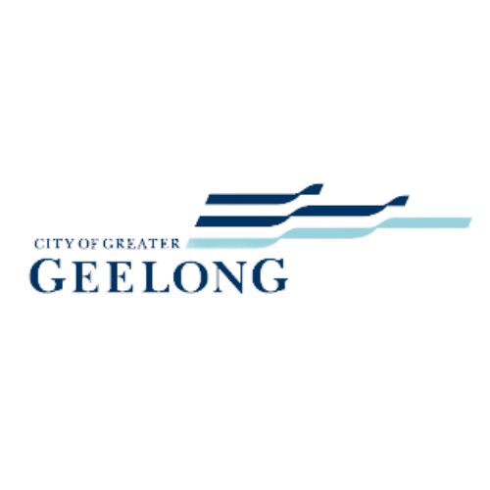
City of Greater Geelong
Positive Ageing Strategy
Conversation Toolkit Summary
5 May 2022

Community
The term community refers to a group of people that has something in common such as identity, behaviours, interests, or values. A community often share a sense of place in a given geographical area (e.g. a country, city, town, or neighbourhood) or in virtual space through communication platforms.

Stakeholder
The word stakeholder refers to individuals, groups or organisations with a stake or interest in the outcome of a decision. Stakeholders may also have the ability to influence the decision given their role or position.

Engagement
Engagement is defined as a planned process with the purpose of working with communities and stakeholders to inform decisions, share knowledge and strengthen relationships.

1 Introduction 4
1.1 Project Background 4
1.2 Purpose of Report 6
1.3 Limitations 6
2 About the Conversation Toolkit 7
2.1 Objectives 7
2.2 Activity Overview 7
2.3 Participation 7
3 Summary of Findings 10
3.1 Question 1 10
3.2 Question 2 11
3.3 Question 3 13
3.4 Question 4 14
4 Summary 16
5 Next Steps 17

- Introduction

1.1 Project Background
The City of Greater Geelong (CoGG) has developed a Positive Ageing Strategy 2021-2047. Following its development, the CoGG is embarking on a co-design process to help build the three-year action plan and measurement framework that will consider current work, highlight gaps, introduce new programs and identify partners who can help bring the actions to life. The co-design process (see Figure 1 on page 5) invites the community to be active participants in the design process of the action plan to ensure it is truly meaningful to the residents of Greater Geelong. The aim of the action plan is to create age friendly communities where people as they age:
- are valued and thrive
- are respected, supported, and participate in strong, local communities
- have equitable access to social, economic, and civic activities
- are from all ages, backgrounds, and abilities
- are welcomed and enjoy interacting with each other.


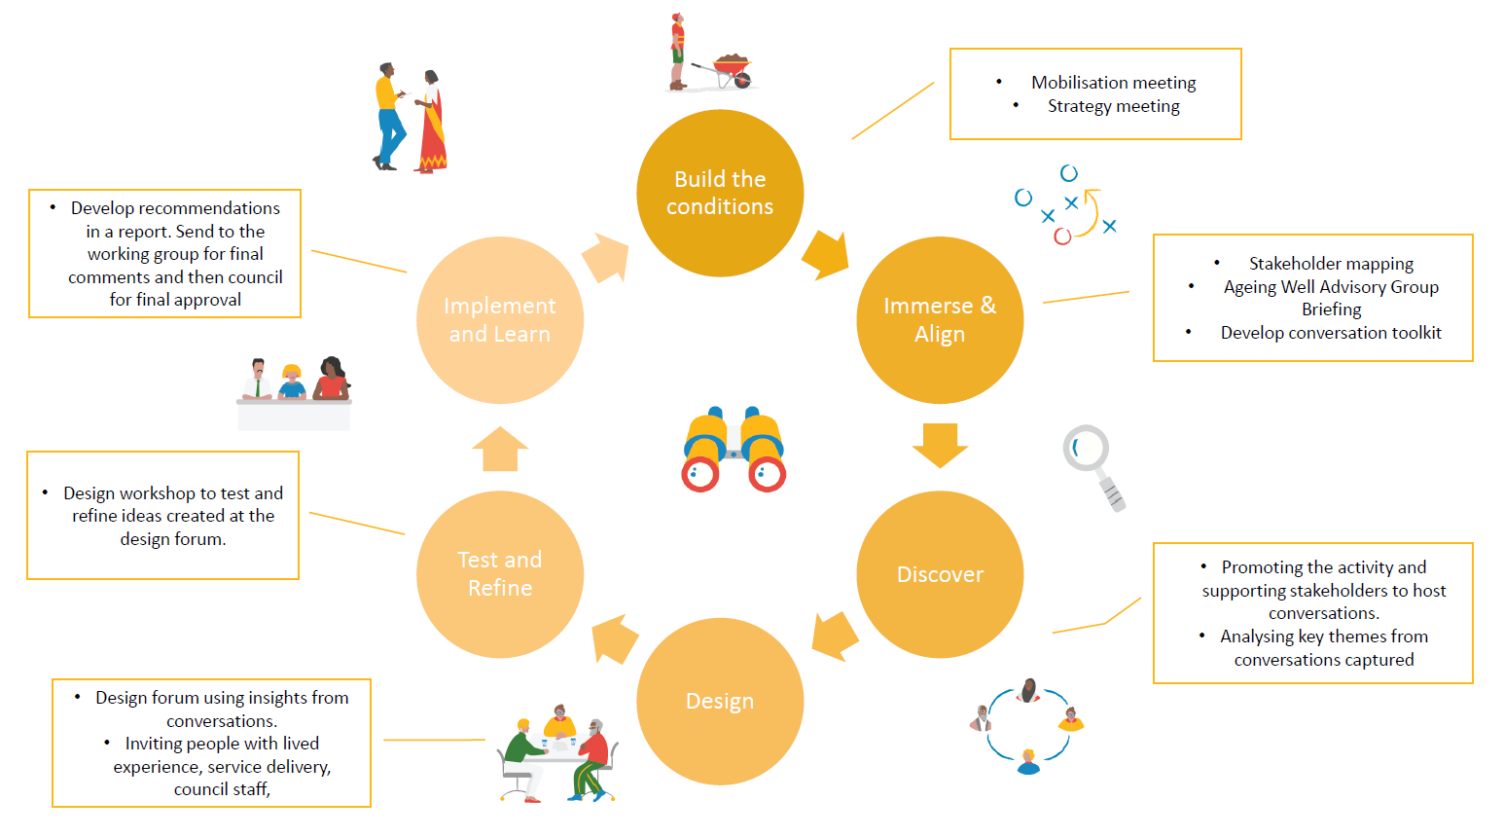
Figure 1: Positive Ageing Strategy Action Plan Co-Design process

1.2 Purpose of Report
This report provides a summary of the key themes heard through engagement guided by the Conversation Toolkit. The findings from this engagement have been compiled by Capire Consulting Group (Capire) on behalf of City of Greater Geelong (CoGG). The conversations were undertaken by members of the community through recorded conversations or individual responses to an online survey. These findings will help inform CoGG’s development of the Positive Ageing Strategy Action Plan.

1.3 Limitations
- Capire has reported on information documented by participants and interpreted the information to represent the views of participants as closely as possible.
- This report is a summary of participant’s responses and does not necessarily represent the views of all people aged 55 and over living in the City of Greater Geelong.
- Survey respondents self-selected to participate and therefore are not a fully representative sample of the community (see Section 2.3).
- The engagement process occurred during some COVID-19 restrictions, when some people in the community may have been fearful of face-to-face contact, and when some care workers were experiencing high demand of work. This impacted the ability to be able to undertake in person face-to-face engagement.
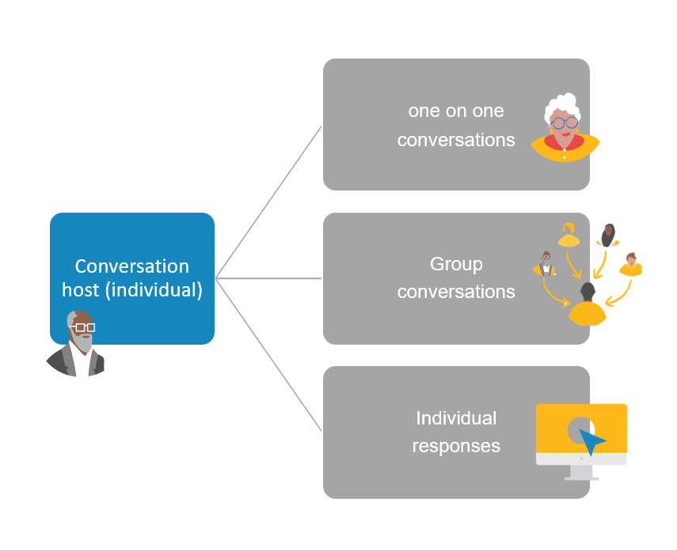
Figure 2: conversation toolkit participation options
- About the Conversation Toolkit

2.1 Objectives
The Conversation Toolkit was developed to reach a wide cross section of older people from different backgrounds, experiences, and perspectives so that they may share their views and help shape Greater Geelong to be an age friendly place. The toolkit was a resource to help the wider community move from participant to active partner by providing the support and tools to have a conversation with the people they are close to over the age of 55. The views shared will build on the Positive Ageing Strategy and inform actions and work to meet local needs and aspirations while building on existing community assets.

2.2 Activity Overview
CoGG invited people to use the toolkit as a guide to host a conversation with someone over the age of 55 between 15th February – 15th March 2022 and to record the key points of their discussion into an online or paper tool. Invitations to the Conversation Toolkit engagement were sent out through Council’s Ageing Well Advisory Group who also contributed to the development of the tool and facilitated conversations. The conversations were also promoted through the City’s social media, newspaper advertisements, community newsletters, direct email as well as promotion through seniors’ centres, libraries, neighbourhood houses, leisure centres and customer service centres. When COVID restrictions eased, staff made in person visits to selected seniors’ centres and a retirement village to facilitate some conversations and assist in recording responses.
The Conversation Toolkit was a document that clearly explained the task, provided clear instructions for different ways hosts could record the conversations, and provided some tips on how to host a conversation that is both respectful and enjoyable for both parties. The toolkit guided people through four questions and participants could choose to answer one or all the questions. The questions were:
- What makes you feel safe? Imagine a community where, as you age, you will feel completely safe and welcome. What types of things would you like to do? What actions need to take place for you to be able to experience this (either right now, or as you age)?
- What actions would support and encourage you to participate more in your community through work, volunteering, leisure, socialising, or study?
- What are the spaces, places, and services you love the most? What actions should be taken to ensure you can continue to access these as you age?
- What do you think will impact you as you age? What support do you think you may need as you age?

2.3 Participation
Figure 3 below provides an overview of the participation that occurred between 15th February to 15th March. The following page will outline a snapshot of the demographics of participants including the age, gender, and other key demographics that gives us an idea of the diversity of voices heard during discussions.
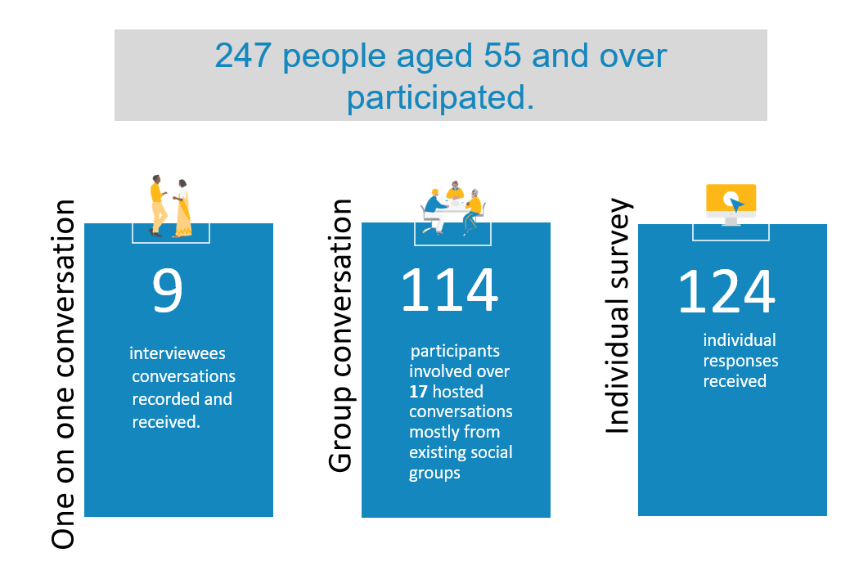
Figure 3: Overview of participation

- Most people participated by responding to the individual online survey.
- 80 percent of participants who responded via the individual tool and one to one tool identified as female.
- The group conversations did not record gender split or demographics questions, but they did give an indication of age range which all together showed 75-79 years as the largest represented group.
- Out of the 116 individuals who did answer the demographics question, 33 were currently working, while 21 were living in an aged care home.

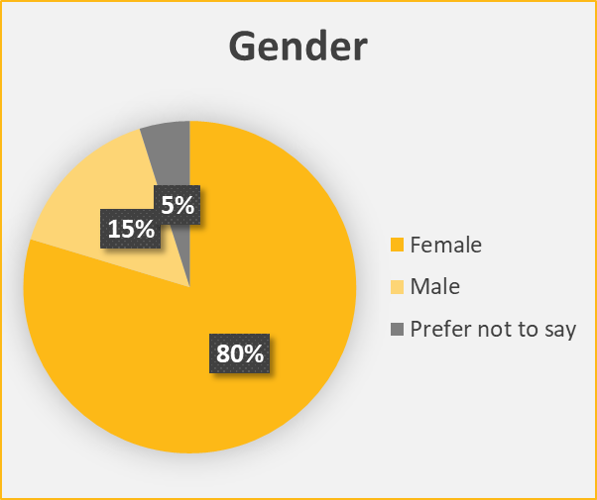


The graphics on this page outline how people participated, their gender, age, and other demographics questions

Figure 4 - How people participated
Figure 5: Gender of participants
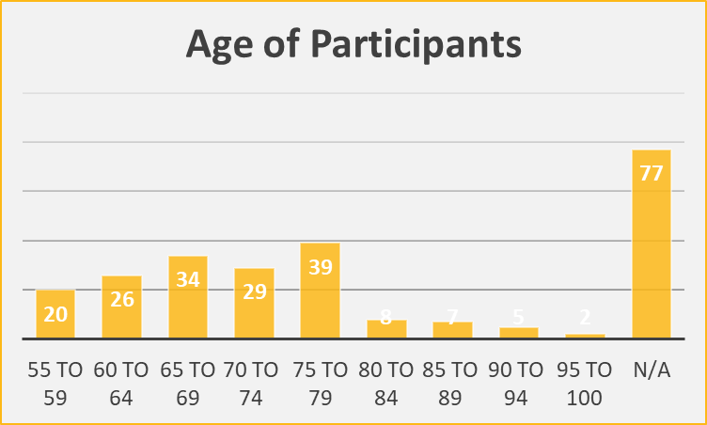

=

Figure 6: Demographics of participants
Figure 7: Age of participants

- Summary of Findings

Key findings have been summarised under each question. The responses summarised include individual responses, group responses, and one to one conversation. The findings are arranged in the order of prominence that they were seen throughout the responses.

3.1 Question 1

What makes you feel safe? Imagine a community where, as you age, you will feel completely safe and welcome. What types of things would you like to do? What actions need to take place for you to be able to experience this (either right now, or as you age)?
The responses below reflect the key themes and ideas expressed in the data relating to the question above.

A range of opportunities and ways to meaningfully connect with others
- Opportunities for socialising were very important and came up most often. People expressed concern about loneliness.
- Participants indicated that they want a wide range of free and affordable entertainment options and activities that are on offer in places that are accessible to them locally. People named a broad range of activities from cafes, shows, fitness classes, education classes, volunteer opportunities and social clubs.
- It is important to ensure social opportunities were clearly communicated, not just when and where but how they could access it.
- Also wanted were groups and activities that cater to people with a range of needs, such as disabilities.
People also suggested having activities in more areas, not just in larger centres and with people that you can rely on to do stuff with and who are trusted.
“Activities and opportunities that cater to a wide range of ages, so that I am not confined to meeting people of only one demographic. Learning programs that offer lessons and a moderated online group to share experiences with other learners.”
"Coming the Seniors club is the only thing helping my mental health, I don't know what I'd do without it"

Infrastructure
- People detailed many improvements to infrastructure that would increase their ability and confidence to feel safe getting out. The most common improvements included lighting at night-time, walking paths that were flat and wide with even surfaces.
- Other suggestions included places to sit and rest and some of those having thoughtful shelter from the sun and rain.
- There were many suggestions around ways to make people feel safe and comfortable in their surroundings including ensuring some consistency with signage that is clear, large enough to see for people with poor eyesight and that clearly communicates instructions where necessary for example, bigger print on bus timetables.

“Better signage taking into account low / poor vision. Larger signage pictorial signage for those for whom speak other languages or are vision impaired.”

Transport
- Access to safe and affordable transport options were a big barrier impacting people’s ability to feel safe and able to get out amongst the community. There were suggestions of volunteer transport options, free taxis, or buses that are accessible and frequent.
- People also talked about better connectivity for walking, cycling, and use of mobility aids.

Reduced perception of crime
- While specific incidences of crime weren’t mentioned, participants expressed concern about it. Some feared for crime in their own home through events like burglaries or being taken advantage of by professionals who come into their homes for utilities, maintenance repairs or home help.
- Some also expressed a perception of unsafe areas around urban spaces. There were suggestions of more CCTV and lighting in public parks and areas which had a reputation for being ‘rough’.
- Some suggested that seeing rough sleepers and graffiti around gives the idea that no one cares which increases feelings of unsafety or insecurity.

“Alcohol free places make me feel safe - Labuan Square feels very unsafe”

Practical living assistance was mentioned a lot, however not with much detail.
- People wanted affordable housing options.
- People want to know they will be able to have their needs met as they change.

3.2 Question 2

What actions would support and encourage you to participate more in your community through work, volunteering, leisure, socialising, or study?
The responses below reflect the key themes and ideas expressed in the data relating to the question above.
Communication
- There were many suggestions about providing clearly communicated information about what’s on and updates in all formats (online, print, phone options).
- There were also sentiments expressed around change in technology. For example, Smart Cities need to ensure they don’t create barriers where people don’t understand or trust the new technology because they don’t understand it. Conversely there were also comments about how digital technology was an opportunity to stay connected.
- One person suggested a targeted welcome book for seniors through real-estate agents would be helpful.

“Perhaps better communication and flexibility of hours would encourage more people to become involved with volunteering. Perhaps if it is communicated that the organisation recognises that health and fitness to attend may fluctuate and that is okay, people may feel more inclined to volunteer.”

“I do think more information about community clubs, easily found online (such as Facebook) or in booklets available at libraries, doctors’ surgeries, hospitals would help people find ways to be involved.”

Affordable and accessible transport is a key service that will increase people’s ability to participate.
- People suggested community run mini cabs and wheelchair accessible vans.
- More bus services between towns were also mentioned.
People want to connect and contribute
- People expressed an interest in genuine opportunities to participate in volunteer work suggesting things like mentoring programs for younger workers.
- People wanted a range of affordable courses and exercise programs to participate in.
- Some people want to participate in things that are multi-age, not just age specific.
- Some people also suggested good old-fashioned opportunities for get togethers.
- Activities that are inclusive of new members, or drop-in groups that are not ‘clicky’. Also suggested was groups and clubs that are flexible to join.

“Better advertising for volunteer opportunities – people are looking for ways to offer their skills and contribute, but not sure where to look.”

Culture shift and empowerment
- Some people talked about a cultural shift being needed in how the elderly are treated and respected in society. People detailed experiences of ageism in places like local restaurants or cafés such as being treated disrespectfully, ignored, or talked down to.
- People wanted to see themselves (older people and people with disabilities) represented in the media and suggested more telling of success stories of older people contributing, learning, working. Some suggested that a challenge to the perception of portraying older people as needing caution, comfort, and self-protection.

“Ageism is tackled - employers demonstrate publicly and in recruitment and retention that they value older workers and provide flexibility too.”

3.3 Question 3

What are the spaces, places, and services you love the most? What actions should be taken to ensure you can continue to access these as you age?
The responses below reflect the key themes and ideas expressed in the data relating to the question above.
People listed several places they loved in Greater Geelong
- People loved a range of places including parks, nature reserves, walks, beach, bike trails, walking trails, shopping centres, libraries, cinema, art galleries, restaurants, cafes, wine bars, nearby towns, community centres, many comments were made about specific spots in nature, and churches.
“People love connection to green spaces whether it is for riding, walking, or just sitting. To access these they need safety, consistency, and accessibility.”

“Neighbourhood houses are important hubs that connect people, they can be run and lead by older people in the community.”
Ensuring these spaces are accessible as people age.
- People expressed a wide range of needs in order to access these spaces including lots of infrastructure upgrades like more seating, accessible buildings that are physically and emotionally safe. Also mentioned was the need to include staff trained to raise awareness around ageism. Businesses will increase their patronage when they create quiet corners for people to sit. These would be accessed by a range of affordable transport options that are also suitable for people who may be impaired.
“If I was unable to drive anymore, I would not be able to participate in most of the above. That would be the end of me if I had to stay home on my own. It would be so lonely.”

Support for individuals to access spaces
- Ensure individuals have access to mobility aids (library of care things).
Other suggestions included:
- lessons/services that can assist individuals to use and understand the latest technology and trustworthy help navigating online services such as paying bills or accessing services
- car drop-off points close to entrances
- car parking spaces near events, venues, and destinations
- transport that is accessible for people with mobility issues as well as affordable
- temporary disabled stickers.
Changes required for spaces to be accessible
- Ensure staff who interact with older people have training to see older people as fully capable humans.
- Work with businesses to create safe spaces such as quiet corners, limiting background noise.
- Provide more safe walking routes with shaded places for sitting and with no threat from bikes or cars.
- Improve signage.
- Deliver communication about cycling rules and courtesy required on shared pathways.
- Provide pedestrian only zones.
- Ensure there is more seating for people to stop and rest.
- Plan for accessible services within 15km of home.
- Create connection to outdoor spaces that is accessible, includes seating, shade, flat surfaces and wider paths, as well as safety from cyclists or cars.

3.4 Question 4

What do you think will impact you as you age? What support do you think you may need as you age?
The responses below reflect the key themes and ideas expressed in the data relating to the question above.
What will be impacted
Participants noted the following things that would be impacted:
- loneliness
- people worrying about their mental health as well as their physical health
- people worrying about how they will adjust to their declining physical health
- reduced fitness/mobility
- more time spent on health appointments and less time for social activities
- impaired hearing
- spending more time at doctors’ appointments
- less confidence
- ability to care for partner or family member
- worries about falls, or injury and being alone.
What support will be needed
Some people could identify things they thought could impact them but were unable to think of what they would need.
“Eventually we will need home help, maybe garden help, but hard to think of services we will need.”

Practical living assistance
Participants suggested:
- mobility aids
- personal alarm system
- flexibility in support such as home support packages that can be tailored to meet the changing needs of a person.

“More difficulty in maintaining our home/property. Everything takes longer and is much harder to do as we age. Access to services such as gardening, home repairs, window cleaning, spouting maintenance, cleaning etc at affordable prices would enable people to stay in their home longer.”

Transport
- Provide financial and physical access to transport options. This includes a range of transport options that can accommodate people at all stages of their life and includes public transport, active transport, assisted transport and personalised individual transport.
“I expect to eventually have to give up my licence. My only access to public transport is via the previously mentioned rough grass. I cannot afford to use taxis. “

Connection and accessibility
- People wanted support as they age to maintain their independence and ability to take part in a meaningful way in community and society. This includes flat even walking paths, frequent spots to sit with shade and shelter, clearly written signage and wayfinding, public toilets, spots for parking and drop offs.
- People felt anxious about constantly evolving and emerging technology. They wanted access to some classes as well as the technology so that they are not left behind.
“My poor hearing. Physically now I’m in good shape but my hearing might impact my ability to do classes later. I sincerely hope not because I enjoy the mental stimulation of my classes and getting my old brain to remember a foreign language.”

Confidence
- Provide support and training to use digital technology & ensure that new digital technology is tested with people from all ages and backgrounds to ensure accessibility.
- Suggested was a database with details of vulnerable people to be accessed for welfare checks during emergencies.
- A data base or services by “trustworthy trades people”, who are vetted by Council to do work for elderly people. (Perhaps offer a training program for trades that builds capacity for respectfully working with people from all ages and backgrounds)

“I like the idea of registering for a weekly checkup phone call for periods of illness or vulnerability. This would be completely voluntary and may ease anxiety in some.”
- Summary
Outlined below are some key challenges that people have experienced which are possible to impact through the action plan:
- Loneliness, isolation – being with people, joining in on things, dropping in, being able to join things without feeling they don’t belong (long established groups, or cliques), loss of carer roles.
- Transportation – as people age getting to places becomes increasingly difficult and threatens to cut off their ability to socialise or leave their homes.
- Fear of new and fast changing systems, such as increasingly automated and digitalised processes, feeling financially vulnerable, not knowing what utilities and services to sign up for or who to trust to fix the car.
- Physical environment – uneven footpaths, infrastructure that does not allow for mobility devices, not enough shady places to rest, low lit places at nighttime, noise considerations in public and private environments i.e.: loud cafes.
- Financial security - Access to affordable housing and support as their needs change.
- Emotional safety – feeling welcome and seeing older people respected, represented, and included.

- Next Steps

This information will be used to help inform our design phase, which is scheduled to take place in April 28th 2022 through a 3-hour mini design forum with experts, people with lived experience and facilitators to explore potential solutions to the identified needs and gaps.

