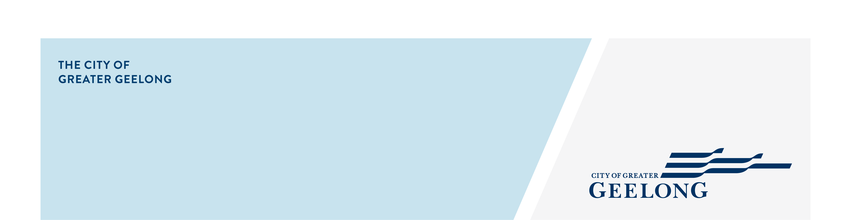
one million trees plan

community engagement summary
Feedback on the One Million Trees Plan Phase 1 consultation has closed, thank you to everyone who provided feedback, your contribution is valued and appreciated.
This stage of the community engagement was to seek your thoughts on what you value and like about trees, and where you think they should be planted.
Community feedback is a vital part of our planning. Your feedback will be used to inform the draft One Million Trees Plan
Over the course of this consultation period the City reached the following achievements.
26 DAYS
of engagement
9 August - 4 September, 2022 (Phase 1)


921
Visitors to the Have Your Say page
SOCIAL MEDIA
42,945
Impressions
577
Link Clicks

349
Surveys completed
99.4%
Support Council investing in more trees to be planted
People following the project
60

I wish there was a tree planted
“for every resident”
“for every child born”
:”to provide shade at every playground”
“in every new housing development on each block”
“along more nature strips”

Next Steps
Phase 1 community engagement is closed for evaluation and review. We will be reviewing your responses and this data will be informing the draft One Million Trees Plan. A further engagement report will be released detailing further analysis, including charts, graphs etc.
There will be a second phase of consultation in 2023 for you to provide feedback on the draft plan. We look forward to your input.

