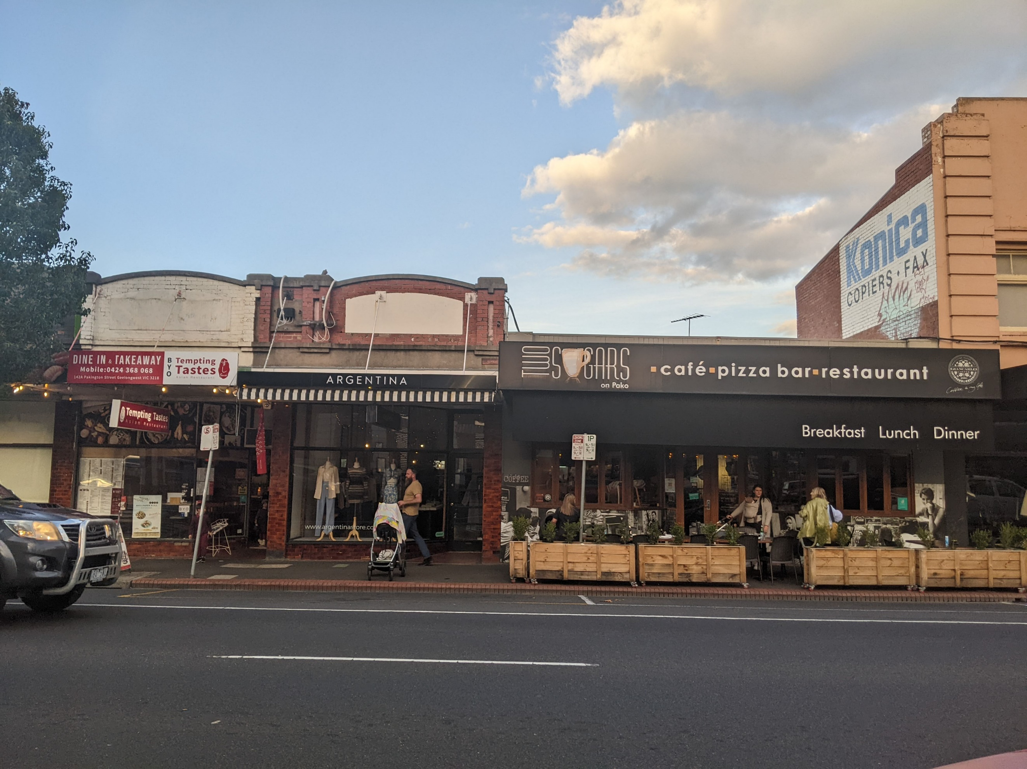
Pakington Street Public Parking Plan
Traders Engagement Report

21 October 2022

Document Revision History
Version | Date | DOCUMENT Type
2.0 | 21 October 2022 | Draft Report

Document Control Panel
 | Name | Date | Signature
Prepared by | Aaron Tepe | 2 September 2022
Reviewed by | Knowles Tivendale | 5 September 2022
Approved by | Knowles Tivendale | 5 September 2022

Addressee:
Attn: Leila Farahani
City of Greater Geelong,
100 Brougham Street
Geelong VIC 3220
Australia

Another Project By:
Movement & Place Pty Ltd
ACN: 625 377 595

Trading As:
Movement & Place Consulting
ABN: 85 375 284 892
PO BOX 8101, DANDENONG VIC 3175
info@movementandplace.com.au
www.movementandplace.com.au

This document may contain confidential and legally privileged information, neither of which are intended to be waived, and must be used only for its intended purpose. Any unauthorised copying, dissemination or use in any form or by any means other than by the addressee, is strictly prohibited. If you have received this document in error or by any means other than as authorised addressee, please notify us immediately and we will arrange for its return to us.
Movement & Place Consulting does not and shall not assume any responsibility or liability whatsoever to any third party arising out of any use or reliance by any third party on the content of this document.

Acknowledgement of Country
The City of Greater Geelong and Movement & Place Consulting acknowledge the Wadawurrung People as the Traditional Owners of Wadawurrung Country including the Djilang lands, waters, skies and animals.
We acknowledge and respect Wadawurrung Elders past, present and emerging. We recognise and respect their unique cultural heritage, beliefs and relationship to their traditional lands, which continue to be important to them today.
Djilang is the Wadawurrung word for the “tongue of land” that signals its past, present, future and continuing spatial and cultural relationship to Coriayo, Barwon, Bella-wein and the Moorabool lands and waters occupies.
We recognise the intrinsic connection of Wadawurrung people to their traditional lands and value the contribution their Caring for Country makes to the management of the land, coastlines, seas and its waterways.
We support the need for genuine and lasting partnerships with the Wadawurrung people to understand their culture and connections to Country in the way we plan for and manage the region. We embrace the spirit of reconciliation, working towards equity of outcomes and ensuring an equal voice for Australia’s first people.

Executive Summary
Greater Geelong is growing significantly. Pakington Street (Pako) is an established high-street shopping precinct and major attractor in Geelong West. Best practice parking management can improve the customer experience in Pakington Street. Traders have unique insights on how existing parking can be managed to improve customer experience in ‘Pako’. In May and June 2022,two workshops were conducted with traders to understand their insights and views with regard to parking for customers, deliveries and employees.
The first workshop focused on discussing customers experience, current parking issues and opportunities. When describing the best customer experience traders focused on reliable access, safety, and sense of place. The parking issues in Pako were focused on controls, availability, and traffic congestion. Some participants also identified enforcement, wayfinding, staff parking and disability access as issues. The issues considered most important were supply/availability, controls, and enforcement. Participants outlined opportunities to improve customer experience, including better controls and an improved public realm. Other opportunities related to improved signage, better public transport accessibility and increasing the supply of parking spaces. These responses informed investigations into how to improve the performance of parking serving visitors to Pakington Street.
There are locations along and adjacent to Pakington Street that can be maximised to gain parking spaces. Revised time restrictions can increase availability in some areas. Staff parking to cater for a wider range of shift lengths and start times should be available in safe locations further away. Loading Zones have low occupancy at various times of day and Loading Zone supply could be reduced in high activity areas to increase general parking.
Off-street parking areas need to have improved amenity and safety of pedestrian connections along with improved access and wayfinding information to make these areas a preferred option. Enforcement should focus on on-street parking to improve availability and make spaces further away more attractive. Improvements to the public realm will change user behaviour, increasing people-friendly uses and transport.
The second workshop summarised the analysis to date, sought additional solutions and prioritised actions. The participants identified key opportunities, such as reducing the number of Loading Zones, shortening time restrictions in key locations, restricting some turning movements to ease congestion, improving safety through urban design, providing signage to parking areas, upgrading the public realm and obtaining data on parking demand on Pako. The second workshop helped to prioritise options for further investigation and implementation. Next steps include a detailed design of the priority changes and implementation processes.

Table of Contents

1 Introduction 4
1.1 Pakington Street local context 4
1.2 Trader engagement 5
2 Workshop 1 engagement and results 7
2.1 Activity 1 7
2.2 Activity 2 8
2.3 Activity 3 10
3 Analysis and exploration 12
3.1 Availability and supply 12
3.2 Time based restrictions 13
3.3 Staff parking 15
3.4 Loading Zone Controls 15
3.5 Signage and wayfinding 17
3.6 Enforcement 18
3.7 Public realm improvements 19
4 Workshop 2 engagement and results 20
5 Conclusion 22

List of Figures

Figure 1-1: Greater Geelong population growth 1
Figure 2-1: Activity 1 responses 3
Figure 2-2: Activity 2 responses 4
Figure 2-3: Activity 2 prioritisation 5
Figure 2-4: Activity 3 responses 6
Figure 3-1: Yuille Street additional parking spaces and movement flow 9
Figure 3-2: Street View of Yuille Street 9
Figure 3-3: Pakington Street study area 10
Figure 3-4: Loading Zones on Pako between Hope Street and Autumn Street 12
Figure 3-5: Loading Zones on Pako between Hope Street and Autumn Street 13
Figure 3-6: Lack of signage for parking on Clarence Street 14
Figure 3-7: Streetscape improvement concept designs 15
Figure 4-1: Activity responses 16

Introduction

Pakington Street local context
The population across the Greater Geelong region has grown by 28.5% since 2011 and is expected to grow by a further 45.1% by 2041. This population and growth will lead to growth in business activity across the whole region. Population growth to 2041 is shown in Figure 1-1 below.
Figure 1-1: Greater Geelong population growth
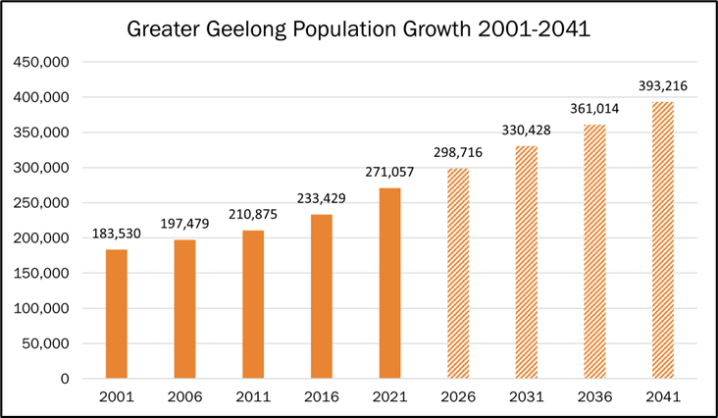Source: ABS and .idcommunity data with M&PC graphics (2022)
Some of this growth is likely to occur within walking distance of Pakington Street, but most growth will occur much further away. To cater for people travelling longer distances, all retail centres will need to manage parking facilities in a manner that reduces frustration for drivers and provides reliable parking options.
The regional attractiveness of cafes, restaurants, and shops in Pakington Street will increase visitor demand. This regional attractiveness will increase demand for car parking in the centre. This parking is used by shoppers, diners, traders and employees. Balancing the needs of each group is key to providing reliable access without devaluing the amenity of the centre.
Pakington Street is an established high-street shopping precinct and major attractor in Geelong West.
Prior to 1900, an activity centre was established in Pakington Street as the heart of the Geelong West community. Pakington Street is a vibrant retail precinct that includes civic institutions, and a slightly newer area at the northern end which includes a supermarket, medical clinics and office buildings. The street is also a north-south collector road that runs for 3km through Geelong West.
Each year there are about 30 large, and 100 small intimate events in the precinct. For example, the Geelong Food Festival is held in the precinct. The longevity and the local village feel of Pakington Street differentiates the activity centre from Central Geelong. The activity centre is widely recognised as a regional destination for specific retail stores and hospitality experiences.
Best practice parking management can improve the customer experience in Pakington Street
Each area of the activity centre has different parking demands. Previous parking and traffic studies have illustrated relatively high demand for the available parking spaces. Parking availability varies by time of day and location, with several areas recording less than 15% availability at peak times.
The lack of availability creates frustration and a perception that Pakington Street is difficult to access. Availability issues also increase parking search time, which contributes to local traffic congestion.
Best-practice management of these spaces is key to reducing frustration for shoppers, employees and traders. An important element of a best-practice approach is transparency and clarity in defining availability objectives so that the community can understand decisions that evolve the parking controls over time.

Trader engagement
The City of Greater Geelong has developed an Urban Design Framework (UDF) for Pakington Street and Gordon Avenue, which will continue to encourage the development of a vibrant Pakington Street. One key action of the UDF is to develop a Public Parking Plan.
Traders have unique insights on how existing parking can be managed to improve customer experience in ‘Pako’.
Traders have an interest in ensuring that customers are not frustrated by poor parking management. Pakington Street Traders were engaged to understand their insights related to current conditions and parking improvement ideas along the street.
These workshops targeted traders specifically due to their constant and ongoing presence on the street and deep local knowledge. City of Greater Geelong recognises the importance of understanding the perspective of traders to ensure Pakington Street caters to the needs of visitors while retaining its unique character as it evolves.
Two workshops were conducted with traders to understand their views.
Workshop 1 consisted of:
- Building an understanding of how car parking controls affect demand and how successful activity centres provide high amenity and carefully controlled parking
- Exploring traders’ perspectives on what the customer experience in Pakington Street should focus on
- Parking related issues in Pakington Street as identified by traders
- Identifying high-level priorities for the parking consultants to consider.
Workshop 2 activities consisted of:
- Explanation of how effective management of parking can address the issues and opportunities addressed in Workshop 1
- Exploration of ideas put forward in Workshop 1, and analysis of the likely impact of each option
- Presenting options that help achieve the objectives of the Urban Design Framework
- Voting on options traders would like to see progress to deeper analysis.

Workshop 1 engagement and results

Activity 1
When describing the best customer experience traders focused on reliable access, safety and sense of place.
Figure 2-1: Activity 1 Responses

A summary of participant responses is provided below, in order of most frequently raised to the least.
- Access/suitability – “Easy access to the car park”
Customers should be able to find a space close to their destination, without spending lots of time circulation or sitting in congestion.
- Safety – “When opening door, not opening onto incoming bike”
Interaction between different road users should be safe with minimal conflict. Footpaths shouldn’t be uneven, and there should be provision for the visually impaired.
- Sense of place – “More verandahs, shade for pedestrians”
Pakington Street should have a strong identity. It is an attractive destination and people enjoy spending time along it. Public space should be clean and well maintained, there should be places to sit with shopping and rest, and walking journeys should be interesting.
- Length of stay – “Clear long and short-term parking options”
There should be a variety of timings to allow for different visits. Blocks should have more than one stay duration, and it should be easy to find long-term options to allow for people to shop at multiple places over a few hours.
- Cost – “Retain free parking”
All drivers pay to drive and park their car. Most people pay by walking further or through frustration and time searching for the ‘perfect space’. High performing centres also provide the option to park in a small number of premium locations for a monetary fee.
- Low stress – “Stopping traffic while parallel parking causes anxiety”
Stress is also incurred by drivers parallel parking when the street is busy, which exacerbates traffic congestion.

Activity 2
The parking issues in Pako focused on controls, availability, loading zones and traffic congestion.
Figure 2-2: Activity 2 Responses

A summary of participant responses is provided below, in order of most frequently raised to the least.
- Controls – “Time restriction zoning is wrong in some places”
Some traders noted that there was a lack of short-term parking, as well as a lack of long-term (all day) parking for employees. Other issues included cars stopping in no standing zones, such as outside the Lutheran Primary School (lack of enforcement) which interrupts the flow of traffic. Further, concerns were raised over the possibility of paid parking.
- Availability – “Supply & availability of parking”
During peak times there can be a lack of parking availability on the street, particularly in the southern end of Pako. A major concern was the loss of any current on-street spaces.
- Loading zones – “Loading Zones are restricted all-day, despite not being needed all the time”
Loading zones should be available when needed by businesses and remain on the main road, not side streets. There are potentially too many loading zones (underutilisation).
- Congestion – “Through traffic is horrible around the school peak and makes Pako feel unsafe” “Right turns at narrow intersections can stop flow of traffic”
Many cars are using Pakington Street as a through route. These cars that do not stop also do not contribute to the local economy or vibrancy of the street. Right turning vehicles contribute to congestion as they have to wait for breaks in steady traffic.
- Enforcement – “Lack of enforcement"
There is an overall lack of enforcement, and it seems as though some employee vehicles are parked in one- or two-hour zones all day.
- Education – “Promotion of parking areas behind the shops in Pakington Street”
The City and businesses should promote/alert visitors to where they can find off-street parking, as these are more available than on-street bays.
- Staff parking – ”Designated staff permit parking areas”
There are perceptions of unsafe walking conditions for staff. Some need to walk 5-10 minutes to their car at night. There are currently no designated precinct parking areas for staff.
- Accessibility – “Disabled parking - not enough room”
There is a perceived lack of Disability Permit Parking and the spaces provided do not seem to have adequate room to be fully accessible for those that need them.
Participants then voted for the issues of highest concern among the group. The issues considered most important were:
- Supply – “Concern of losing off-street parking already in place”
“Staff car parking all day”
- Controls – “Time restriction zoning is wrong in some places”
“Autumn Street Council car park does not provide enough for business employees”
”Too many loading zones”
- Enforcement – “Lack of enforcement particularly employees staying all day in 2P spaces”
- Education – “Promotion of car parks behind shops in Pakington Street“
- Accessibility – “Disability Permit parking”
One of the activity sheets showing the issues and votes for importance are shown in Figure 2-3 below.
Figure 2-3: Activity 2 Prioritisation
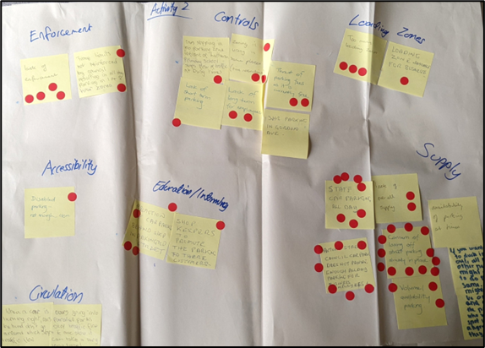

Activity 3
Activity 3 asked the group to outline their ideas for improving the quality of customer experience for visitors for Pako in response to the issues they had identified and prioritised in the prior activities. The most common responses were in relation to more appropriate parking controls and an improved public realm.
Figure 2-4: Activity 3 Responses

A summary of participant responses is provided below, in order of most frequently raised to the least.
- Controls – “More mixed time zone parks (time restrictions to vary)”
Free parking at the rear of shops should remain free and publicly available. There should be a greater mix of time restrictions, including more two-hour bays. These bays could replace either one-hour bays on Pako or some of the off-street unrestricted bays.
- Improved streetscape – “Shared zone / pedestrian only segment”
The participants identified opportunities for side-street closures and pedestrian only street segments. Other opportunities included more seating, places to stop and rest, interesting and active building frontages and even footpaths. These opportunities would improve the public realm and attractiveness of active and public transport options, easing the burden on the car parking supply in the area.
- Circulation – “Alternate routes for riding - dangerous on Pako”
Pakington Street is often congested at peak times and road space is at a premium. There were some comments on bike lanes, including that they take up too much space and aren’t currently being heavily used. It is also perceived that zebra-crossings contribute to congestion more so than signalized crossings. Right turns, in this case at the intersection of Pakington Street with Candover Street/Albert Street, don’t have green arrows and hold up the flow of vehicles going straight through.
- Loading Zones – “Remove duplication of loading zones on corner of Preston/Pako”
Loading Zones exclude most users for a large part of the day. On Pakington Street Loading Zones are from 9:00AM-5:30PM, and on Saturday 9:00AM-12PM. Some Traders suggested there is a potential surplus of Loading Zones (corner of Preston Street and Pakington Street). Other comments suggested the need for more Loading Zones on Gordon Avenue, while another was happy with the current level of Loading Zones.
- Signage – “Improve signs to rear parking”
All the comments on signage were in reference to providing clearer wayfinding to off-street/rear of shop parking bays. Specific locations identified include Candover Street and Weller Street.
- Supply – “Multi-level car parks”
Despite supply being the highest weighted issue votes by traders, it only ranked 6th in comments made about supply opportunities. This highlights the difficulty Pakington Street and any other vibrant high street faces in increasing the supply of parking bays, given the available road space and surrounding land. Comments made on supply were unspecific, such as increasing the overall supply and not taking away on-street bays. Outside the scope but relevant to supply was a comment on providing multi-storey parking structures.
- Public transport – ”More public transport”
Opportunities for public transport included increasing the frequency of bus services, providing more public transport options and reducing the size of buses to suit ridership and reduce the size of Bus Zones.
- Enforcement – “Increase enforcement slightly”
There was one comment around increasing enforcement. This is in response to the perception that time restrictions are being ignored and vehicles are occupying premium spaces for long periods of time.

Analysis and exploration
The responses from each activity informed investigations on into how to improve the performance of Pakington Street’s parking. They were investigated in order of importance placed on issues by traders, which were:
- Availability and supply – productivity of parking spaces
- Time-based restrictions
- Safe and available staff parking
- Loading Zone controls
- Signage
  - Clear wayfinding to off-street and available parking
  - Directing longer stay customers to off-street parking spaces
- Enforcement
- Visitor experience and user behaviour through streetscape improvements

Availability and supply
There are locations along and adjacent to Pakington Street that can be maximised to gain parking spaces. Closing a side street intersection created additional parking within proximity of destinations along Pakington Street. At least four spaces can be created on each leg that is closed. It also improves safety, pedestrian amenity and traffic flow.

Yuille Street
An example of this exists in Yuille Street on the western side of Pako. By removing two car parking spaces at the end of Yuille Street, up to five can be added to the southern side of the street, resulting in a net gain of three spaces. Such opportunities should be explored in the whole study area to optimise the amount of space that can be used for additional parking. These interventions generally should not come at the expense of area allocated to pedestrians, cyclists, businesses or moving vehicles. Figure 3-1 and Figure 3-2 show the potential location of additional parking on Yuille Street.
Figure 3-1: Yuille Street additional parking spaces and movement flow
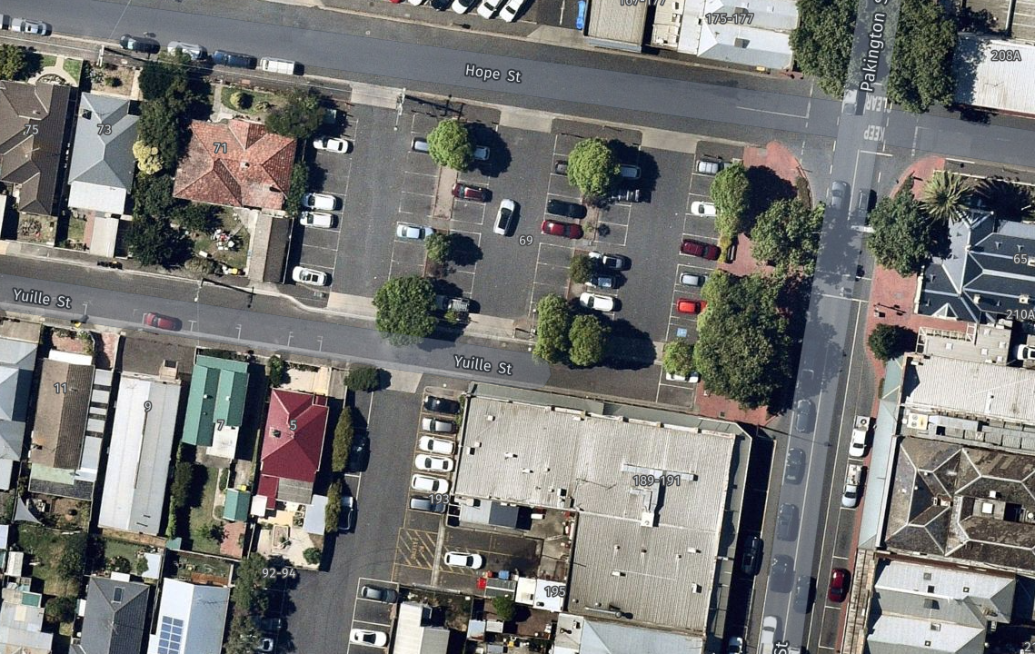Source: Near Map with M&PC analysis (2022)
Figure 3-2: Street View of Yuille Street
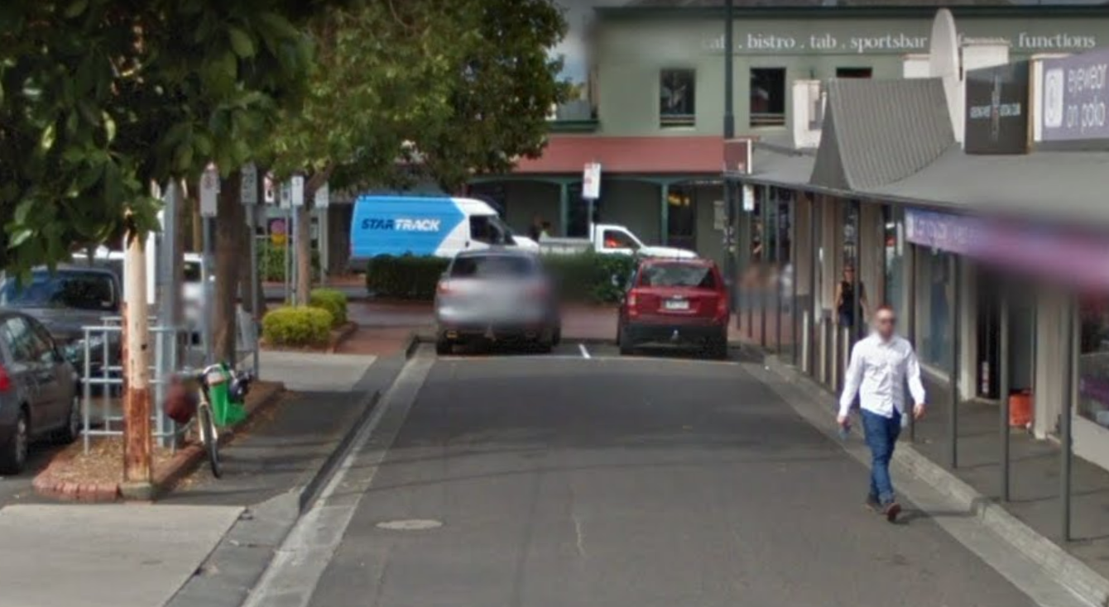Source: Google Street View, image taken 2015 (2022)

Time based restrictions
Revised time restrictions can increase availability in some areas, and opportunities differ depending on the intensity of the area and land use. North and South Pako have different mixes of land use and thus must cater to different customer segments.

Opportunities in South Pako
- Greater range of time restrictions due to the nature of businesses. This area is characterised by short stays and visits to grocery stores, butchers, cafes and banks
- On-street 1P spaces could be reduced to ½P to increase availability and turnover.

Opportunities in North Pako
- Greater range of time restrictions as there are currently many unrestricted bays allowing for all-day stays
- If availability is an issue in unrestricted bays, more 4P, 2P and 1P restrictions can be gradually introduced.
North Pako and South Pako are defined in Figure 3-3.
Figure 3-3: Pakington Street study area
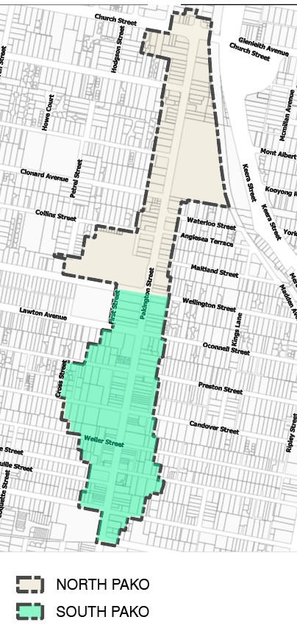
Source: City of Greater Geelong with M&PC analysis (2022)

Staff parking
There were a range of concerns highlighted by the group around staff parking, such as:
- There isn’t a mix of options for different shift start times or lengths
- Staff arriving late, end up being much later because they have to park further away
- Need to balance making it easy for staff, without just encouraging more staff travel by car
- Staff aren’t always able to find parking in their desired location
- Employees must often walk back to their cars at night.
Opportunities to address the above concerns include:
- Having safe and walkable designated staff parking
- Having a mix of times restrictions to suit various needs in dedicated or publicly accessible parking facilities
- A small number of paid parking spaces close to the centre could facilitate all day parking for late arriving staff
- Catering for staff arriving later in the day through a small number of paid, all-day parking spaces close to the centre of the study area.

Loading Zone Controls
Loading Zones have low occupancy at various times of day outside the busiest delivery times. This means that there could be scope to open access to more users.

Current condition
- There are 19 Loading Zones
- There is a combined capacity of 10 spaces in South Pako. The average capacity is 24% during the week and 21% on weekends
- There is no apparent peak in demand on any given day
- There are a number of Loading Zones close to each other that occupy highly sought-after parking spots, such as those in Figure 3-4 between Hope Street and Autumn Street.

Loading Zone control opportunities
- Change loading time restrictions from 9am-5pm on weekdays and 9AM-12PM on Saturday
  - Restrict Loading Zone use to AM or PM times (dependent on the needs of businesses being served) and allow customer use at other times
- Change restrictions from 15-mins to ½P for any user
  - This spot can be used for both loading and short-stay customers
- Reduce other 1P spaces to ½P in high-activity areas would align to visitor needs (e.g., outside banks, butchers and grocers) and increase availability.
Figure 3-4: Loading Zones on Pako between Hope Street and Autumn Street
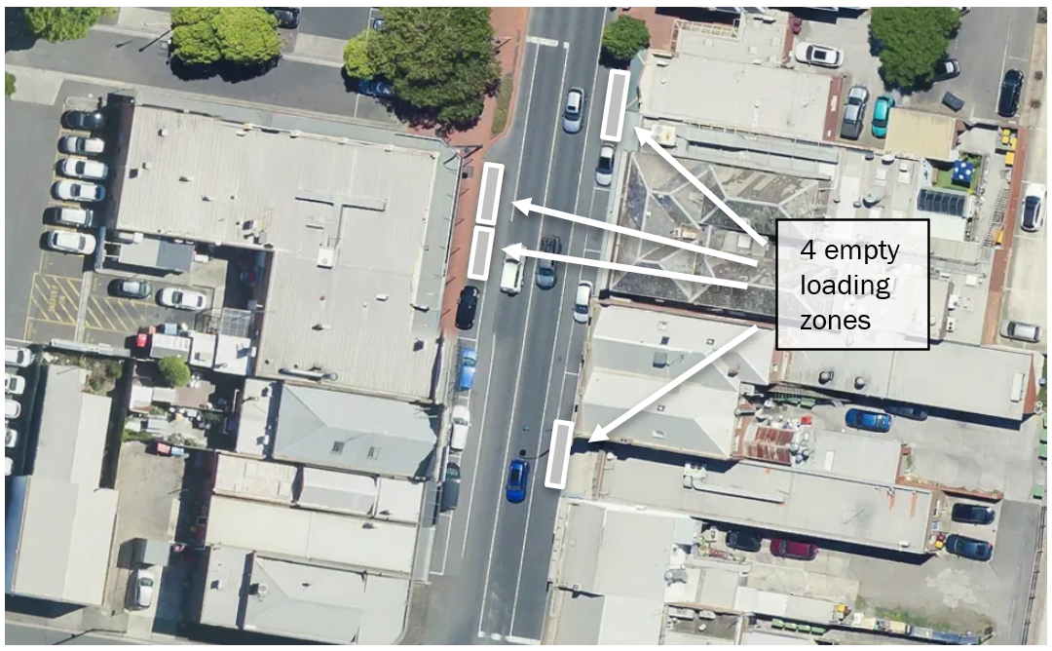Source: Near Map with M&PC analysis (2022)

Loading Zone supply opportunities
- Remove Loading Zones between Hope Street and Weller Street (Figure 3-5)
  - There are two Loading Zones on this high activity, 60m stretch of Pakington Street
  - Businesses include Pako Meats, Geelong Fresh Foods, Heritage Meats, Weiser’s Continental Bakehouse, Panache Café, 7 Origins Café, and the Newsagent. Many of these, particularly the butcher and grocer, would benefit from more short-stay parking on the street which is currently occupied by 15-minute Loading Zones
  - Loading for these businesses could occur before peak times, or one Loading Zone could be retained with shortened operating hours.
- Turn Loading Zones either side of Preston Street/Clarence Street into general parking bays accessible by any user.
Figure 3-5: Loading Zones on Pako between Hope Street and Autumn Street
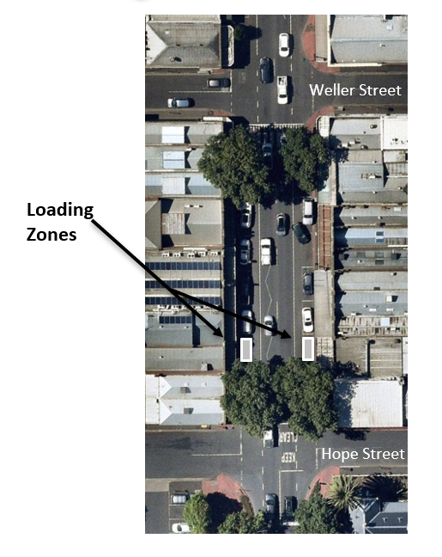
Source: Near Map with M&PC analysis (2022)

Signage and wayfinding
Off-street parking needs improved access, information, amenity, and safety of connections to make it the best option.

Current behaviour and impacts on Pakington Street
- People will generally use off-street parking if they don’t find a spot on Pako – as shown in the 2018 visitor survey results. Of those surveyed, 95% said they would look for off-street parking if they could not find a spot along Pakington Street.
- Circulating to find on-street parking exacerbates traffic congestion.
- On-street 2P parking in Pakington Street reduces parking availability for users with tight-time constraints who are unwilling to deviate to park at the rear of shops.

Opportunities
- Consolidate most 2P parking at the rear of shops along Pakington Street.
- Provide clearer signage to off-street parking locations.
  - Clarence Street has no signage, however there is parking available behind Pakington Street at Virginia Todd Hall (Figure 3-6).
  - Similarly, signage to parking along Candover Street, Lawton Avenue and Waratah Street could all be improved.
- Make off-street parking the easiest and most readily available option.
  - People arriving by car have certainty that off-street bays will be there when they arrive.
  - Strategies include better signage and real-time parking information.
Figure 3-6: Lack of signage for parking on Clarence Street
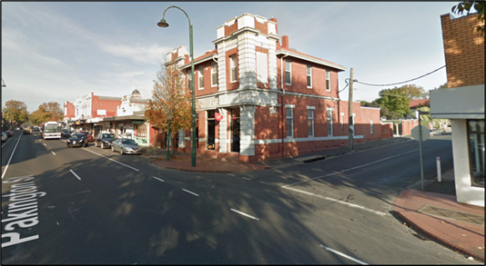Source: Google Street View (2022)

Enforcement

Opportunities
Tighter enforcement in high demand locations across the study area can help to improve availability by ensuring that the intended market segments are using the spaces. Appropriate enforcement of restrictions has the potential to:
- Deter people from overstaying and occupying space that could otherwise be used by more users
- Ensure visitors are mindful of the best location to look for parking based on how long they are planning on staying
- Establish a clear process for people to contact Council with observations where issues exist.
The City should be mindful of the risk of over-enforcement deterring people from visiting. It is important to apply enforcement appropriately based on a lack of availability. An enforcement rate of 2-3% should be sufficient to ensure a high level of compliance without creating the impression that a ticket is issue every time someone visits. This can be modelled to determine the most appropriate enforcement regime for various parts of the centre.

Public realm improvements

Opportunities
There are opportunities to upgrade the public realm and support mode shift to active and public transport journeys, relieving the pressure of Pakington Street’s parking supply. Opportunities include:
- Streetscape improvement, such as those proposed in the Pakington Street and Gordon Avenue Urban Design Framework (as shown in Figure 3-7 below) including initiatives that make walking, cycling and public transport the most attractive for local trips
- Convert underutilised bays to improve pedestrian amenity, and increase space for commercial activity such as outdoor dining and stalls
- Make the street safer for cyclists and pedestrians through intersection design and a greater share of the road for bicycle lanes
- Create additional bicycle parking facilities every 20-30 metres along Pakington Street
- Consider Yuille Street style street changes to increase parking supply on Pakington Street and increase space for outdoor activity or economic activity
- Activate the street and building frontages to make journeys interesting and interactive. Art installations and murals make the street more vibrant and attractive, thus making active transport trips to the centre more likely.
Figure 3-7: Streetscape improvement concept designs
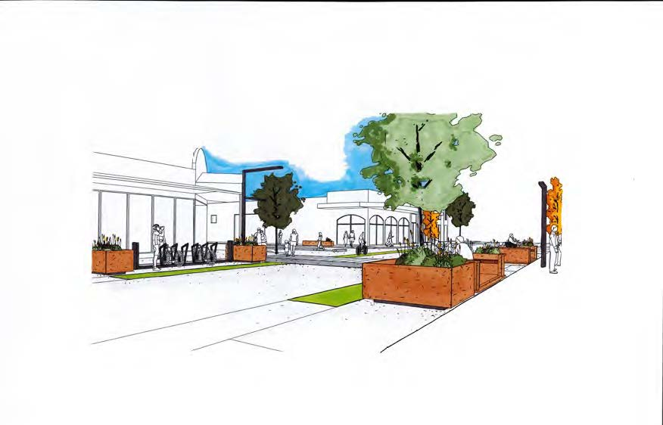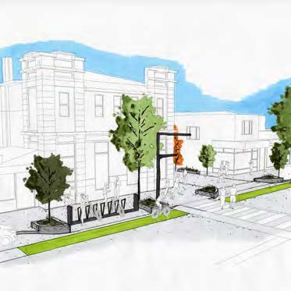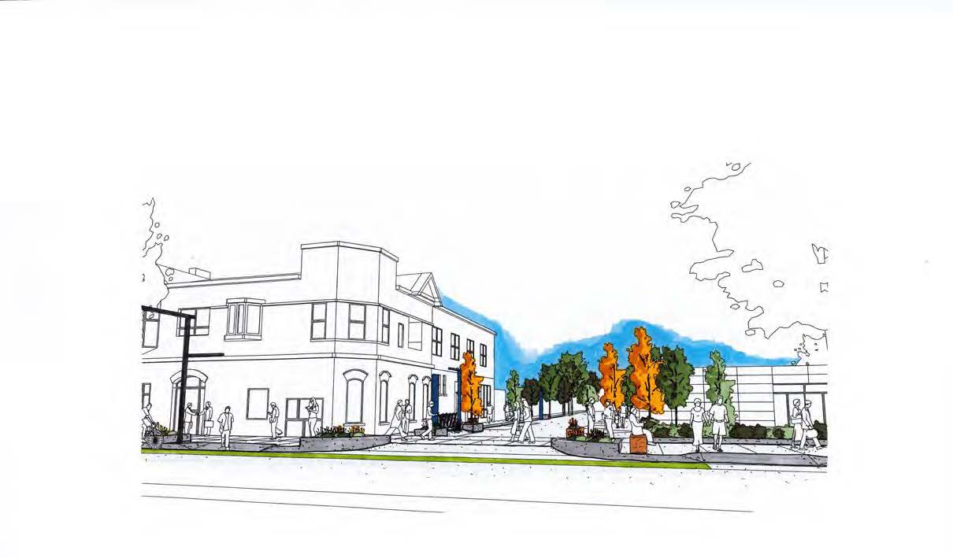Source: City of Greater Geelong (2021)

Workshop 2 engagement and results
The second workshop presented the outcomes from analysis completed to date, developed additional solutions and prioritised actions. A presentation of M&PC analysis on issues raised in workshop one, provided a basis for attendees to give detailed feedback and their current thoughts on improvement options that can improve parking options and outcomes in Pako.
The group identified key opportunities such as reducing the supply of Loading Zones, shortening time restrictions in key locations, and restricting some turning movements to ease congestion. A summary of responses is provided in Figure 4-1 below.
Figure 4-1: Activity responses

A summary of participant responses is provided below, in order of most frequently raised to the least.
- Loading Zones – “Too many Loading Zones, loading is generally done by 3PM”
Loading Zones occupy a space that could otherwise be used by customers, increasing the productivity of the space throughout the day. Participants typically suggested either a reduction in overall supply of Loading Zones, a change in time controls to allow for general use for a greater portion of the day, or both.
- Time controls– “Should be more half-hour parking”
Discussions around time controls centred around the need for a mix of controls, with the areas of most frequent visits having shorter time restrictions (compared to current controls) to allow for a greater number of short visits in proximity to key destinations.
- Congestion – “Right turning movements causing congestion”
Traffic congestion is a concern for traders as it is viewed as a barrier to visitors enjoying their Pakington Street experience and being able to spend more time in local businesses. Congestion is caused by a range of factors including excessive through traffic, parallel parking manoeuvres and right turning movements.
- Enforcement – “Stronger enforcement in car parks off Candover Street”
Comments about enforcement called for more regular enforcement of restrictions in key locations. Specific areas were targeted for where traders believe enforcement is the most important. These areas are typically in the busiest section of Pakington Street around the heritage core.
- Safety – “Back section of Town Hall parking is poorly lit”
Employees and visitors are more likely to embrace a walk from their car to their destination if they feel safe on and around Pakington Street, particularly at night.
- Signage and wayfinding– “Signage at Albert Street to rear parking”
There is a large supply of off-street parking around Pakington Street. Traders have identified signage as something that is lacking in some areas and could be used more effectively to direct visitors to available spaces and improve their experience.
- Demand – “Count the staff using all day parking around Pakington Street”
There is currently a knowledge gap among traders and The City regarding how many people are visiting Pako each day and at what times. Understanding these figures will assist help to develop improvement options that will best meet visitor needs.
- Public realm improvements – “Use footpath around The Barking Dog for bicycle parking, alfresco dining”
Public realm improvement options change the user experience and affect mode share, particularly for local trips. This directly impacts the attractiveness of the place, and influences transport choices, particularly for local residents living 1-2km away.
- Supply - “Redesign of Yuille Street to create a few additional spaces”
There is a limited amount of space around Pakington Street to increase the supply of parking spaces. However, a small number of modest interventions could create opportunities for some more bays in premium locations.

Conclusion
The project sought to engage with Pakington Street traders to discuss parking issues and improvement opportunities across the Pakington Street Activity Centre (Pako). The team completed several walk-throughs of the centre to understand the current parking supply and controls. Traders were engaged to better understand the market segments and trader needs including those related to staff and loading zones.
The project prioritised options for further investigation and implementation. A summary of opportunities is provided below:
- Re-consider Loading Zone space locations and controls. This is due to low occupancy and what seems like an oversupply at all times of the day.
- Design the streetscape to improve pedestrian safety through:
  - More lighting and CCTV
  - Active frontages that create interesting environments and opportunities for ‘eyes on the street’
  - Greater pedestrian and cyclist amenity.
- Upgrade the public realm to encourage an increase in active and public transport usage. This can be achieved through:
  - Improving walking and cycling infrastructure
  - Improved signage and wayfinding to support off-street parking, reducing the number of circulating vehicles on Pakington Street.
- Investigate the demand for short-stay on-street parking in high activity areas and appropriately adjust the mix of time restrictions. Optimising on-street controls can:
  - Ensure availability for those who choose to drive
  - Improve traffic flow by reducing circulation of drivers looking for on-street spaces
- Increase enforcement to improve traffic flow while balancing attractiveness of the precinct
- Explore the opportunity for real-time parking information technology for off-street parking areas
- Manage off-street parking to support Pakington Street staff needs. This includes:
  - Increasing real and perceived safety of walking at night to facilitate walking from all-day parking spaces to places of employment
  - Directing staff to locations that do not compete with short-stay users.

Key next steps
- Draft a Precinct Parking Plan
- Design priority improvement actions
- Facilitate a continual cycle of reviewing controls to ensure parking availability
- Work with Pakington Street traders to highlight the need for continual improvement and publicise key changes.

Precinct Parking Plan
- Map the parking sub-precincts based on user catchments
- Define the customer mix that each sub-precinct should cater to, for example:
  - Visitors: 20% drop in, 40% sort-stay, 30% long-stay
  - Employees: 10% part time, 0% full-time
  - Residents: 0%
- Create a set of controls that will meet those user needs
- Test availability and refine.
These next steps can be included within a Parking Plan for Pakington Street that can guide short-term improvements and longer-term frameworks and methods that can be applied to help ensure the future parking controls are designed to best meet future needs.

GHD. (2018). Pakington Street (Geelong West) Car Parking and Traffic Study

