community engagement summary report

The City is progressing the installation of new sports lighting at selected local sporting reserves to support safe, inclusive and sustainable use of community facilities prioritised based on utilisation, current condition, and in some cases the absence of existing lighting.

The City currently manages over 200 floodlit sporting assets throughout the municipality, including over 120 tennis courts, ovals and soccer pitches.

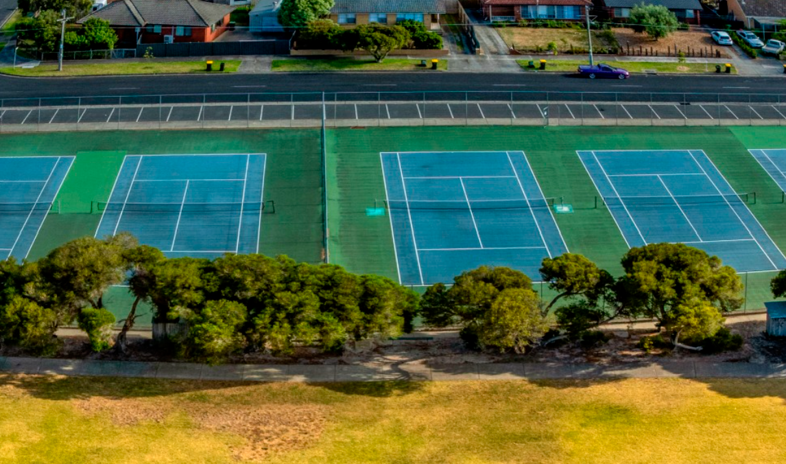

COMMUNITY ENGAGEMENT PURPOSE

The objective of this engagement is to inform the community about the proposed sports lighting project at Ervin Reserve (26 Richard Street Newcomb), Estuary Reserve (4-30 Estuary Boulevard Leopold) and Doris Smith Reserve (11 Arnott Street Geelong West).

The new sports lighting will be installed to enable organised training and competition to occur safely during evening hours. The works will involve the installation of lighting poles, fittings and associated electrical infrastructure.

Sports lighting has been designed to meet Australian Standards and meets the Obtrusive Lighting Compliance Testing as required.
- Lighting is purpose designed to illuminate the playing surface only
- Poles and fittings are positioned and angled to minimise light spill beyond the reserve
- Modern LED technology is used to improve control and efficiency
- Council will ensure the final installation meets all compliance requirements before the lights are commissioned
- Lighting will be used within approved operating hours.

HOW WE ENGAGED
Community engagement was undertaken between 1 and 28 May, 2026. A project specific engagement page was developed to provide project information and to enable the community to ask questions regarding the installation of sports lighting at the three reserves.
Letters were distributed to surrounding residents, and signage was installed at each site to inform reserve users about the project.

3
Onsite drop in sessions
11 people attended sessions.

Questions were raised on the HYS page
6

305
Views of the HYS page

28 DAYS

.

WHAT WE HEARD
Thank you to everyone who provided feedback through our engagement activities. We are committed to supporting safe and inclusive community sport while minimising impacts on nearby residents.
Key themes raised by the community in regards to the sports lighting project included:
- Safety & lighting
  - Poor lighting in the Leckie Place car park and along access paths
  - Safety concerns, particularly at night for families and women
- Use of sports lighting
  - Questions about operating hours and potential impacts on residents.
In response to your questions, the City is taking the following actions:
- Enhancing safety
  - Installing additional lighting between the courts and the car park
  - Improving visibility and safety along pedestrian access routes
- Managing lighting use
  - Ensuring sports lighting operates within approved hours
  - Supporting compliance with EPA noise and environmental guidelines
  - Management of unreasonable use and/or behaviour.
While consultation was focused on sports lighting, we also received questions relating to broader issues outside the scope of this project. Although these matters were not the subject of the current review, they have been noted and are being considered separately, with further investigation and follow-up occurring where appropriate.
- Parking & traffic
  - Concerns about parking compliance and vehicles blocking driveways
  - Difficulty accessing properties due to increased traffic
  - Underuse of the Leckie Place car park
  - Concerns of unauthorised vehicles being left in car park
- Noise & neighbourhood amenity
  - Concerns about noise from people arriving and leaving at night
  - Management of unreasonable behaviour.
In response to these queries, the City is taking the following actions:
- Improving parking & access
  - Formalising and line-marking the Leckie Place car park
  - Installing signage to direct users to available parking in Leckie Place
  - Ongoing monitoring and enforcement by Local Laws
- Managing noise & behaviour
  - Installing signage to encourage users to respect nearby residents
  - Working with clubs to promote responsible use of the facility
  - The booking system requires all users to provide contact information ensuring participants demonstrating unreasonable behaviour can be restricted from further court access.
NEXT STEPS

Expected Completion Dates

Estuary Reserve- Late 2026
Ervin Reserve Tennis Courts- TBC
Doris Smith Reserve Tennis Courts- TBC

