community engagement summary report

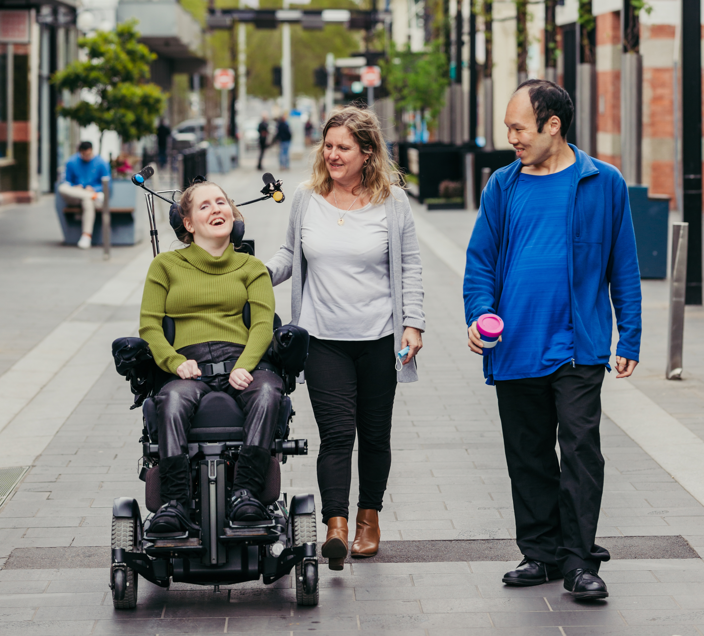

INTRODUCTION
This report outlines the process and feedback received from engagement with community to inform the development of the City of Greater Geelong’s Access & Inclusion Action Plan 2024-2028. The plan will outline actions to create a city that is more accessible, inclusive, welcoming and supports the full participation of people with disability.

For the development of the new Access and Inclusion Action Plan, the City of Greater Geelong worked with consultants to conduct extensive community engagement with external and internal stakeholders. Through the engagement we heard from residents with disability, their carers and supporters, service providers and City of Greater Geelong employees, to ensure the needs and aspirations of people with disability were reflected in the plan. The City’s Access and Inclusion Advisory Committee provided guidance on the community engagement.

The Access and Inclusion Action Plan is a legislative requirement and will be registered with the Australian Human Rights Commission.

HOW WE ENGAGED
Engagement Techniques
A project specific engagement page was developed for the City of Greater Geelong website Have Your Say platform to provide project information and communicate ways that the community could contribute to the development of the Access and Inclusion Action Plan.
A range of engagement tools and techniques were used to provide a range of opportunities for stakeholders and community to have their say. The main tools and techniques are explained in further detail below.


People Attended Workshops

128

55
6
20
72

Surveys Completed
Days of Engagement
People Attended Hosted Conversations
Service / Advocacy Providers Interviewed

engagement methods
Have Your Say Online Portal | An online Have Your Say project page was designed to share relevant information to encourage community feedback throughout the engagement process.  https://yoursay.geelongaustralia.com.au/AIAP2024-2028
Survey | An online survey was available on the Have Your Say page from Thursday 27 July through to 19 September 2023. Voice recording capability was available for the open text survey questions and a hard copy version of the survey was also available by request.  The survey provided the community with the opportunity to share their thoughts on how we can make Greater Geelong more accessible, inclusive and welcoming, and support people with disability to fully participate in community life.
Community Workshops | The community was invited to give feedback at workshops facilitated by independent consultants. We held two in-person workshops and one online workshop with the general community, and one workshop with the Access and Inclusion Advisory Committee.
Hosted Conversations | Host a Conversation Toolkits were available for download from the Have Your Say project page. Community members were encouraged to use the toolkits to support them to host conversations with groups in their community. Staff from the City of Greater Geelong also provided support. This toolkit was used to gather responses to the survey questions from the following groups:  - Sensitive Support Services  - Back-to-Back Theatre Company  - City of Greater Geelong Youth Council  - Nelson Park School  - VALID Peer Support Group  - Bellarine Disability Services Forum
Interviews | Interviews were conducted with:  - GenU  - Barwon Disability Resource Council  - Rights Information Advocacy Centre  - Wathaurong Aboriginal Cooperative  - Access and Inclusion Advisory Committee Members (x2)
Communications
The opportunity for the community to help shape the Access and Inclusion Action Plan was communicated across multiple platforms and methods. People were directed to the Have Your Say project page for information about the project and details on how they could participate.


Presentations to local Disability Networks
2
SOCIAL MEDIA
115,049
Reach/Impressions
2,673
Actions (Clicks, reactions,
shares, comments etc.)


147
Community organisations emailed
Flyers distributed
2001

Communication Methods | Number
Facebook | 2
Instagram | 1
X (Formerly Twitter) | 3
LinkedIn | 3
Meta | 2
Media Releases | 2
Posters at key locations | 10
Flyers (with QR Codes) | 200
Emails to key community groups | 147
City of Greater Geelong Staff Newsletter | 2
Presentations to Disability Networks | 2

Who we engaged with
Between the 27 July and 19 September 2023, the City of Greater Geelong received 226 responses from the community to inform the development of the Access & Inclusion Action Plan.
The community were invited to share some demographic data with us, primarily through our Have Your Say survey.
Who responded: Snapshot of Have Your Say survey respondents
48% identified as people with disability

39% were carers or family members or a person with disability
13% had a disability and were also carers or family members of a person with a disability
25% worked in the disability sector
31% were aged 35-49 years and 45% were aged 50-69 years
3% were Aboriginal or Torres Strait Islander
70% were women, 22% men, 3% non-binary (5% didn’t say)
13% were from the LGBTIQIA+ community (of those, 53% had a disability)
5% were migrants
9% were employees of City of Greater Geelong

WHAT WE asked
We asked the community to tell us how they felt about current accessibility in Greater Geelong compared to five years ago and what were the most important things we can do to make Greater Geelong more accessible and inclusive.
Specifically, we asked:
- How accessible do you think Greater Geelong is right now?
- Do you think Greater Geelong is more accessible now than it was 5 years ago?
- What is the most important thing we could do to make Greater Geelong more accessible and inclusive for people with disability?
- How can we make City of Greater Geelong (Council) services and facilities more accessible for people with disability?
- What can be done to increase employment opportunities for people with disability across Greater Geelong?
- What can be improved to enable people with disability to fully participate in community life across Greater Geelong?
- What can we do to make sure people with disability are treated fairly and equally in Greater Geelong?

WHAT WE heard
There were mixed feelings about the progress the City of Greater Geelong has made over the past 5 years in improving accessibility, with 36% of respondents feeling Greater Geelong was more accessible than it was 5 years ago and 38% feeling it was less accessible. When asked to rate Greater Geelong’s current accessibility, respondents scored it an average of 2.7 out of 5.
We heard the following feedback in relation to our key questions.
The most important change
Two-thirds (66%) of people with disability and 90% of those without disability want the City to continue improving accessibility in public places and spaces as the most important change. The importance of parking and transport were the next highest priorities.
Improving services and facilities
Throughout the engagement process, the physical environment, facilities, and ability to travel throughout Greater Geelong were raised repeatedly. These factors were considered essential to people with disability being able to work, attend events, be independent and generally participate in society. With regard to physical access, people wanted:
- More accessible public places and spaces.
- Greater provision of well maintained, accessible public toilets and changing rooms (including for adults).
- More disability parking (increased number of parking bays and increased length of stay).
- Improved accessible public transport (more accessible buses, improved routes and increased frequency).
- Physical access for the whole experience or journey (e.g., a beach may provide access to the sand, but not access to the water).
Improving participation
- As noted above, ensuring people with disability are able to physically access public places, events and employment is key to them being able to participate.
- Clear communication to show how a place is accessible builds confidence to go there.
- Building community awareness and understanding of disability and the different ways people with disability can be supported was considered important.
Improving employment
- Paid employment of people with disability is a high priority.
- Workplace changes post-COVID provided for more flexibility to work from home and flexible hours which creates greater accessibility for many people with disability.
- Ideas for improving employment opportunities for people with disability included:
- Greater engagement, education and training of local businesses.
- Promoting the strengths of people with disabilities as employees.
- Supporting people with disability to find work.
- Ensuring that people with disability have the supports they need in their jobs.
- The City could be a model employer to other businesses by employing more people with disability.

Making Greater Geelong more equitable and addressing discrimination
- The community’s highest priorities in addressing discrimination were changing community attitudes, making more places and spaces more accessible, and improving employment opportunities.
- The community discussed the lack of knowledge of the rights of people with disability generally and that an acceptance of diversity was lacking.
- Engaging people with lived experience of disability to help develop policy, programs and infrastructure, as well as develop and deliver training for employers and businesses, was seen as critical to raise understanding of people with disability and their diversity.

“Treat people with disability as part of society and not a subset of society.”
“Ensure buildings are thoroughly audited not just entrance accessibility.
Increase accessibility on all public transport. Increase accessibility with all toilets and change rooms within CoGG.
Providing quiet rooms in public places.”

Six Community Priorities
The engagement highlighted opportunities to reduce barriers faced by people with disability. These can be grouped under six main themes.

Physical Access
Continue work to remove physical barriers and consider the different types of disability to improve accessibility of buildings, public spaces, facilities, and signage in both the city and outer areas of Greater Geelong.
- Inclusion and Participation
Improve participation by people with disability in the City of Greater Geelong’s events, activities, sport, services and employment by improving physical access and creating environments where they feel welcomed, supported and that they belong.

Employment
The City of Greater Geelong to become a leader in employing people with disability in the region. Then advocate to, and educate local businesses, by promoting the strengths of people with disability as employees. Provide support to people with disability to find and do their job.

Lived Experience Engagement (‘Nothing about us without us’)
People with a diverse range of disabilities should be engaged in the planning and design of infrastructure, facilities, services, and programs to ensure they are functional, appropriate and avoid segregation from the broader community.

Communication
Establish accessible* communication between the City of Greater Geelong and people with disability for information about services and timely notification of activities or events (including how they are accessible). Establish a central point of contact to report accessibility issues.
*Easy English, Easy Read, Auslan, live and closed captioning, braille, audio description.

6. Respect and Understanding
Educate the broader community to accept diversity, understand and recognise different types of disability. Grow community understanding of how they can support people with disability to participate in the community. Promote the rights of people with disability and their contribution as valued members of the community through their stories and achievements.
Community Aspirations for 2028
People held a vision for Greater Geelong as a place where people with disability feel:
- welcomed,
- a genuine sense of belonging, and
- safe to enjoy the wide range of experiences offered because they were accessible and inclusive.

“All-Abilities philosophy is business as usual across [the City of Greater Geelong] in all its planning.”
“Community awareness of inclusion and [everyone] making things more accessible.”
“Many more people with disability are out and about and are getting to go to the beach, the countryside or wherever.”

“People with disability are involved and contributing to [City of Greater Geelong] decisions.”
“[Greater Geelong] becomes a model for an accessible city.”
“Facilities and amenities improved for people with disability. I could walk into a facility and not be disappointed that my client hasn’t got what they need.”

NEXT STEPS

Community feedback gathered during this engagement will be used to inform the development of the draft Access and Inclusion Action Plan 2024-2028. The action plan will establish the steps Council will take to reduce and remove barriers experienced by people with disability.
The draft action plan is due to go before Council in February 2024 to be endorsed for public exhibition. The draft action plan will then be released for public comment, before being presented to Council for adoption.
Council will continue to engage with the community throughout the lifespan of the action plan to track our progress on becoming a more inclusive and accessible Greater Geelong.

