Ramblers Road Foreshore Master Plan - Survey January 2023
Please complete and return to apoole@geelongcity.vic.gov.au

A bit about you...
By telling us a little about yourself we can ensure we are hearing from a broad range of voices.
How did you hear about this engagement? Please select all that apply
 By being a member on the City’s Have Yor Say page
Community Update
Letter/mail
Email
The City’s website
Social media
Radio
Signage
Newspaper advertisement
E-newsletter
Family/friends
Other (please specify)

Do you reside in one of the following locations? Required
 Ramblers Road /Point Richards Road
Portarlington
Indented Head / St Leonards
Clifton Springs / Drysdale
Greater Geelong region (other than suburbs listed above)
Other (please specify)

What is your connection to the area? Required Please select all that apply
Full time Resident
Part time Resident
Land Manager
Visitor
Other (please specify)

What is your age group? Required This helps us understand what is important to each demographic.
Youth
18-24
25-34
35-44
45-54
55-64
65-74
75+

Are you affiliated with any of the following groups? Required
Bellarine Landcare Group
Friends of Hooded Plover
Friends of Ramblers Road
Geelong Environment Council
Geelong Field Naturalists
Portarlington Community Association
I am not affiliated with a group
Please list your group, if not listed.

Current - Ramblers Road Foreshore
How often do you visit Ramblers Road Foreshore? Required
Daily
Weekly
Monthly
A few times each Year
Yearly
Rarely
Never

Select the top 3 ways you USE the Ramblers Road foreshore.
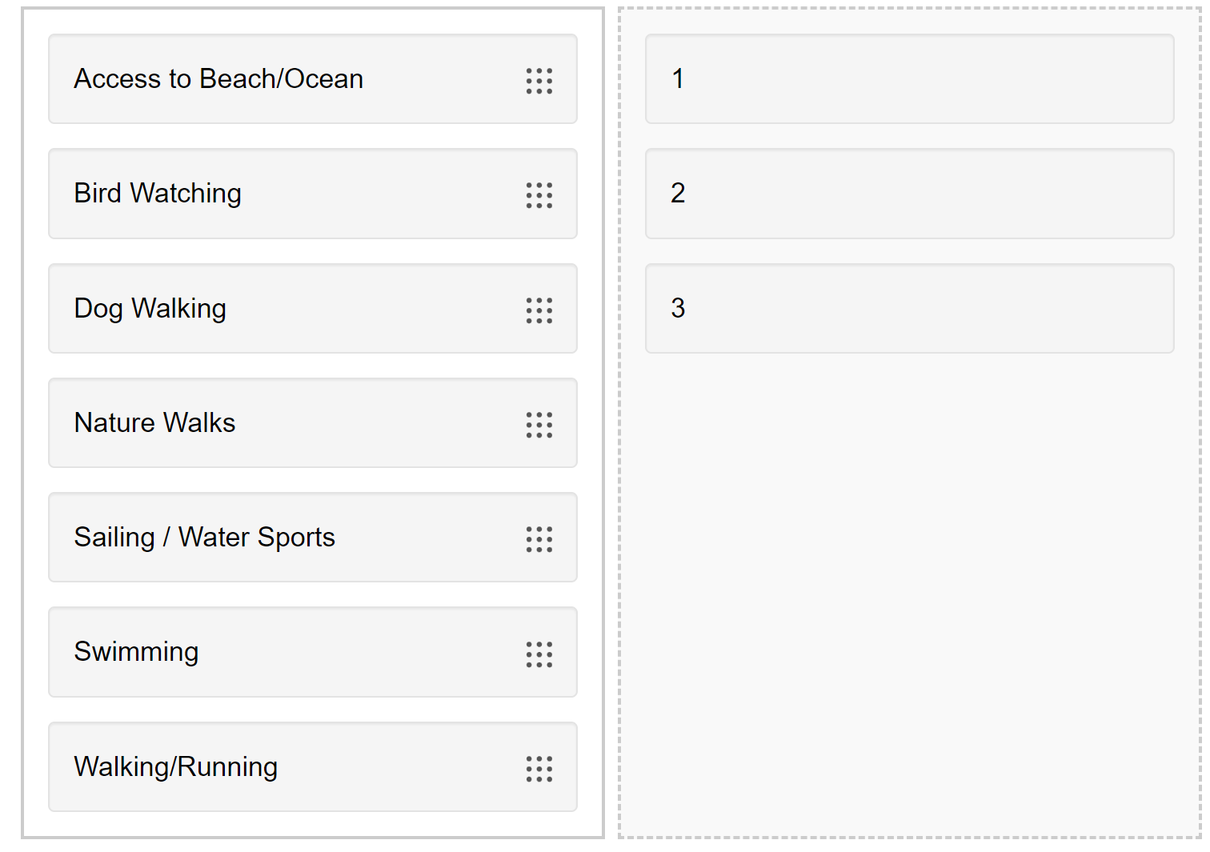
Have we missed any ways you USE Ramblers Road foreshore?

Rank the top 3 elements you see as VALUES for the Ramblers Road foreshore.
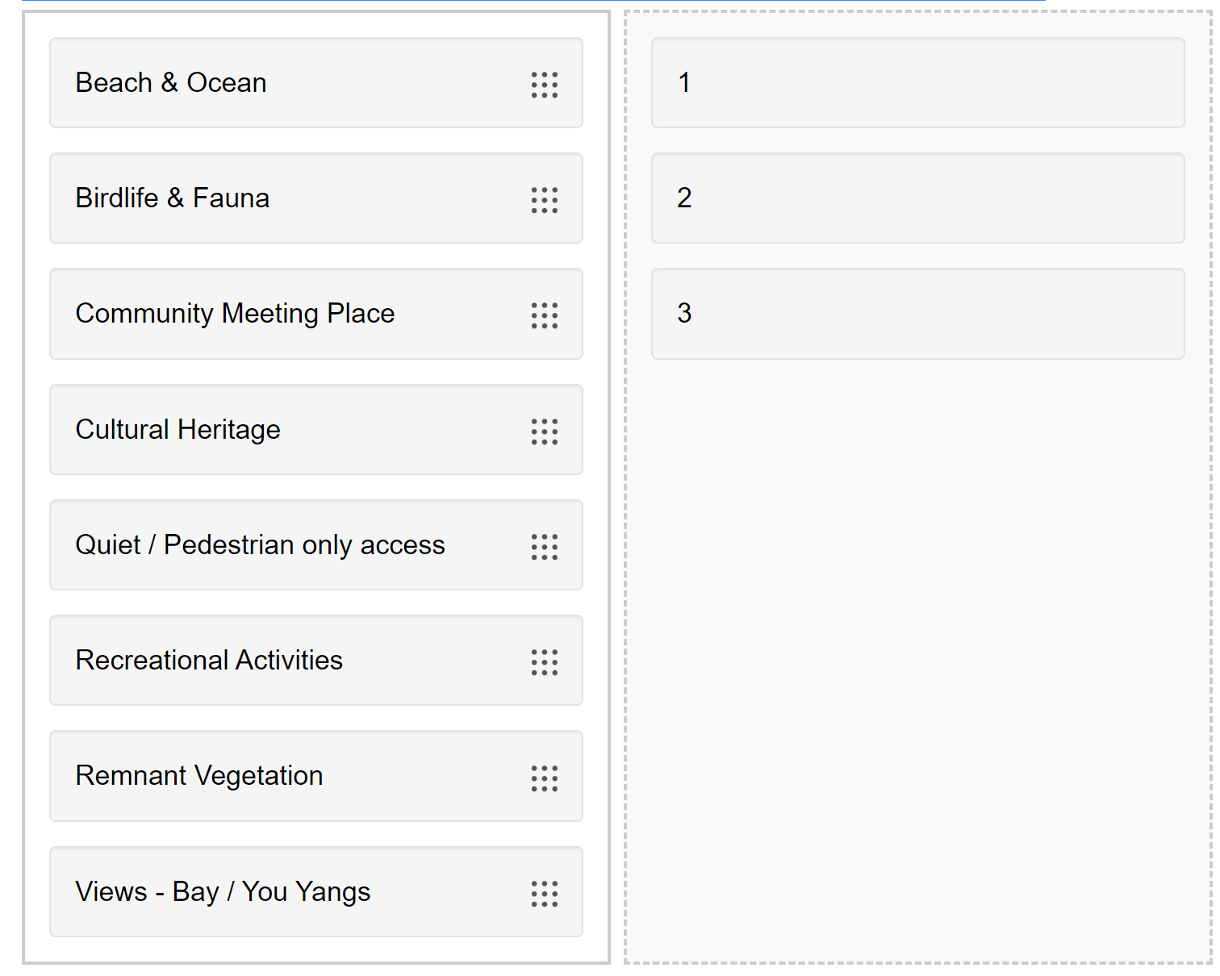
Have we missed any elements you see as VALUES for the Ramblers Road foreshore?

Rank the top 3 elements you see as THREATS for the Ramblers Road foreshore.
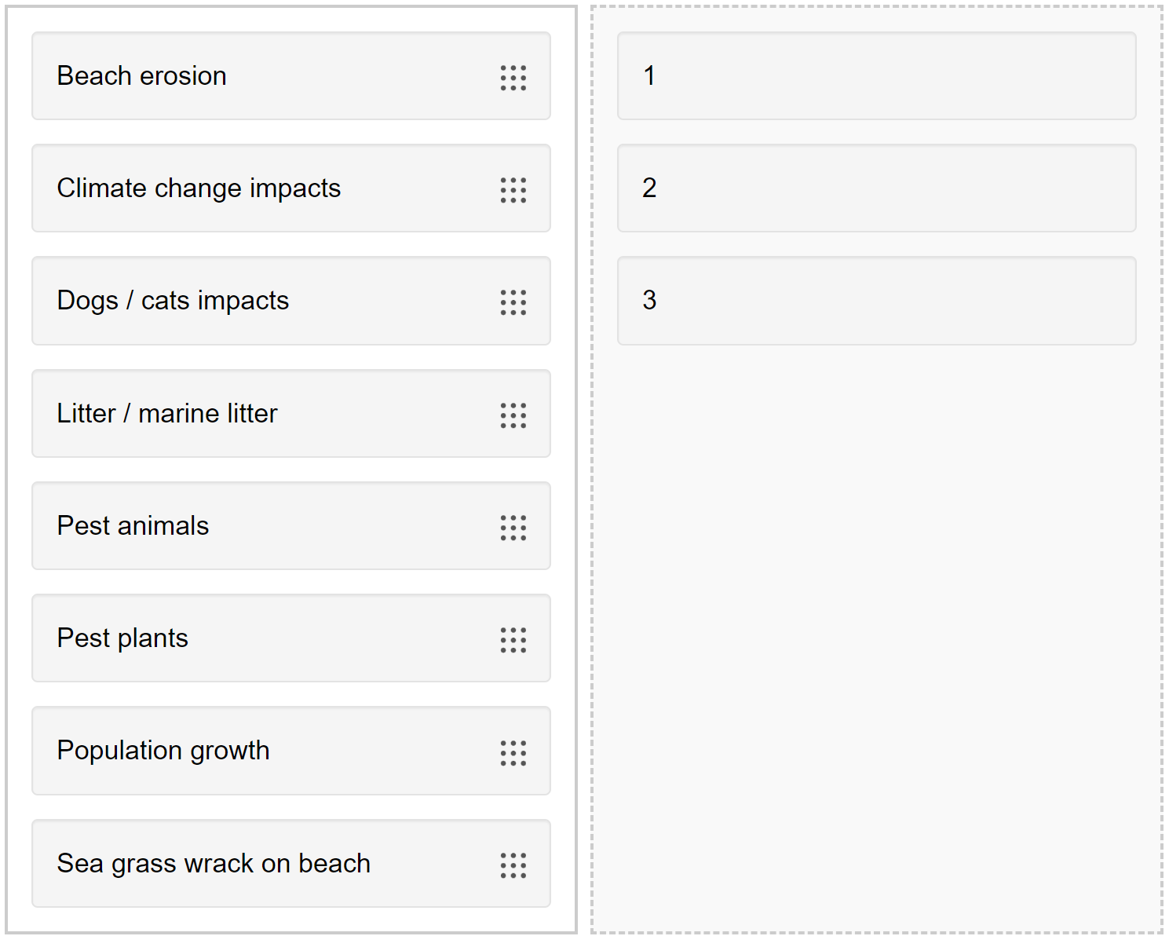
Have we missed any elements you see as THREATS for the Ramblers Road foreshore?

Future - Ramblers Road Foreshore
Do you have any suggestions of how this area could be better protected into the future? List your suggestions below

You have 255 characters left
Do you have any suggestions of how this area could be utilised into the future? List your suggestions below
You have 255 characters left
Please add additional comments with regards to the Ramblers Road foreshore area.
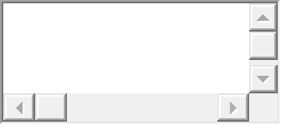
You have 1,000 characters left

