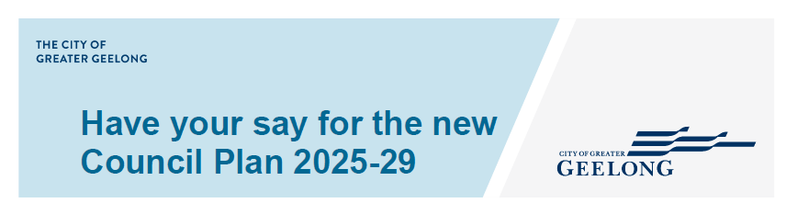

Tell Us What You Think – Draft Council Plan Survey

Introduction

Privacy Statement
The personal information requested on this page is being collected by City of Greater Geelong for the purpose of the developing the Council Plan 2025-29 or any other directly related purpose. If the personal information is not collected, we may not be able to contact you for further questions or solutions. Your personal information will only be disclosed to carry out a deeper analysis of the data* or as required to do so by law. Our privacy policy is available on our website. If you wish to alter any of the personal information you have supplied to City of Greater Geelong, please contact us by sending an email to privacy@geelongcity.vic.gov.au.
*In order to gain a deeper understanding of the data provided to the City and improve our services to you, we may disclose the information you provide to us to AWS Comprehend and Converlens Pty Ltd which carry out analysis of the data. Your personal information may be disclosed to AWS Comprehend and Converlens Pty Ltd based in Sydney only in relation to the primary purpose of collection. View the following link for AWS Comprehend’s Data Privacy statement and Converlens Pty Ltd Data Privacy statement.
Check this box to indicate that you have read, and agree to the privacy statement
Yes | ☐

Which of the following best describes your connection to the area?
I am a local resident | ☐
I am employed in the area | ☐
I own a business in the area | ☐
I am a visitor to the area | ☐
I am studying or training in the area | ☐

Community Vision

Background
In 2017, 16,000 members of our community helped to develop a Community Vision that outlined their aspirations for a thriving Greater Geelong (see figure below).

Legislative Requirements
As part of the Victorian Local Government Act 2020, a Council must:
- Maintain a Community Vision that is developed with its municipal community in accordance with its deliberative engagement practices.
- The scope of the Community Vision is a period of at least the next 10 financial years.
- A Community Vision must describe the municipal community's aspirations for the future of the municipality.
- A Council must develop or review the Community Vision in accordance with its deliberative engagement practices and adopt the Community Vision by 31 October in the year following a general election.
- The Community Vision adopted under subsection (4) has effect from 1 July in the year following a general election.
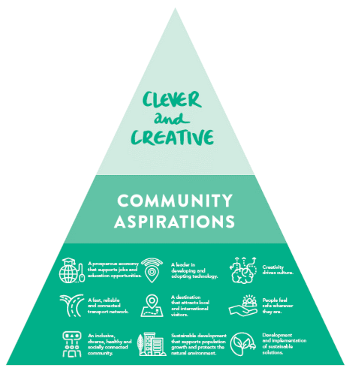
Community Vision: By 2047, Greater Geelong will be internationally recognised as a clever and creative city-region that is forward looking, enterprising and adaptive, and cares for its people and environment.
Please provide your feedback on the community vision below:

Strategic Direction & Objectives

Overview
Have you read the draft Council Plan 2025-29?
Yes | ☐
No | ☐

To what extent do you support the draft Council Plan 2025-29 as it is currently presented?
Strongly support | ☐
Somewhat support | ☐
No strong opinion | ☐
Somewhat oppose | ☐
Strongly oppose | ☐

Strategic Direction
Strategic Direction: We are committed to advancing community outcomes for a thriving Greater Geelong
Do you support the strategic direction?
Yes | ☐
No | ☐
Unsure | ☐

Please provide your feedback on the strategic direction below:

Strategic Objective 1: Core and Critical Infrastructure
Strategic Objective 1
Plan, deliver, manage and optimise core and critical infrastructure across the region
Outcomes
- Responsible and sustainable growth and development.
- Multi-modal transport networks are well-connected and accessible.
- Community facilities and public spaces are accessible and fit for purpose.
Do you support the Strategic Objective 1?
Yes | ☐
No | ☐
Unsure | ☐

Please provide your feedback on the objective below:

Strategic Objective 2: Healthy and Caring Communities
Strategic Objective 2
Identify, promote, advocate for, and deliver equitable health and wellbeing outcomes for our diverse communities
Outcomes
- A community that is fair, compassionate and inclusive.
- A community with the resources and capacity to control their health and wellbeing.
- Services and facilities that enhance health and wellbeing are accessible to all.
Do you support the Strategic Objective 2?
Yes | ☐
No | ☐
Unsure | ☐
Please provide your feedback on the objective below:

Strategic Objective 3: Economic Development
Strategic Objective 3
Lead efforts to strengthen our diverse economic precincts and workforce to enhance prosperity across our community
Outcomes
- New businesses, events and investment are attracted to the region.
- Local businesses, industry clusters and precincts are supported to thrive.
- Greater Geelong attracts, retains and develops workforce capacity and capability.
- Sufficient land supply to enable sustainable growth, business expansion and attraction.
Do you support the Strategic Objective 3?
Yes | ☐
No | ☐
Unsure | ☐
Please provide your feedback on the objective below:

Strategic Objective 4: Heritage and Culture
Strategic Objective 4
Champion our unique heritage and culture
Outcomes
- Increased engagement in arts, culture and heritage experiences across Greater Geelong.
- Greater Geelong’s diverse culture is shared and celebrated.
- Increased investment in our creative, cultural and sporting activity hubs.
Do you support the Strategic Objective 5?
Yes | ☐
No | ☐
Unsure | ☐
Please provide your feedback on the objective 4 statement and outcomes

Objective 5: Environment & Circular Economy
Strategic Objective 5
Protect and enhance our unique natural environment and surrounds
Outcomes
- Natural habitat and areas of important biodiversity are identified, protected, connected and restored.
- Significant reductions in emissions.
- Increased community resilience to climate change impacts.
Do you support the Strategic Objective 5?
Yes | ☐
No | ☐
Unsure | ☐
Please provide your feedback on the objective 5 statement and outcomes

Strategic Objective 6: Governance & Integrity
Strategic Objective 6
Commit to the highest levels of leadership, integrity, financial stewardship, and meaningful community engagement
Outcomes
- Public funds and assets are used equitably and efficiently.
- Decision making is evidence-based, transparent and strategically aligned.
- Community engagement, strong partnerships and effective advocacy delivers value and impact.
Do you support the Strategic Objective 6?
Yes | ☐
No | ☐
Unsure | ☐
Please provide your feedback on the objective 6 statement and outcomes

Other Feedback
Do you have any other feedback on the draft Council Plan?

About You
Before you go, can you tell us a little bit about you? In this section we are asking for information about you to help us understand who we are hearing from in the community. Any information you provide will be de-identified (i.e. anonymous) from your survey responses and managed in line with the City of Greater Geelong Privacy Policy
Suburb: _________________________________
Age Group:
Under 18 | ☐
18-24 | ☐
25-34 | ☐
35-49 | ☐
50-59 | ☐
60-69 | ☐
70-84 | ☐
85+ | ☐

What is your gender?
Man | ☐
Woman | ☐
Non-binary | ☐
Prefer not to say | ☐
Self-described (please specify) | ☐

Do you identify as any of the following? (Please select all that apply):
Aboriginal origin | ☐
Torres Strait islander origin | ☐
Both Aboriginal and Torres Strait Islander | ☐
Migrant | ☐
Refugee | ☐
Asylum Seeker | ☐
LGBTIQA+ | ☐
Carer | ☐
Parent/Guardian | ☐
Person with a disability | ☐
English Is not my first language | ☐
None of the above | ☐

First Name: _________________________________
Last Name: _________________________________
Contact Email: _________________________________

Thank you
Thank you for completing this survey. Please return this to a City of Greater Geelong Customer Service Centre by the 15 September or post to:
Strategy & Performance
City of Greater Geelong
Wadawurrung Country
P.O. Box 104
Geelong VIC 3220
Alternatively, you can scan and email to:
strategyandperformance@geelongcity.vic.gov.au

