

THE CITY OF GREATER GEELONG
PUBLIC ART STRATEGY
COMMUNITY ENGAGEMENT REPORT AUGUST 2025

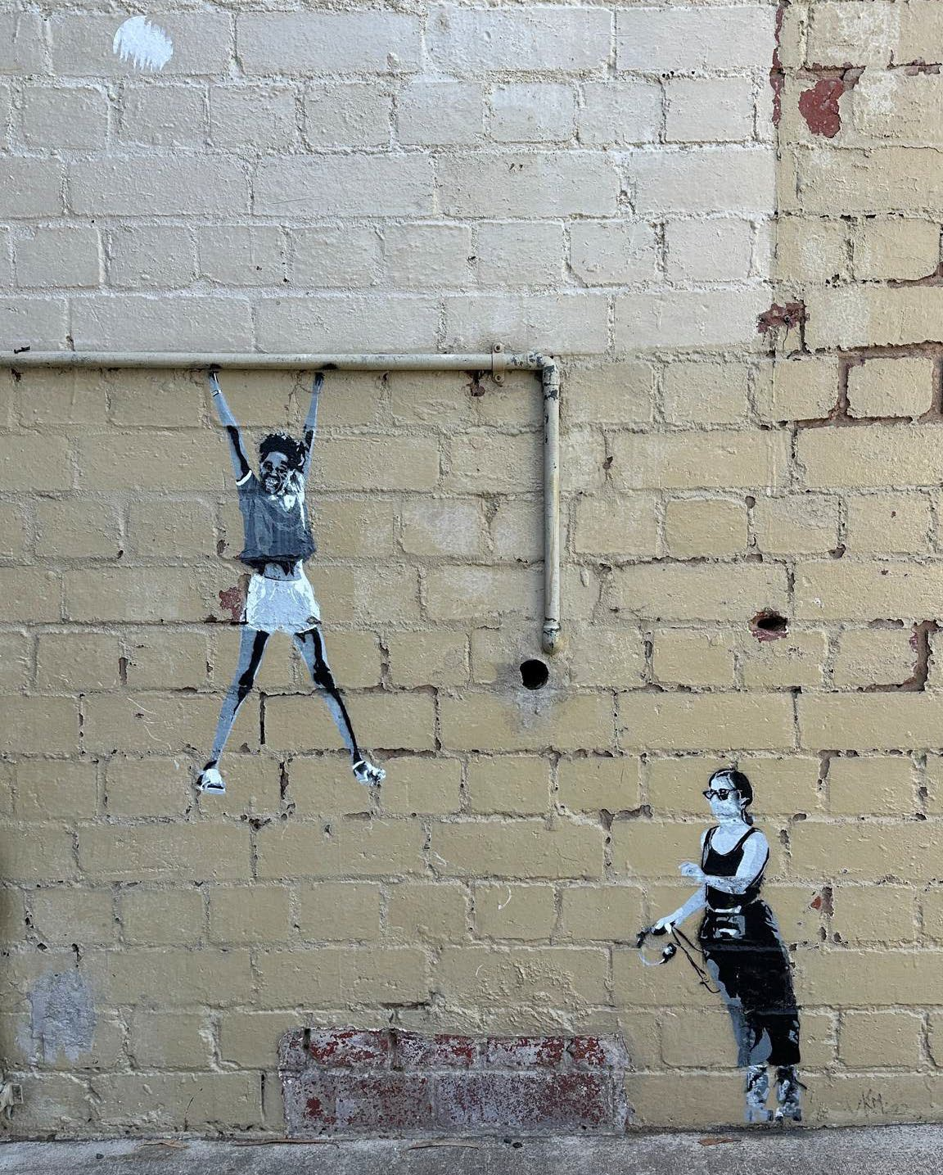
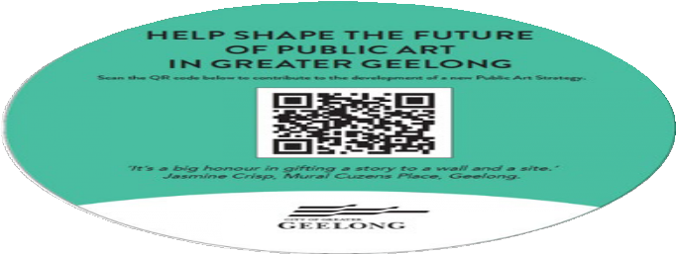
VKM - 1 Wright Pl, Geelong

EXECUTIVE SUMMARY

BACKGROUND
The City’s Public Art Strategy (2012-2022) is being renewed. The development of a new strategy is an opportunity to align and reset strategic priorities and approaches with recent local, state and national plans. Importantly, it also gives an examination of where gaps to program and service delivery exist in line with more contemporary approaches to public art.
This Public Art Strategy 2025 Engagement Report provides an overview of the findings from the online and face-to face community/stakeholder engagement activities conducted between March and August 2025 to inform development of the new Public Art Strategy.
Consultation is a critical component of developing the new Public Art Strategy. It ensures the strategy is inclusive, relevant, and sustainable, identifies opportunities and challenges, reflects the values and needs of our community (and stakeholders) and helps create a shared cultural legacy for the City. The overarching goal of the consultation/engagement was to build a shared vision for public art - enhancing its relevance and ensuring strong community impact for the strategy and program.

KEY OBJECTIVES

The key objectives for the consultation and engagement were to:
- gain an understanding of community values and priorities for art in the public realm.
- gather diverse perspectives - voices from different demographic, cultural, and stakeholder groups including artists/creatives.
- identify opportunities and challenges.
- Inform strategic decision-making - guiding goals, policies and implementation plans.
- build public awareness and support for the public art program - develop frameworks and relationships for ongoing public art initiatives.
- investigate operational directions - new ways of working, governance and procedures.

ENGAGEMENT OVERVIEW
Initial consultation began with the City of Greater Geelong staff (internal workshops + interviews) which comprised 71 participants across the organisation. Furthermore, to ensure a wide range of community interaction and stakeholder engagement, the consultation process provided multiple ways to get involved including:
- Have Your Say Webpage - including the opportunity to share a story about a piece of public art that the community values or share a story about a place that the community would like to see celebrated through public art. Additionally, a map of the City was provided to allow our community to drop a marker on the map to share their experiences with public art in the City.
- 6 workshops – staff, community, artists / creatives, peer review panel, and the Youth Council.
- an online survey and targeted youth survey.
- face-to-face drop-in sessions at our libraries, community events (Cultura) and community programs (Norlane Community Centre).
- youth program drop-ins (the NEST, fORT) and targeted survey.
- Interviews with developers, and First Nations community.
Participation opportunities were promoted through arts/cultural networks, social media, media releases, local newspapers, A1 posters, postcards, and street decals (signage) across the City, featuring a QR code for the Have Your Say Page and survey. In total, the process gathered more than 590 individual engagements including, interviews, 167 survey responses, 164 participants across 6 workshops, 254 community drop-in participants, Youth Council participation, and ongoing First Nations discussion.

KEY FINDINGS
Overall, the public art strategy consultation received widespread feedback from community members, and stakeholders, reflecting strong local support and engagement. This is consistent with recent community feedback for the Council Plan 2025-29, which highlighted Arts and Culture as one key priority area - noting the community’s desire for more support for arts and cultural activities, especially for youth. Community and stakeholder feedback highlighted several reflections, issues and opportunities and embraced a broad vision for public art into the future. Commentary included:
- The community and stakeholders placed a strong value on public art noting that public art adds a ‘defining image to our city identity’, ‘enhances our cultural destination offer’, ‘builds connection and expresses our people and place’, and highlighted how public art enriches public life in meaningful ways.
- Participants acknowledged the ever-changing definitions of contemporary public art and practice - that contemporary public art is constantly evolving, shaped by cultural, social, political, and technological changes. It has become more temporary, participatory, engaging and often challenges boundaries of art, space (public realm) and audience.
- When asked about public art in Geelong now – observations noted that whilst the current program is varied, participants considered public art to be lacking broad visibility and being somewhat ‘timid’ – ‘minimal and sparse’, ‘conservative’ etc. When asked about a future vision for public art across the city, responses were extremely positive – ‘be ambitious’, ‘inspiring’, ‘challenging’, ‘authentic’ etc.
- The key phrase that resonated with most participants was ‘to make art public’. They wanted to ensure that public art remains democratic – a visual voice that can speak truth, raise awareness, celebrate identity, and inspire change. Contributors expressed the desire to see public art ‘say something’ and how public art can spark conversation amongst the community and be a powerful voice for communication and expression in a variety of contexts. Participants saw this a way to connect community through public art being socially driven and inclusive – and as platform to express the community’s stories and histories.

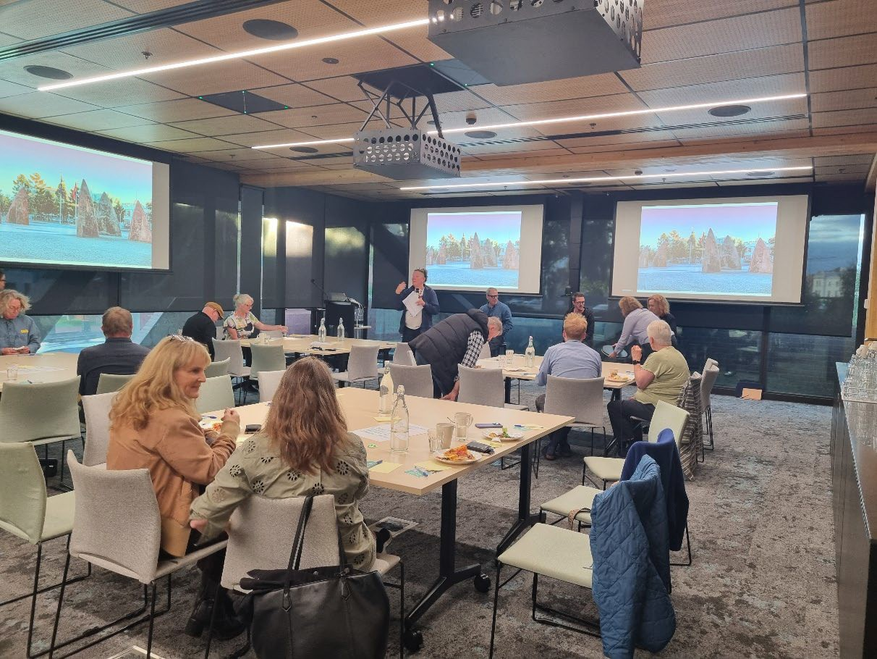
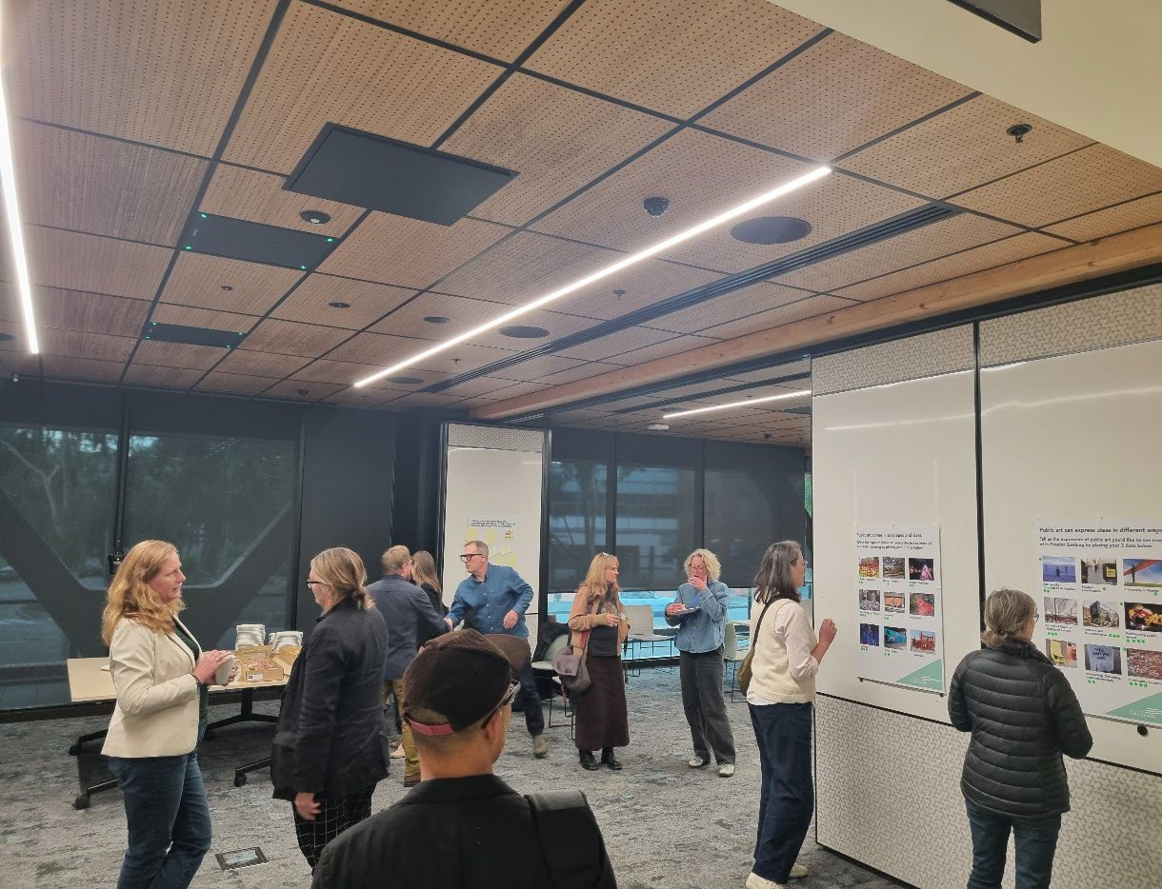

Artists/Creatives Public Art Talk/Workshop

  - Our community and stakeholders also conveyed their aspirations for ‘public art to help to enhance/ develop/investigate the identity of place across Geelong’. This is particularly applicable given the City’s current and rapid urban transformation, driven by strategic planning, significant infrastructure projects, and a surge in population growth.
This would involve a more interdisciplinary approach to public art, urban design and activation creating places for interaction. Participants also acknowledged that being ‘inventive’ with public art and the public realm’ would ‘support the municipality’s designation of UNESCO City of Design’ using public art as a visible embodiment of design thinking, cultural identity and civic innovation.
  - Respondents expressed comments on revitalising Central Geelong and how temporary public art and ‘art inventions/activations’ could help transform neglected areas into vibrant places of meaning, shifting how people use and relate to those spaces. Likewise, how more engagement with the development sector on public art can have a stronger role in shaping our emerging (greenfield) communities and setting the cultural tone of a place – ‘being a foundational storyteller’—drawing from the area’s natural features, history, or intended community values. A process whereby developers collaborate with local artists and communities from the start.
  - Our community shared their interests for public art to be strongly place driven and be investigative and responsive to environmentally sustainable practice/issues, ecology and adopting First Nations ‘Care for Country’ principles (cultural, spiritual, and physical connection). This could be expressed through community-generated projects contributing to sustainable design, whereby public art can be integrated into landscape architecture, green infrastructure, and environmental design—like water-sensitive art features, wind-powered sculptures, or shade structures that double as aesthetic interventions.
  - Stronger value also was expressed by participants on public art sustaining local events, festivals and traditions supporting the City’s wealth of shared history/heritage. An opportunity exists in creating shared, vibrant, and often temporary experiences in public space for cultural celebration. This could include site-specific installations, light projections, performances and collaborative art projects with community participation and be ‘seasonal’ calendar.
  - Respondents to our youth survey, want to be a part of the process to produce public art to help them feel as though they belong and to make spaces inviting especially for younger people – ‘young people involved in the art making process would be awesome!’. They also want to be able to interact with the public art, be able to create with it or play with the space.
  - The arts and cultural sector highlighted their needs and interests for more accessible opportunities to gain experience with public art projects including – ‘mentorships, artist projects and residencies. The sector, particularly artists and creatives expressed the need for the City to have clearer policy and practices in developing and managing the public art program in line with current industry best practice.

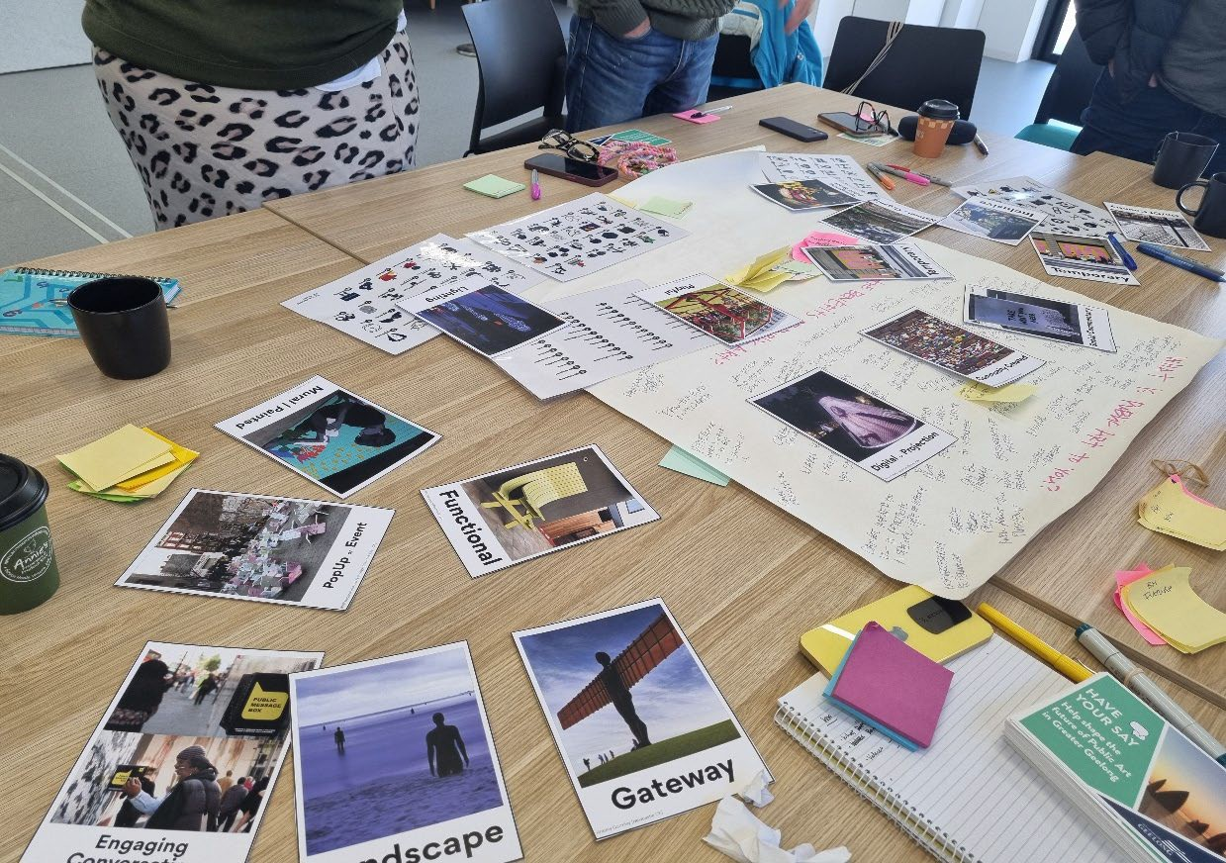
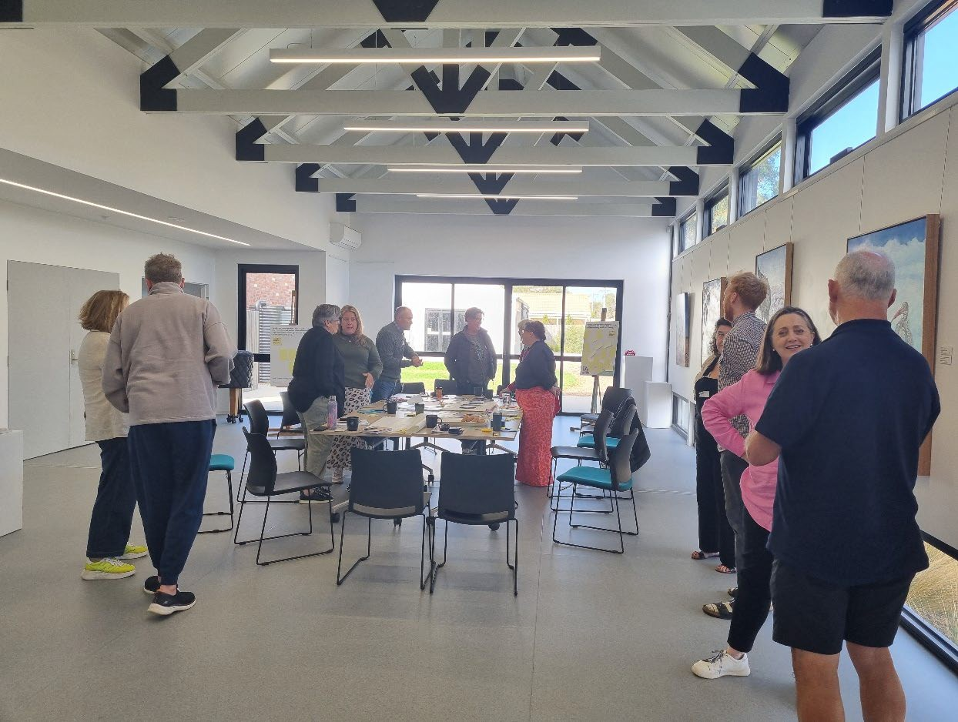

Barwon Heads Public Art Strategy Workshop

HOW WE ENGAGED WHAT DID WE DO?
The primary purpose for the consultations was to engage the community in shaping a Public Art Strategy that reflects local identity, values, and priorities.


The methods undertaken align with the objectives of the engagement to collect information on the typology of public art - gathering input on locations, themes, and forms; understanding community aspirations and opportunities; ensuring the strategy reflects social and cultural diversity and inclusivity; and gauging the sense of ownership and local pride in the public art program.
public, artists, developers + Youth Council
70 DAYS
of online engagement and drop-ins
174
6 WORKSHOPS
167
Copies of surveys received.
1,500+
Views to the project page.
Contributions
(comments) from
the public left online.
164 participants consisting of
Stakeholder mapping was used to identify influence, interest, and the type and level of engagement for each group.

DATA METHODOLOGY
A strong data methodology for the survey and broader community consultation was adopted to ensure findings were largely credible, inclusive, and actionable. This included identifying and targeting primary stakeholders: e.g., residents, artists/creatives and underrepresented groups including youth and First Nations.
Data methods included both quantitative, close-ended questions, such as multiple choice and rankings, . and qualitative,open-ended questions, including: comments, opinions and stories, . along with detailed, strategic input from key cultural leaders through selected interviews.

ENGAGEMENT TOOLS AND TECHINQUES
Anengagement project page was developed to provide information and methods of ways to engage.. A range of engagement tools and techniques were used to provide different types of opportunities for stakeholders and community to have their say.
Primary methods included collection of ideas, issues and opportunities through drop in engagements with the public and interviews with stakeholders, andposters, surveys and facilitation during workshops – using visual aids - flip cards, maps, dot democracy boards and post-its.

HOW WE ENGAGED

HAVE YOUR SAY ONLINE PORTAL YOURSAY.GEELONGAUSTRALIA.COM.AU
An online Have Your Say project page was designed to share relevant information to encourage community feedback and participation. This included an introductory video about public art across Geelong and a gallery of different kinds of public art.
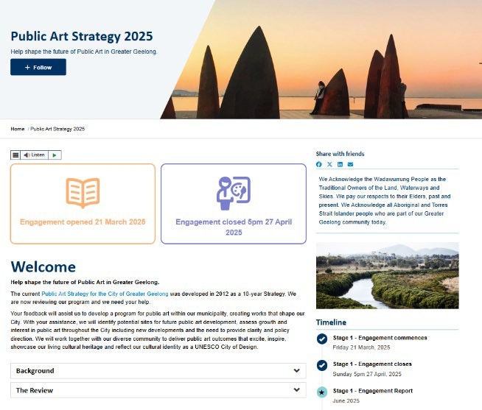
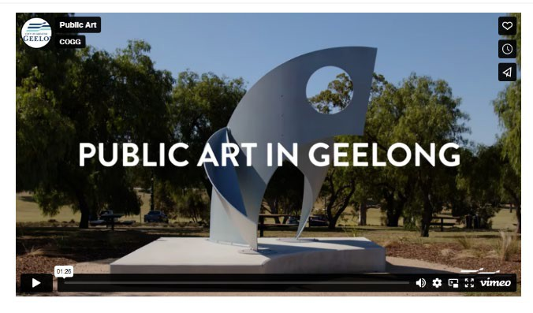
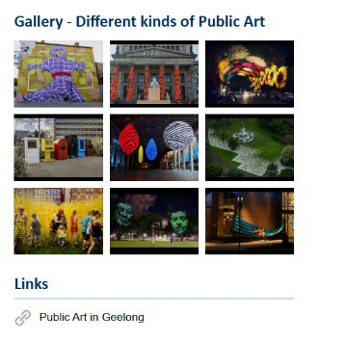

SHARE YOUR PUBLIC ART STORY

ONLINE INTERACTIVE MAP

SURVEY (ONLINE)

WORKSHOPS X 6

DROP-IN FACE TO FACE SESSIONS ACROSS REGION (LIBRARIES)

POSTERS, POSTCARDS AND DECALS
Opportunity was provided on the Have Your Say page to share a story about a piece of public art that the community values or share a story about a place that the community would like to see celebrated through public art.
Opportunity was provided on the Have Your Say page for the community to interact with an online mapping tool by dropping a pin on the map to provide an idea or comment about where they would like to see public art across the LGA.
An online survey was generated for the project and was available from 21 March - 27 April 2025. The survey generated 167 responses.
The 6 workshops were delivered primarily face-to-face and/or online. The workshops allowed the public/stakeholders to provide their feedback, ideas/opportunities and apply their expertise. This included a targeted Artists/Creatives Forum representing industry colleagues and highly accomplished contemporary public artists. The workshops facilitated by our project consultants (2 hours each) and City staff delivered at several locations and times to suit contributors. There were 164 participants in total
Public drop-in face-to-face sessions across the region (libraries, youth and community programs) were undertaken that resulted in 254 participants in total.
To help inform local residents and the arts/cultural sector, postcards were made available at Council offices, libraries, and cafes across Geelong. A1-sized posters were used as a part of the consultation process, supported by decals posted throughout the city.
ONE-ON-ONE INTERVIEWS

WRITTEN SUBMISSIONS

YOUTH

FIRST NATIONS
Open at any time during the public engagement period. Submissions could be provided by email or mail.
A number of one-to-one interviews were undertaken with key stakeholders to gauge issues and opportunities.
Youth engagement sessions were undertaken and supported by a youth specific survey.
Initial conversations have begun with WTOAC (Wadawurrung Traditional Owners Aboriginal Corp.) and Wathaurong Co-op. Discussions remain ongoing on how knowledge systems, cultural protocols, and ongoing Connection to Country can be meaningfully incorporated.

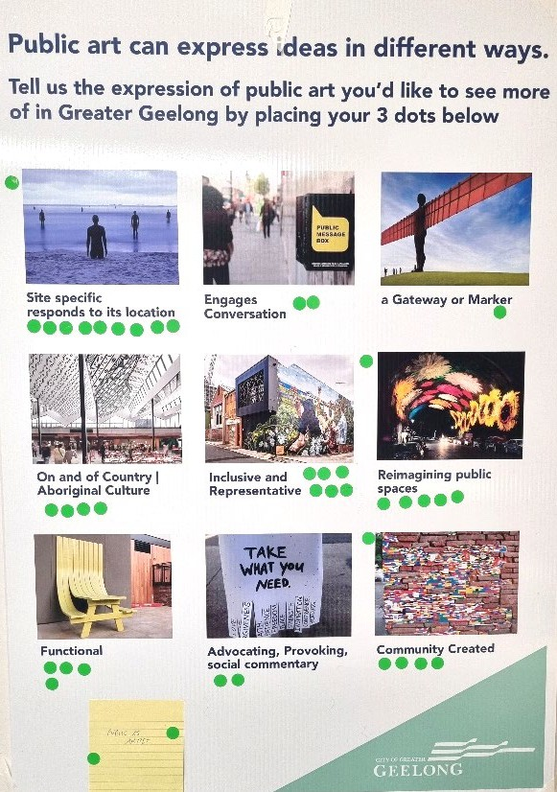
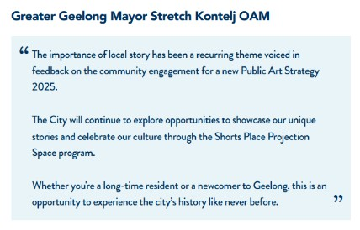
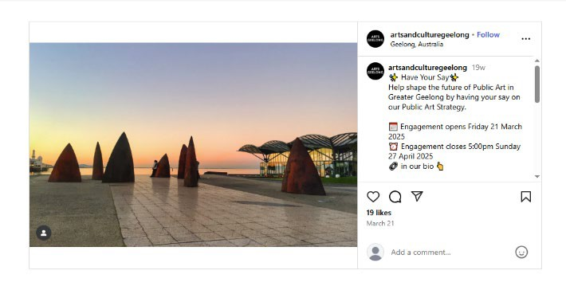

‘Creative use of public space that facilitates coming together, connecting as a community and beautifying spaces in line with the needs of the community. Art is a powerful connector that can be creatively used to address infrastructure gaps.’

COMMUNICATIONS

The engagement for the Public Art Strategy was widely promoted. It included a number of methods to promote engagement activities, forums, workshops, surveys and
drop-ins.
The primary method was contact derived through direct email (mailouts) through existing arts/cultural databases and networks followed by more public facing and accessible advertising. An email campaign attached to HYS page included 3,176 recipients.
Social Media platforms used included - e.g. Facebook, Instagram for tiles, polls, comments, hashtag campaigns to direct people to the Have Your Say page. Other printed media methods used including newspapers incorporating a City News Article, postcards for distribution and decals posted throughout the city.


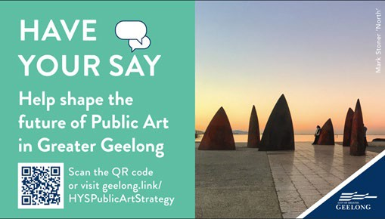
Information regarding key visitation and utilisation
Dates: 21-03-2025 - 02-06-2025
1,549
1,141
174
Views to pages on the HYS site.
Visits - user sessions on HYS site.

Contributions - number of responses or feedback collected through the participation tools.

SOCIAL MEDIA
2,450 reach
3,090 reach
230 likes

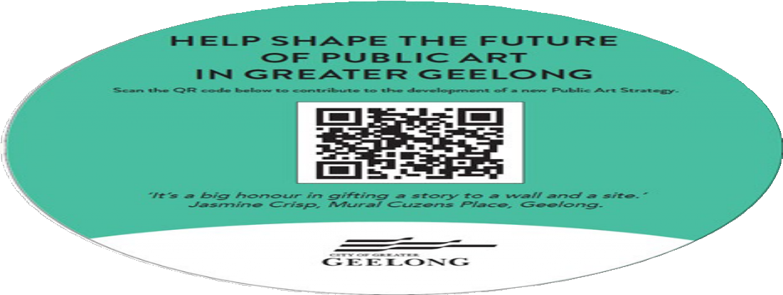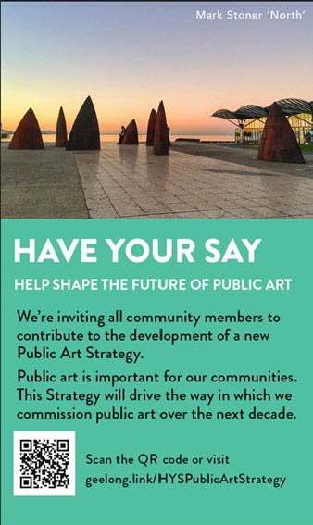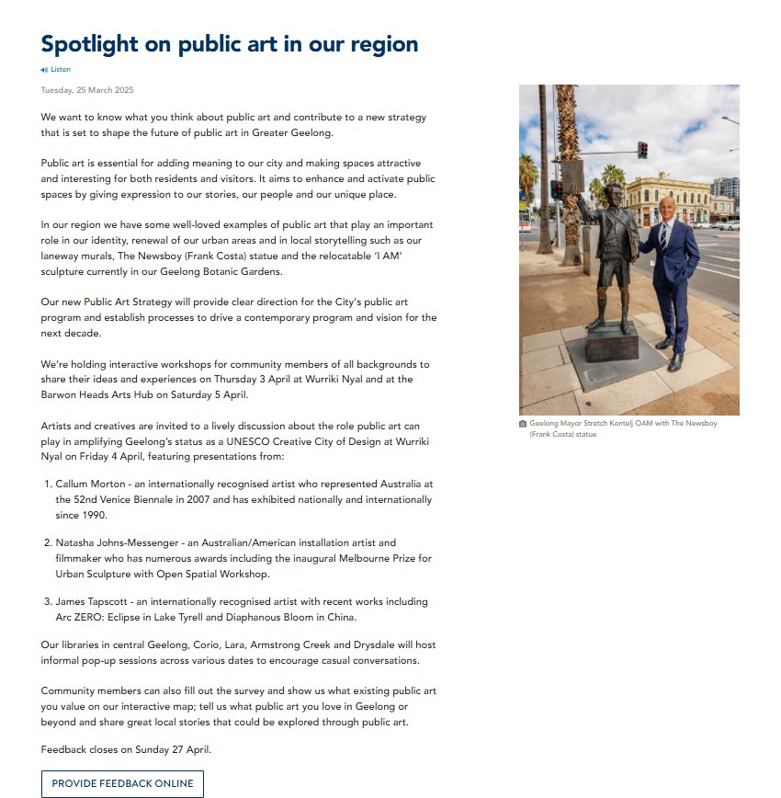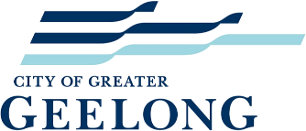

WHO WE ENGAGED WITH

PARTICIPATION
Overall, from 21 March to 2 June 2025, more than 590 people directly engaged with the City about the Public Art Strategy. Of these, approximately 174 (30%) engaged online, 416 (70%) engaged in person through workshops, and our face-to-face events.
Information regarding key visitation and utilisation on the Have Your Say page from March to June resulted in the following:
- 1,549 Views to pages on the Have Your Say site.
- 1,141 Visits - user sessions on the Have Your Say site.
- 174 Number of responses or feedback collected through the participation tools.
The community was invited to share some demographic data with us, primarily through our Have Your Say page and community and youth surveys.

The community survey attracted feedback from the demographics that appear in the charts below.

The age range of participants for the general survey ranged from 29 to 64 years old.

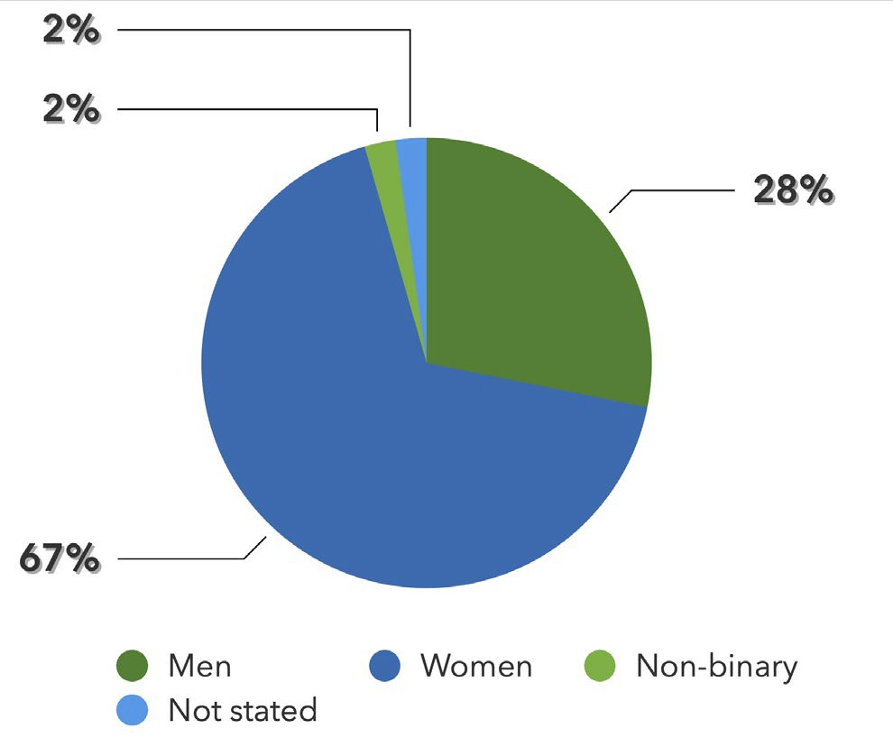

Do you identify as:

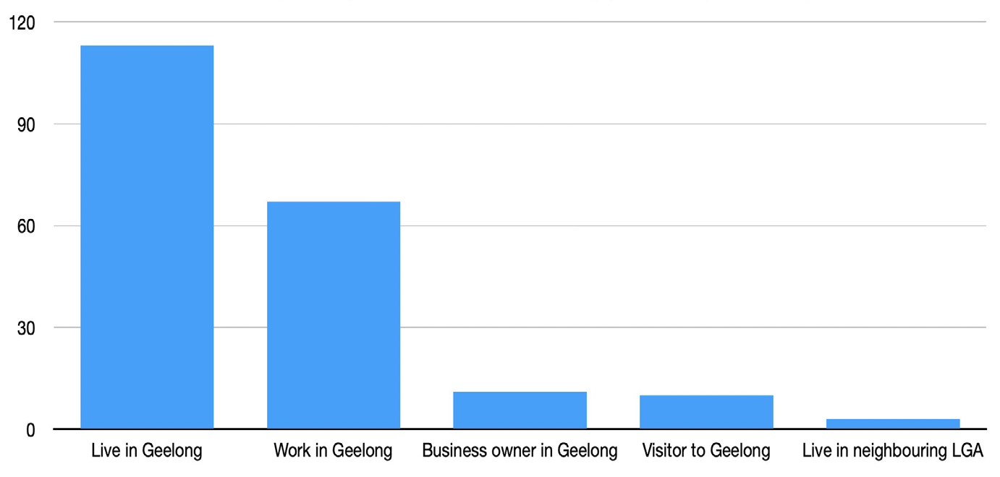
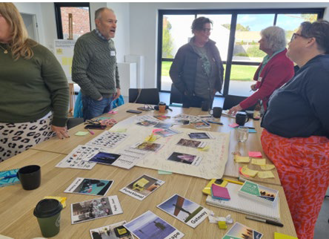

Connection to Greater Geelong






How old are you? [Choose 1 answer only]
60.00%
50.00%
40.00%
30.00%
20.00%
Responses
10.00%
0.00%
Under 12 12-15 years 16-20 years21-24 years 25 years years old old old old old and
over
Do you identify as:
Gender Fluid, Prefer not to
4.55%
say, 4.55%
Non Binary, 9.09%
Female, 31.82%
Male, 54.55%

Young people demographics with participation in the Youth Survey included:

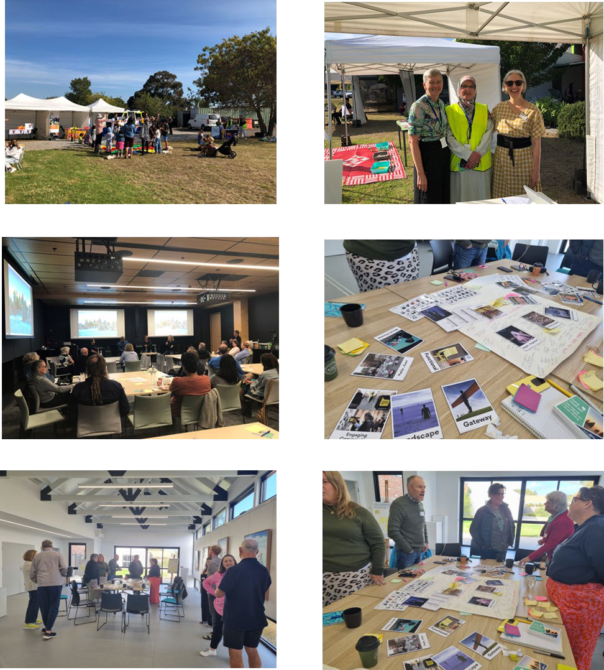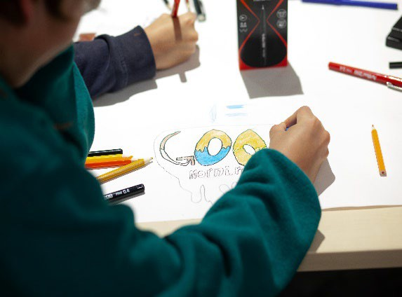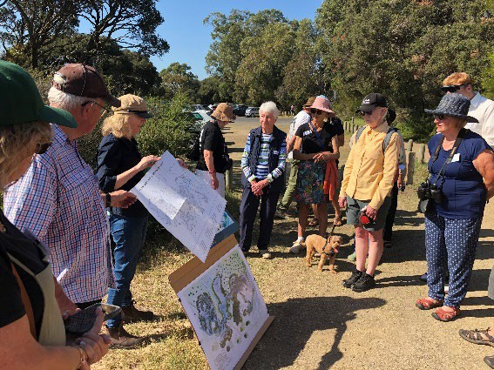

WHAT WE HEARD THE FEEDBACK
Overall, the public art strategy consultation received widespread feedback from community
members and stakeholders, reflecting strong local support and engagement.
This is consistent with recent community feedback for the Council Plan 2025-29 which highlighted Arts and Culture as one key priority area - noting the community’s desire for more support for arts and cultural activities, especially for youth.
Participants value public art for enriching public spaces, fostering a stronger sense of identity, and celebrating local culture and creativity. Community surveys, public consultations and engagement events have consistently highlighted broad enthusiasm for ‘more accessible and inclusive art in public places’. The positivity of the feedback demonstrates a deep public appreciation for public art’s capacity to inspire, connect, and transform shared spaces across the City.

OVERALL KEY FINDINGS

Consultation key findings are summarised across the following areas of interest/concern:

DEFINITION
Extensive discussion in consultations centred on whether there was a need to define/redefine contemporary public art. It was noted that defining contemporary public art can be challenging due to its evolving nature, diverse forms, and broad social functions and contemporary public art resists simple definition because it is inherently diverse, interdisciplinary, and context driven. It was considered that rather than seeking a rigid definition, it might be more productive to view contemporary public art as a flexible and evolving practice—one that reflects the complexities of contemporary life and invites ongoing dialogue.

VISION
Discussion on vision set a strong tone for how public art will contribute to the identity, growth, and inclusivity of Geelong into the future. Respondents want public art to ‘make them feel proud their City and environment’. Feedback emphasised the need for public art to contribute to urban design, public infrastructure, and civic identity. Key responses included: ‘Public art will shape our city to be creative and inclusive’, ‘be ambitious’, ‘inspiring’, ‘challenging’, ‘authentic’ etc. – ‘to make art public’.

PURPOSE
Considerable feedback related to finding some priorities for the ‘purpose’ of public art in the City. It was acknowledged that public art has intertwined purposes that plays a vital role in the cultural, social, and economic development for Geelong. Far beyond aesthetics, it contributes meaningfully to how people experience and interact with urban environments, making cities more vibrant, inclusive, and future-ready.
Purpose was underlined by some of the following feedback: Art-led revitalisation - ‘redefine public art conversations with the community and visitors – acknowledge the City is growing and changing and that new voices are needed to communicate this dynamism’ to continuing to support community with social connection and inclusion – ‘embed public art as a vital and visible part of everyday life’.

SELECTED FEEDBACK
A cross-section of comments from the consultations and surveys are listed below:

‘Need more First Nations language and signage’
‘Different things in different areas - respect context and place’.

‘Bring back the life and spark into city centre’ ‘Digital projection’

‘Better promotion and communication’

‘Large, iconic sculptures that can become local landmarks’.

‘Themes respond to things that have been relevant to Geelong’s past like manufacturing, agriculture, sport etc.’

‘Interventions that occur at small scales would be nice. I.e. we have murals on large walls which are a great start, and they are legible at large distances. Smaller scale interventions may provide moments when they are 'found'.’

‘ I’d just like to see more spaces be brought to life by art to make Geelong more inviting and fun to be in’

‘I'd like to see more public art that represents women.’

‘I would like to see ambitious and internationally celebrated public art in Geelong.

‘More sculptures, interactive play spaces and murals. More vibrant designs that create landmarks and also make the area safer and more inviting.’

‘Ephemeral installation and performance in spaces hidden from general access and view’.

‘Carefully selected and strategically placed. A combination of artworks tells a story rather than random art placed around.’

‘Art works that make you think. Artworks that connect you to stories and place.’

‘The quirky, the unusual, the bizarre, the inexplicable. Give us something that prompts discussion. Give us something beyond decoration. ‘

‘Diverse offerings that create conversation and interest with people feeling it is part of their community.’

CONTEXT
Public art with context was an underlying concern for artists and creatives. It was noted for public art to be meaningful, impactful, and embraced by the community, it must be contextually aware and site-specific – where art is thoughtfully integrated with its setting, it resonates more deeply with its audience and contributes to a stronger sense of place – ‘designed in harmony with their surroundings’ - embedding narratives into public space fosters a more inclusive, reflective, and unified community identity.

OVERARCHING THEMES

The consultation produced a number of emerging themes from discussion and the surveys including:

PUBLIC ART, URBAN DESIGN AND LANDSCAPE
Integration was highlighted as an important factor in the future success of the public art program and how it could assist/encourage community participation in the design and use of public realm - rather than being an afterthought or standalone element, public art can be woven into the fabric of city planning to shape more engaging, inclusive, and visually dynamic environments. How collaboration between artists, architects, landscape designers, and planners can lead to more innovative and holistic outcomes - designing public art as a core component of urban infrastructure –‘creating spaces for interaction’.
A range of comments included making public art ‘more inviting and fun’,’ interactive’, ‘creating landmarks’, ‘bringing spaces to life’ and ‘small scale interventions (discovery) - using spaces hidden from general view’. This also included suggestions for public art on the City’s arrival routes by car, train, plane, boat, Central Geelong areas like Malop Street and Market Square to smaller neighbourhood centres and shopping strips. i.e. Hughes, Thornburn, Norlane/Corio etc.

ENVIRONMENT AND SUSTAINABILITY
Respondents also valued Geelong’s varied natural environment and landscape and expressed the interest in how contemporary public art projects can highlight environmental themes, raise awareness, inspire change, shape public space and promote sustainable urban development. Comments included public art can be ‘a medium for environmental commentary, awareness, and action.’ This included promoting long-term ecological balance and responsible resource use, promoting walkability and alternative transportation (bike paths, walking & rail trails) with public art.

ENHANCING CITY IDENTITY
It was noted that as the city continues its transformation from an industrial/manufacturing hub to a vibrant cultural centre, public art can continue to serve as both a visual marker of change and a connector to Geelong’s rich identity. It can therefore help ‘create a more distinctive visual landscape’ - contributing to a unique and recognisable urban character.
Respondents wanted to see public art reflect ‘a more forward-thinking and creative identity - like the Geelong Arts Centre redevelopment’. This included comments whereby ‘involve community in public art projects, it deepens the sense of place and ownership.’ Other comments reflected supporting/ celebrating Geelong’s UNESCO City of Design status – using design-driven projects, to showcase the city’s commitment to creativity, innovation, and cultural leadership.

FIRST NATIONS
Respondents across all surveys and consultations wanted public art to help in elevating the Wadawurrung people to play a more central role in Geelong's heritage narrative. The theme of First Nations appears frequently in the consultations, reflecting a focus on indigenous peoples, their culture, and their contributions. Contributors also acknowledged the dynamic nature of public art and its ability to reflect and respond to changing societal perspectives through community engagement and cultural reflection. Public art can provide a platform for both truth-telling and cultural continuation. Suggestions included ‘First Nations wayfinding and language’.

SHARED HISTORY AND HERITAGE
Participants valued public art that resonates with local values and histories through reflecting the City's rich cultural heritage and evolving identity - how public art in Geelong can act as an everchanging canvas that reflects the community's collective identity – serving as both storyteller and connector. By visually expressing the stories, struggles, and achievements of people across generations, public art can foster understanding, reconciliation, and collective identity.

LOCAL EVENTS, FESTIVALS AND TRADITIONS
Supporting the above, stronger value also was expressed by participants on public art sustaining and elevating local events, festivals and traditions. An opportunity exists in creating shared, vibrant, and often temporary experiences in public space for cultural celebration. This could include site-specific installations, light projections, performances and collaborative art projects with community participation and be ‘seasonal’ calendar.
Participants expressed opportunities for shared cultural experiences that energise public spaces, foster social connection, and celebrate community identity. Festivals often include temporary public art installations, light projections, sculptures, and performances that transform familiar places into vibrant, interactive environments. Use of new technologies and innovation to tell our stories is an identified program service gap at present.

COMMUNITY ENGAGEMENT
Participants wanted to ‘engage with art in their everyday environments’, as they expressed that public art creates a sense of belonging, pride, and shared experience that strengthens the social fabric. They suggested that public at should be ‘responsive and more agile’.
They wanted to ensure that public art remains democratic – a visual voice that can speak truth, raise awareness, celebrate identity, and inspire change. Contributors expressed the desire to see public art ‘say something’ and how public art can spark conversation amongst the community and be a powerful voice for communication and expression in a variety of contexts. Participants saw this a way to connect community through public art being socially driven and inclusive.

YOUTH FOCUSSED
Our young people wanted to be a part of the process to produce public art to help them feel as though they belong and to make spaces inviting especially for younger people. Suggestions included using public art in youth-friendly urban design – creating safe, engaging, and inclusive spaces that support the needs, rights, and aspirations of young people.

Youth also indicated that participation in public art might give the pathway to creative careers into the future. Involving youth in community-based projects fosters a stronger sense of belonging, responsibility, and active citizenship, helping them see their potential to shape their environment. build artistic, project management, teamwork, and communication skills that are transferable to other areas of life and work.

BUILDING THE LOCAL CREATIVE SECTOR
Our stakeholders (artists/creatives and the cultural sector) highlighted their needs and interests for more accessible opportunities to gain experience with public art projects, including – ‘mentorships and artist projects and residencies’. As public art continues to evolve in scale, complexity, and community impact there is a need to invest in the professional development of artists. Upskilling empowers artists to navigate the specific demands of working in public spaces, enhances the quality and sustainability of public art and supports the growth of a strong local creative economy. It also ensures that public artworks authentically reflect local voices, stories, and identities—while also building long-term cultural capacity.

CLEARER POLICY AND PRACTICES
The sector, particularly artists and creatives expressed the need for the City to have clearer policy and practices in developing and managing the public art program in line with current industry best practice. Establishing clear and consistent policy and practices to allow for the effective planning, commissioning, management, and maintenance of public art – supported by guidelines/procedures for project approval and implementation/delivery, responsibilities and addressing lifecycle costs, including maintenance and conservation.
This also included better guidelines and encouragement for developers to invest in in the social and cultural life of the area with public art as a part of their developments. How it is necessary to engage artists early in the design process—not as afterthoughts and collaborate with local communities.

CONCLUSION
The public engagement process has clearly demonstrated the value that the community places on public art and its role in shaping Geelong’s identity, inclusivity, and public spaces. Participants expressed strong support for public art that reflects local stories, celebrates cultural diversity, engages youth, and connects people to place.
Across consultations, there was a shared aspiration for public art that is thoughtful, site- specific, and grounded in community context—art that speaks to the city’s rich First Nations heritage, evolving cultural landscape, and bold vision for the future. The feedback also emphasised the importance of transparency, collaboration, and artist development to ensure public art continues to grow in both relevance and impact.
This engagement process has laid a strong foundation for the development of the public art strategy that is not only community-informed, but community-driven. By embedding these insights into policy, planning, and commissioning, the City of Greater Geelong can foster a dynamic, inclusive, and connected public art program that reflects who we are—and who we are becoming.

APPENDICES
PUBLIC ART STRATEGY
COMMUNITY ENGAGEMENT REPORT

APPENDIX 1:
PUBLIC ART STRATEGY 2025 CONSULTATION RESULTS (OVERVIEW)

WORKSHOPS
A more detailed outline is provided as APPENDIX 2: Community Workshop Discussion Notes (Accumulated) 3 + 5 April 2025. A summary of key areas on discussion related to:
- Impact and visibility of the public art program now and in the future – ‘having purpose’, ‘a voice’, ‘being more inclusive, accessible and relevant’. Promoting public art more – tours, talks and events to bring public awareness.
- Ensuring that public art continues to reflect the identity and diversity of the community.
- As demographics shift and new generations emerge, public art should adapt to reflect the current realities and aspirations of the community. Public art becomes an essential tool for representing this richness and fostering a sense of shared belonging.
- Using public art in urban revitalisation of the city – ‘draw on the cultural/social/historical legacy of the city and its people to help reimagine the future’.
- The need to establish strong partnerships and collaboration for the public art program – Deakin University, property developers and other layers of government etc.

PEER REVIEW PANEL
A panel of peers was assembled from the art/design/educational/ business sectors across Geelong to provide advice on the development of the Public Art Strategy. A term of reference was endorsed for the duration of the engagement, but the panel at this time remains temporary until formal governance structures are agreed.

The panel’s comments captured the following key feedback:
- Public art in Geelong has to become more enduring and have broader relevance to people.
- There is a need to ‘redefine the current program to be more reactive and opportunistic.’
- Align public art to the city’s strategic direction of ‘creative and clever’ and UNESCO City of Design designation.
- ‘Put public art through a design lens’ - Opportunities to play with the ideas of space and place – ‘let public art speak to the challenges facing Geelong – let it be more investigative and experimental’.
- Leverage other projects and design opportunities – ‘make public art about process as well as the product’. Give artists the time and space to work interdisciplinary with other design professions.
- A need to focus on the ‘less permanent’ (public art)
- Opportunity exists for public art to be and to an advocate for sustainability and the circular economy.

ARTISTS AND CREATIVES FORUM
This was an opportunity for the sector to share their ideas, experiences and expertise to inform the public art strategy. The consultation featured presentations from acclaimed public artists including:
- Callum Morton - an internationally-recognised artist who represented Australia at the 52nd Venice Biennale
- Natasha Johns-Messenger - an Australian/American installation artist and filmmaker who has numerous awards including the inaugural Melbourne Prize for Urban Sculpture
- James Tapscott - an internationally recognised artist with recent works including Arc ZERO.
Participants valued the dialogue amongst the artists and the relationships required to carefully inform the public art process, with one respondent noting:
‘It was especially valuable to hear candid accounts of both the positive outcomes and the challenges they encountered throughout the process. Their stories reminded me just how complex—and rewarding—the world of public art can be. When thinking about public art, I believe there are three core stakeholders whose interests must be acknowledged and balanced throughout the process: The artist, the community, and the commissioning body. Each of these groups brings different needs, values, and expectations to the table. How the commissioning process is structured—and the relative weight given to each of these three components—should be a central consideration right from the beginning, particularly during the selection process and the development of the artist’s brief.’
Discussion also recognised that public art comes with unique challenges that differ from working in galleries or private commissions. These issues can affect the creative process, rights, and long-term legacy of the work with maintenance requirements. Conversations also noted that artists require a broad mix of creative, technical, and interpersonal skills to navigate the complexities of working in public spaces, with diverse stakeholders, and on large-scale or site-specific projects.
Artists/Creatives called for more opportunities to upskill into public art projects through opportunities to collaborate with multidisciplinary teams.

DEVELOPERS DISCUSSION
The discussion centred on understanding how the City and developers can work together to deliver on a public art program, understanding what the barriers are and what the challenges and opportunities might be now and into the future. Conversation focussed on the general understanding of processes and expectations and how balancing developer goals with public access, artistic integrity, and community inclusion in projects, and how the City of can further encourage private developers to incorporate public artworks into their sites and buildings.
This included how developers are beginning to understand that public art can transform a site from a mere location to a desired destination, expressing in recent experiences they have evidence of that well-executed public art draws visitors, creates social media interest, and encourages people to be around their sites. Success saw the importance of site-specific art plans developed in correspondence with the community and location’s unique attributes.
Public artworks can be integrated into an existing environment – for example being part of the façade, structure of a building or the floor of a plaza – or be stand alone.
There was a willingness to working in partnership with the City, and how more communication particularly at the beginning of projects would create better outcomes.

PUBLIC ART STRATEGY 2025
COMMUNITY WORKSHOP DISCUSSION NOTES (ACCUMULATED) 3 + 5 APRIL 2025

WHAT DOES PUBLIC ART MEAN TO YOU?

  - Multi modal – no rules
  - Provides a high element of surprise
  - A dialogue between place and the public
  - Art in public spaces and public spaces as possibilities for art and/or activations.
  - fosters a dialogue and debate between people
  - Art that is free
  - Art that makes you think about things
  - Foster a connection to place
  - It is culture making
  - Is democratic
  - Can be engagement with/enhancement of the environment
  - It is consideration of the whole space – the surrounding context/area/activities/architecture
  - includes memorials, sculptures (i.e. soldier, King George Statement of era)
  - Marker of fun
  - Engaging
  - Public art is a civic responsibility
  - Enlivens spaces and engages people. [It] incites discussions.
  - Reflects community’s history and aspirations
  - Socially responsive
  - Funding artists
  - Ephemeral
  - Collaborative
  - Wonder – [possibility to] think differently
  - Democratic/political
  - Point of connection and disconnection
  - Thumbprint of the community and of the individual artist
  - Civic responsibility
  - Historical measure
  - Subversive
  - Initiates discussion through narrative
  - Cultural exchange
  - Aesthetic barometer
  - A range of mediums
  - Contemporary place making
  - Non-permanent
  - Creates memories (of all creative, talented artists)

WHAT ARE THE BENEFITS OF PUBLIC ART?

  - Tells a story of the area (history, places, community, industries)
  - Accessibility – culture being public. It reaches everyone and not those that have in interest in art or feel welcome to go into a gallery
  - Can provide a wide range of creative possibilities
  - Challenges what we know about art to be and how we experience it
  - A way to talk about difficult histories/places and have difficult conversations about issues
  - Can enhance/develop/investigate the identity of place.
  - Can give commentary to the things that might otherwise be unspoken
  - Can make spaces friendly
  - Diversity – keep the stories alive through protecting our valued heritage architecture – celebrating it rather than demolishing it.
  - Connect the local environment with the viewer
  - Add colour to the city
  - Beauty
  - Enables artists to make a mark
  - Provides artistic elements to the city
  - Image to the city /identity
  - Connection – builds a dialogue
  - Encourages reflection
  - Tells our stories
  - Helps people to think about things in new ways
  - Function and design
  - Cultural tourism opportunities
  - Brings the feeling of ‘ancient’ /original culture back to life.
  - Visual audience
  - Accessibility – but this doesn’t mean that everyone has to like it.

HOW WOULD YOU DESCRIBE PUBLIC ART IN GEELONG NOW?
  - Minimal or Sparse – Have to think really hard to remember were the public art is located in Geelong.
  - Timid – mostly not pushed boundaries. Often not site driven.
  - Varied – lots of different things of different styles [but] what is the overarching ideas
  - Subversive
  - Expensive
  - Mood Change – being able to play with the bollards (like the one that you can join the band)
  - Traditional/conservative – referencing the collection
  - Careful – Risk adverse
  - Eclectic – Offers grand statements (i.e. Johnstone Park) to graffiti style art.
  - Oldish – been there forever
  - Reflective – history and story
  - Lack of graffiti and street art style work that people doing it by themselves

HOW WOULD YOU WANT TO DESCRIBE PUBLIC ART IN GEELONG IN THE FUTURE?
    - Ambitious – reacting and connecting beyond the region
    - Stewardship – community owned and cared for
    - Connected – to residents and visitors
    - Original and different
    - Inspiring
    - Visionary
    - Down to Earth – because it is often home-grown, on the ground, involves locals gathering to activate spaces locally.
    - Inclusive – they tend to be accessible, inclusive for all, but some public art (artist groups)
can be a bit un-inclusive.
    - Diversity in the types of artwork, cultural stories and the arts (both their medium and background)
    - Ambitious
    - Exciting
    - Socially driven
    - Full of possibility
    - Curious
    - Challenging and provocative that makes people really think
    - To keep the value of public art going
    - Authentic

EXPRESSION/TYPE/FORM PREFERENCE OF PUBLIC ART FOR GEELONG
    - More playful and interactive (not screens)
    - Incorporating the environment
    - Engaging conversations between place and public. Possibilities for place imagined through the conversation
    - Art that incorporates function
    - Event or pop up – creates a shared space, adds colour to a space, increases the mood and experience
    - Organised murals
    - Natural and organic – use of sustainable materials, incorporation of landscaping such as Indigenous plant species.
    - Playful and interactive – musical elements
    - Experimentation – how to convey intervention.
    - Supports a diversity of perspectives - but needs to say something.
    - Not being viewed as a singular piece but is one that speaks to its context
    - Balance with thematics both indigenous and non-indigenous

OPPORTUNITIES AND CONSIDERATIONS FOR THE STRATEGY
  - Quality materials and construction - low coast maintenance over its lifetime
  - Choice of artist and artworks – governance process, i.e. selection committee
  - Mangroves art in town – connect people to the environment and enable them to learn about the local environment.
  - Keep Geelong After Dark lighting – use it to enhance the spaces and provide a safety
benefit
  - Consider Deakin public art collection in the public realm
  - Opportunity for art and landscaping or other podiums/platforms to suit ongoing public art
  - Use of car parking (i.e., near Cunningham pier) for art and creative expression. Thinking about different spaces as opportunities
  - UNESCO City of Design – can we have a hub like in Dundee, Scotland to enhance or
inform our status.
  - Funded by developer contributions (i.e. % of cost) not rates. [another participant expressed that they felt the developer contributions are adequate]
  - Balance with thematics both indigenous and non-indigenous

APPENDIX 2:
PUBLIC ART STRATEGY 2025

COMMUNITY SURVEY (ONLINE)
Data methods included both quantitative, close-ended questions, such as multiple choice and rankings, and qualitative, open-ended questions, including, comments, opinions and stories. A total of 167 responses to the survey were received from the public. Questions included:

What is your connection to Greater Geelong?
    - I live in Greater Geelong 89%
    - I work in Greater Geelong/ I am a business owner in Greater Geelong 56.9%
    - I am a visitor to Greater Geelong 7.3%
    - I live in a neighbouring Local Government Area 2.2%
    - Other 1.5%

Which of the following best describes where you live?
    - Geelong and surrounds 117
    - Metro Melbourne 7
    - Elsewhere in Victoria 7
    - Interstate 5
    - Overseas 0
    - Other 1
The following questions ask for your views on the quality and impact of your public art experiences (not necessarily in the Greater Geelong area). Please indicate what level you agree or disagree with each statement. 0%=strongly disagree, 100%=strongly agree.
    - It helped me to feel connected to people in the community 68/100
    - It made me feel welcome and included 67/100
    - It gave me the opportunity to access cultural activities 61/100
    - It encouraged me to participate in community activities 57/100
    - It made me feel proud of my local area 78/100
    - It's important that it's happening here 83/100
    - Provides an important addition to the cultural life of the area 84/100
    - It was well produced and presented 73/100

Public art location survey: please provide a brief description on why you have chosen this location and if there is any specific art you would like to see.

  - I chose this specific area because it's the most local to me, but I believe all the small suburban shopping precincts across Greater Geelong would benefit from public art on their huge blank walls, would provide character and identity to otherwise cut and paste suburbs and promote tourism.
  - It would be nice to see more public art along the entrance from Melbourne that would be more inviting than industrial buildings. Not just for visitors but also for the working and living residents.
  - It a popular and beautiful location. It could be from a local indigenous artist who creates something related to the flora and fauna.
  - I added my comments to the Marker pin. I'd like to see art that responds to the birdlife along this stretch of coast. It has been derelict for too long and needs an environmentally sensitive development response. An art and science collaboration are ideal.
  - There are a number of walls in this area that would benefit from mural artworks. This would increase the appeal of the area, reduce the tagging, encourage visitors, build on a sense of place and aid in generating revenue for businesses. Parkington Street CBD is a good location as well.
  - I would love brighter and colourful spray paint murals. Makes an area look happy.
  - Belmont High Street is a hub for locals and a great place to shop. But it doesn't have any landmarks or beauty! It has so many ugly and falling apart shops. It needs trees, murals and sculptures to upgrade it. Where the library is has lots of surfaces that could be painted.
  - Market square is in the heart of Geelong, and yet it is an abandoned ghost town. With all the empty shops and dark corners that create a miserable atmosphere, some vibrant public art could help give market square a more appealing look.
  - If the installation is something instagrammable it could draw more people into the shopping centre to help revive the stores there.
  - Art near the hospital would be really nice. Something that feels really comforting without harsh materials.
  - There is one mural on a bridge pillar, but I think it would look nicer with murals on them all.
  - A large sculpture would be interesting for viewers from the land or watercraft / cruise ships. Something that would be good to photograph with a drone would be great.
  - Changeable large art displays that can feature local artists and students.
  - Interesting sculpture/seating to encourage community engagement and interactions.
  - Water feature sculpture for sound/movement/temp to enhance space for relaxation for locals to pause and engage, especially for young children, elderly (many in this area), shop and business owners in the area.
  - It often gets graffiti, and it would be good to have a mural to discourage tagging.

  - Geelong Convention and Exhibition Centre is a place to display Geelong as Australia’s UNESCO City of Design and honour our designers and artists. This would highlight Geelong’s achievement in being designated as a UNESCO City of Design for local people, and for national and international visitors to conferences. GCEC could also connect with Geelong’s heritage through interpreting Waverley, which was demolished to make way for the GCEC, despite its being built by significant Western District architects Davidson and Henderson, and their innovative use of hollow brick walls.
  - Geelong’s outstanding designer/inventor/engineer was James Harrison. When he commissioned local foundries to produce his ice-making machines from 1860, he boosted their manufacturing and engineering expertise, helping to underpin and diversify Geelong's industries as they expanded into the 20th Century.
  - Train stations are the best place to display art because many people travel to different places via train and some inspirational messages or some train designs to suit the vibe of the place.
  - It would be great to continue the 'green corridor' theme of Malop St and have plant and art installations along Moorabool St to stop it being so depressing/oppressive and empty.
  - This location is adjacent to schools with disengaged students. Engage school students in public art projects.
  - As this area is frequented by people in the evening, sometimes affected by alcohol, I think it is important to highlight the need to protect women from violence, that violence against women and children is abhorrent to society. I would like to see a mural saying no to violence against women.
  - Please replace the ugly brown sculpture thing on the lawn in front of the Lara Pharmacy/Bendigo Bank etc. it is SO UGLY & embarrassing! Even having nothing there at all would be a better alternative to that eyesore lol!!!
  - The entry from Melbourne to Geelong is very grey and industrial. It needs more colour and a refresh! I think a great place to start is adding a colourful, abstract mural to the silos on Mercer Street.
  - There is also a number of walls of Malop Street that could be painted. So many empty buildings that could have a mural on the side of it. Something to delight and surprise you as you explore the city of Geelong. I would also like to see more street art in the suburbs, such as Grovedale and Waurn Ponds. There is a lot of tagging on power poles and no quality murals in the area.
  - This is where I live and as there is a lot of new development it would be nice to see some interesting and diverse artwork here.
  - The surrounds of the station are a cultural precinct of the city.
  - I would like to see art of different cultures that have moved to and impacted our city over time.
  - It would be great if the silos could be included in this public art space.
  - Utilising vacant industrial spaces in the model of 'kunshalle', particularly in North Geelong and North Shore, as a public art SPACE, thus using structures of social and cultural value.
  - Through this goal, revisit and re-attract funding for ambitious projects such as Guggenheim for Geelong, which have been proposed in the past. This direction can start through smaller- scale opportunities and activities (planning through doing). Exchange knowledge on the use of industrial heritage with other projects is valuable.
  - Use it as a platform to grow contemporary art activity, local contemporary art practice, and art audience in Geelong.
  - Lara has no public art currently and nothing worth looking at. It could be linked to the You Yangs which are strongly linked to the town.
  - Would like PAM the bird to remain. The artist was convicted for the crime, but PAM is a much-loved icon. Please keep it.
  - I think interactive art is priceless. Showcasing local artists where their art is designed to be used for tourism photography would be ideal.
  - As you drive through East Geelong shopping area you notice the plain wall of the toilet block
- ugly and unwelcoming. Artwork of local flora would be good.
  - Freeways, Lara, Pakington street and events
  - Art should be placed at the "entrances" to Geelong to welcome visitors and residents returning home.
  - This is a busy activity centre, and public art here would be embedded within an already vibrant context.
  - I haven't put a marker on the map, but I would like to nominate Latrobe Terrace for the whole length from Corio to Waurn Ponds. This is a key corridor through our City and the main arrival route for visitor and most people travelling to a destination in Geelong. The route does not present our beautiful city well. It would be great to see public art along this route making this route interesting, inviting and inspirational while also reflecting fragments of the areas we are driving through.
  - I would like to see public art in as many places that lend themselves to the installation.
  - Whether it be sculptures, realistic and abstract or murals etc. I think they are all fabulous.
  - An art/sculptural piece to be viewed as you enter the town, announcing the town name and something iconic about the town would be great. At the moment, entry into the town is very low key and not at all impressive.
  - The bus interchange and the Market Square mall area on Moorabool and Lt Malop St need a thoughtful, community-engaged, and site-responsive redesign to create a more open, inclusive, and desirable space to visit, utilise, or simply spend time in (eating lunch, as a meeting point, etc).
  - Artists such as Linda Tegg, Mike Hewson, Sibling Architecture have all done site specific works and designs to help create destination public art works that have a high interactive- element, as opposed to static public art sculptures that do little to drive visitation, or to shift usability of a space.

  - Princess Hwy to and from Melbourne is and has always been a flat soulless experience underscored by the Industrial nature of the arrival experience and the working-class history on arrival in Geelong. As a UNESCO City of Design and a satellite city of Melbourne offering so much more than its immediate past history implies surely here is an opportunity for a grand arrival statement like the Melbourne Cheese Sticks, the Sound Tunnel, and numerous other arrival statements at towns around the country, just not under scaled or apologetic, but a proud statement to put Geelong on the cultural map in the minds of onward tourist traffic using the bypass and the hearts and minds of the growing resident population.
  - To commemorate and celebrate the migrant story in Geelong.
  - Growth corridor
  - This is a heritage district which has a strong connection to various places of Christian worship. For instance, the church at 233 Pakington St has had a place of worship (Wesleyan) on that land since 1847. It is now home of the Christian Reformed Church.
  - I envisage a permanent art installation that honours the pioneers of Christian faith in the Ashby and Pineville heritage districts.
  - Seagull paddock is beautiful and love the creek area, but there’s no obvious designated landmark that reflects its significance for bird life- only the seagulls. It would look beautiful to have a sculpture somewhere on the grass.
  - There's a blossoming community here and it would be great for these people to see art local to them! Some sculptures or some murals would be amazing, or even a little exhibition somewhere.
  - Colourful Murals either local history as well notable Geelong people i.e. Minns Lane
  - I've walked along here and think this would be the best place to have a sculpture trail.
  - Armstrong Creek, the entire area is completely devoid of culture.
  - I would like to see a kids play area made in a non-conventional way or fountains with picnic tables so I can buy food and have somewhere to eat. A play area will bring life back and make it family orientated again and room for markets and food trucks while enjoying functional and non-functional public art. This could be done in many places.
  - A statue of local surfer Chooka at OG main beach to recognise him and the culture of locals. Chooka has surfed here since the 60s and is a great guy. Could easily become a tourist attraction photo op for tourists like the Duke statue in Waikiki. Be nice to have some art recognising cool locals here in Ocean Grove
  - there is a playground in this area. I think abstract colourful art would be beneficial as parents/carers can draw attention to it as a talking subject with their child and explain the importance and appreciation of art. many people walk this road therefore it would get many views.
  - New residential development with people new to the area, varying demographics often relocating from somewhere else and don't have strong family, friend or community networks in the area - public art can be welcoming, help connect people and place and encourage social interaction.

  - For acknowledging Anne Drysdale and Caroline Newcomb and the contributions they made to our community.
  - I would like to see a sculpture along Portarlington road because it’s very empty and would help connect central Geelong with the Bellarine.
  - I would love to see a nice mural added to the station to help being the creative city of Geelong to travellers as soon as they step off the train!
  - public art and in turn the activation of a community space on this premium patch would be a great use of space - this area has so much potential to be a great gathering place.
  - This area will be developed in the future, and I would like to see something big enough to be seen from Corio Bay.
  - Malop Street Geelong-central Street through Geelong
  - Market Square - shopping precinct and shared space
  - James Street Geelong - bars/pubs and pedestrians
  - Geelong Waterfront - more nautical themed to add to/enhance the bollards which are brilliant, the statue on Moorabool lower and link the whole lot together.
  - It is a well-used thoroughfare for walkers and people in the community. The plants and construction are good as is the exercise equipment. A public artwork installation would help anchor the space, provide identity and help promote engagement and ownership of the space and for it to seem less utilitarian.
  - This park gets lots of families and buses visit but has not received an upgrade in a number of years.
  - This location is lacking basic infrastructure, like bins, shade, or any beauty at all. A community driven project to revitalize this area with an interactive public art installation would engage the wider community in better utilizing the space. Norlane deserves beautiful green spaces like the rest of the Geelong region that add wellbeing value to our area.
  - On the silos. It’s an entry landmark into Geelong and important historical building as part of Geelong’s identity, which needs to be preserved, and serve as an emotional artistic connection to the community.
  - Art to see: old Geelong in the 1800s and early 1900s with piers and bathing promenades on the waterfront, reflection of industrial history i.e. wool stores and tram network. The silos could reflect the past life occurred around it such as equipment, workers etc.
  - The Nest Youth Hub as a public art location will promote the wider community to see young people as a part of their community and if young people are a part of the creative process, it will increase their sense of belonging and purpose.
  - something over the bridge at LaTrobe Terrace as you are coming off the highway and into Latrobe Terrace - an archway over the bridge or decorative pole style on either side of the bridge - something to be excited about as you are coming into the centre of Geelong that families will want to drive through/under/past and would also encourage people to not skip the town centre and stay on the ring road - it would make them want to come into the city to drive past the artwork and into town and the water front.

    - Sculptures along the bay or river could be a fun interactive. Sculptures could be at walkable distance to get people walking. Strengthen connection to place.
    - A sculpture, Balyan is great wildlife location that the community enjoy. Would be nice to see some art focussing on animals instead of people or history for a change.
    - on the walls of Centrepoint arcade. potential to indicate there is a great collective of artists inside.
    - It would be lovely to see some of the suburbs with some art installations from artists in the local suburbs.
    - I drive through Norlane/Corio all the time and it’s such a busy area with a lack of art currently it would be great to have something beautiful to drive past every day.
    - This is close to my house, and I would love to see a sculpture here.
    - This area is sadly neglected.
    - More in Eastern Park and Gardens, and all public Parks
    - There is currently no art here and near the new library would be awesome.
    - Murals need to cover the back of building along train lines to beautify. Trees have been removed on the train line, and more graffiti has been created which is extremely ugly.
    - It's a new area that a lot of people walk and ride along and it would bring this area to life.
    - Chihouly glass works exhibition in Adelaide Botanical Gardens - acquired a permanent artwork.
    - The northern suburbs of Geelong are disrespected and sometimes neglected. Public art that adds to a vicinity can only increase the respect for that area. Labuan Square is quite unique. A small shopping village in the northern suburbs that is a marker of its time. It doesn't need to be fixed. Draw attention to it.
    - The rail trail could double as a corridor sculpture park. Beautify bike and pedestrian zones to incentivise active transport.
    - East Geelong is neglected and investment in the area would be encouraged by the city’s confidence in the area. It should be another hub.
    - Any parks and waterfront areas. Would love to see some around the Market Square precinct and surrounding streets (hoping the market square plan goes ahead). There are some amazing empty old buildings and facades up between Market Square and Ryrie Street that would be perfect for Geelong's version of a market similar to South Melbourne/Prahran/Northcote where public art could also be incorporated.
    - Some parts are pretty dull. Might liven up the area. Or even adding some colourful flowers along the road and median strips.
    - Historical area including Osborne house, Submarine facility, Marine museum, Powerhouse art precinct, Federal Mill, gateway to the Northern Suburbs.
    - High visibility area. Outside library precinct in Belmont also at Armstrong Creek Library!

  - Similar to some Scandinavian countries, I would love an accessible ‘Sculptural Walk’ from Limeburners Rd and Herbert Parade, right around our foreshore to Rippleside Park.
  - I would love the theme to be nature based and fairly organic. We already have our lovely stork in flight sculpture. The large rustic metallic seed pods near the Melbourne Zoo, the large brass fruit in the veggie patch of the Geelong Botanic Gardens, etc would be appropriate. No bright colours or temporary work, but rather works that we can live with, enjoy & never tire of.
  - It would really put Geelong on an international stage & be a huge key travel destination. Alternatively, any of our coastal towns would benefit from it.

OPEN ENDED RESPONSES
  - Murals and creative wayfinding
  - Positive and colourful and interactive. That makes you want to stop and see what's going on.
  - Large scale murals, sculpture in gardens & public space.
  - Digital signage. Footpaths. Green wall scapes
  - Connect people and give people a sense of pride in our city.
  - Art that reflects the dark stories of European history and celebrates the Wadawurrang people yet also welcomes the new diversity and residents moving in.
  - Art that celebrates the identity and places... grittier like Art Murals to suit the area. Like, Walsgott and Kendra St in Nth Geelong are going to be hyper local places for coffee and food. Like in Separation St shops - beautiful artwork. Make us proud. Also, the shopping strip like Hughes x Thornburn shops or Hilton x Maple shops in Bell Park. Or those shops in Norlane. Also, something that reflects our name of being Pivot City. Something in Armstrong Creek Town Centre that has art and play value for the kids.
  - I personally love sculptures.
  - I love the variety of offerings we already have. Sculpture, paintings, installations, projections. They are all fabulous, I just would love to see more in the suburbs.
  - Just more... but no more statues. Considered, conceptually interesting contemporary art that responds to place and enhances place. Art that contributes to bringing Geelong to life as a cultural centre in the regions.
  - More physical space. There is a lack of open area for community to relax without being largely out of the city. Park and picnic space, walking tracks.
  - More murals and physical art across buildings or integrated into the city layout to bring more personality and identity to spaces.
  - I love public art that can have multiple use - for example, a skateable sculpture. Murals that are more than birds and flowers - giving artistic freedom for artists to express themselves is important.

    - Both 3D public artworks and 2D artwork in the form of murals and projection.
    - I would love brighter and colourful spray paint murals. Makes an area look happy.
    - I love bright pieces that add a lot of colour and character to a space.
    - Murals!!
    - Pieces that showcase emerging artists
    - Brighter and more colourful art to bring life to spaces compared to the darker colours of the streets/businesses.
    - Many more murals! Sculptural works, interactive exhibits
    - We have a great range of public art which is good. I'd like to see more sculptures.
    - Sculptures -Bronze statues of important local Aboriginal inspirational historical leaders
    - Water features for sound and coolness in summer
    - Immersive art that you can walk through/drive through (like the yellow sculpture on the Tullamarine Fwy that lights up at night). Covered walkway that is sculptural that connects the Geelong Station to CBD and or Geelong Library, so you don't get wet in the rain. -Art that lights up and feels safe and fun
    - Interesting -Large and visible as a marker/meeting space -Art in public bathrooms or on external walls -Art festivals that are engaging for the public -Fun pop ups and entertainers on weekends and when events are on in Geelong.
    - The form of public art may vary from sculptural to ephemeral, murals to pop-up street performances, lighting and/or use of empty shop fronts for installations.
    - Art depicting a harmonious relationship between humans and nature and all living beings. Promoting a human/animal relationship, which does not promote the suffering of animals at any stage of their lives. A future of what is possible for a future Geelong that is clean and healthy and sustainable and kind.
    - I would like to see art you can interact with in different ways: e.g. - kids can climb, feel: https://www.friesland.nl/en/locations/3982033357/11fountains-dokkum - responds to people when there are passing through sound or light - art we can influence - art we can walk through - e.g. land art In other words make it playful and make them a destination.
    - Art in lots of different sizes in different locations so not only in central Geelong but also on the Bellarine and Anakie where it can be more about the landscape.
    - Multi use i.e. historical, visually appealing (shiny, sparkling or colourful), great photo opportunity and multi-purpose i.e. a large artistic construction that can be climbed or walked through, or used as a maze, or sat on, or sat under. A 'boat' in the waterfront area for example.
    - Reflections of history. But more connection to the water bodies - Corio Bay and Barwon River. People and the past - Geelong waterfront was known to be the place of baths, and the promenade still captures this.

    - Anything that creates a conversation. Art should be controversial. It should make people uncomfortable. Art should divide. It should never be used to create pride or patriotism. That comes from human behaviour, and community. That is not the purpose of art. Art should evoke emotion and deep introspection. It could be funny, obscure, inane, bizarre, outrageous. It should always be different.
    - Both indigenous and more recent stories that talk about our town. A walking tour app that guides people through our town.
    - Less painting of murals. They soon look tacky & like graffiti. They compete & detract from our beautiful historical buildings.
    - I personally love sculptures.
    - I love the variety of offerings we already have. Sculpture, paintings, installations, projections. They are all fabulous, I just would love to see more in the suburbs.
    - Just more... but no more statues. Considered, conceptually interesting contemporary art that responds to place and enhances place. Art that contributes to bringing Geelong to life as a cultural centre in the regions.
    - More physical space. There is a lack of open area for community to relax without being largely out of the city. Park and picnic space, walking tracks.
    - More murals and physical art across buildings or integrated into the city layout to bring more personality and identity to spaces.
    - New and contemporary sculptural art would be great - the bollards need some reimagining.
    - Just stuff that is not ugly! Something that most normal people would enjoy not something obscure and weird and abstract.
    - More art incorporated with green spaces.

YOUTH SURVEY
30 young people responded to the youth survey. The purpose of the youth survey was to investigate how youth participation can help foster future generations of local artists and art appreciators, while also deepening community connections for young people to be involved in art and creative projects. Youth service organisations along with the success of past projects have indicated that engaging youth in public art initiatives is a powerful way to foster creativity, build community pride, and support personal and social development.
The throughline throughout the responses is that young people want a sense of inclusion and belonging to the Geelong area and want a diversity of voices that are shown throughout public art with a focus of art to be permanent and able to be interacted with.
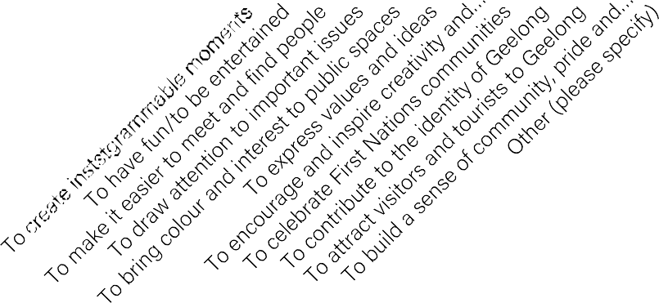

From this question many of the respondents wanted to increase the attractiveness of public spaces through art, this is through to have fun and be entertained, to bring a sense of colour and build a sense of community. The respondents want to feel a sense of inclusion and attraction to Geelong, that there is interest in public spaces through the use of art that celebrates communities in Geelong such as First Nations people.
There are many reasons why people value public art within our public spaces. Which of the following reasons to you value public art?
80.00%
70.00%
60.00%
50.00%
40.00%
30.00%
20.00%
10.00%
Responses
0.00%

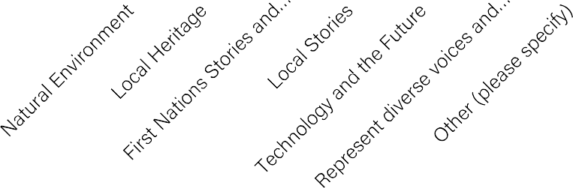
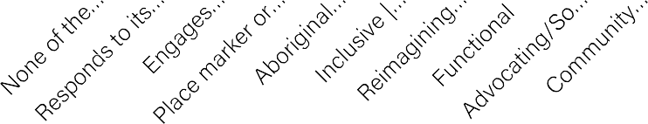
Public art can express ideas in different ways. Which of the following expressions of public art you would like to see more of in Greater Geelong? [Pick up to 4 answers]
60.00%
50.00%
40.00%
30.00%
20.00%
10.00%
0.00%
Responses
What themes/stories are important to you and other young people that could be reflected in the future public artworks? [Pick up to 3 answers]
60.00%
50.00%
40.00%
30.00%
20.00%
10.00%
Responses
0.00%
The major stories that young people want to be told through public artworks is that of the natural environment of Geelong alongside First Nations Stories and Knowledge, but they also want different identities and diverse voices to be expressed and represented through their public art in their public spaces.

The respondents were evenly spread but with the majority wanting the public art to be community created and creating a sense of inclusivity and belonging for the young people of Geelong, through the public art they also want to see their public space reimagined.
They also want it to be responsive to the local Aboriginal history and the location.

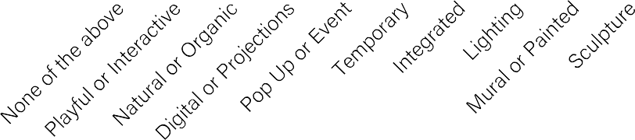
Public art comes in all shapes and sizes. Which of the following types of public art you would like to see more of in Greater Geelong? [Pick up to 4 answers]
70.00%
60.00%
50.00%
40.00%
30.00%
20.00%
10.00%
0.00%
Responses
As a young person in the Geelong community, what are the issues that currently concern you the most? [Select up to 3 answers]
40.00%
35.00%
30.00%
25.00%
20.00%
15.00%
10.00%
5.00%
0.00%
Responses

From the above question, the respondents of the survey mainly picked the options in which the people in the space can interact with the public art and where the art remains there permanently and is embedded with the built form of the area rather than being temporary or something that can be moved easily. From this we can tell the respondents want to be moving through spaces and being a part of the public art.

The main concerns of the respondents were to do with the cost of living and housing costs, as well as mental health issues and discrimination.
Health of the… Climate change… Housing and your… Mental health…
Safety and violence Social inequality…
Cost of living School and study…
Feeling… Artificial… Racial… Gender and… Disability… Global and…
Social media use
Other (please…

OPEN ENDED RESPONSES
- Sport related artwork that is functional for sports
- Not an idea, but I would love if young people could create a group to create a piece of public art together!
- More art in Highton. Possibly on the Highton library
- What kids wanna see
- Some near Portarlington or around Geelong
- I’d just like to see more spaces be brought to life by art to make Geelong more inviting and fun to be in
- Opening up unseen parts of the city to public viewing, on a rotation of different areas. Inside parts of city hall, old factories, unused buildings, tunnels and the Geelong underground.
- A sculpture of a seagull out the front of the dunes cafe in ocean grove representing the beach and a tourist attraction destination called the big seagull idea from all the other big tourist spots.
- I don't have any specific ideas, but allowing young people to be involved in the art making process would be awesome! If there's a public space that you'd like to recreate, create a small group of young people to design and paint the area!
- A big bird, there’s so many birds in Australia and it would represent the birds of Australia. Also, everyone loves birds. Could be cool at the Geelong waterfront!
From these comments we see that the respondents want to be a part of the process to help them feel as though they belong and to make spaces inviting especially for younger people. They also want to be able to interact with the public art, be able to create with it or play with the space. There were also two respondents that want ‘big birds’ along the foreshore.

