
The City Of
Greater Geelong

ASSET PLAN

2025-2035

Acknowledgement to Country

We acknowledge the Wadawurrung People as the Traditional Owners of the Land, Waterways and Skies. We pay our respects to their Elders, past, present and emerging. We Acknowledge all Aboriginal and Torres Strait Islander people who are part of our Greater Geelong Community today.
Contents

Title | Page
Executive Summary | 1
Introduction | 1
Definitions | 2
Our Place | 2
Our People | 3
Community Engagement | 3
Our Asset Plan | 4
City Planning | 4
Council Plan | 5
Financial Planning | 5
Organisation Strategy | 7
Service Planning | 7
Our Assets | 9
Our Asset Portfolio | 9
Asset Attributes | 9
Asset Classes | 9
Primary Asset Classes | 10
State of Assets | 10
Asset Age Profile | 10
Asset Health Profile | 11
Asset Condition | 12
Asset Management | 13
Asset Performance Reporting | 13
Community Value | 13
Ten-Year Forecast | 14
Challenges | 14
Opportunities | 15
Conclusion | 15

EXECUTIVE SUMMARY
The City of Greater Geelong (City) manages a diverse and extensive asset portfolio valued at $6.094 billion, encompassing infrastructure essential to the delivery of 30 community services across more than 1,200 hectares. This Asset Plan 2025 – 2035 sets out a strategic approach for managing, maintaining, and renewing our assets to support the City’s long-term vision and community outcomes, in alignment with the Council Plan.
This Plan meets the legislative requirements of Section 92 of the Local Government Act and is a key component of the City’s integrated planning and financial management framework. It defines how asset management underpins service delivery, sets performance expectations, and guides investment decisions to ensure the asset portfolio remains functional, financially sustainable, and fit for purpose.
Drawing on data-driven insights and asset performance measures, the Plan responds to evolving community expectations and challenges, including climate change, population growth, demographic shifts, and service delivery pressures. It commits to maintaining asset health above 65% across all classes, limiting poor-condition assets to below 6%, and sustaining an asset renewal ratio of at least 85% over the next decade.
The Asset Plan 2025 – 2035 provides a clear framework to guide investment, improve asset performance, and ensure the City can continue to meet the needs of a growing and changing community.
INTRODUCTION
This Asset Plan will be adopted as the next Asset Plan 2025-2035 for the City in accordance with Section 92 of the Local Government Act 2020. The Asset Plan performance indicators align with the Council Plan and will be incorporated into the City’s annual performance reporting. This asset Plan is to be reviewed on an annual basis and republished at the change of each Council term.

Definitions
Terminology | Description
Asset capacity data | The ability of the physical infrastructure to meet service delivery needs. It measures the appropriateness of asset usage for the designated service hierarchy. Capacity data typically informs demand management, upgrade, expansion and/or disposal strategies.
Asset condition data | The condition of the physical infrastructure that allows it to meet the intended service level. Where condition data is available, it can assist in estimating remaining useful life as input into the capital renewal projections.
Asset functionality data | The ability of the physical infrastructure to meet program delivery needs. It measures appropriateness of the asset to meet the designated service hierarchy. Function data typically informs demand management, upgrade, expansion and/or disposal strategies.
Asset health | Average remaining useful life of an asset class
Capital renewal asset expenditure | Expenditure on an existing asset or on replacing an existing asset, which returns the service capability of the asset up to that which it had originally
Capital asset upgrade expenditure | Expenditure which enhances an existing asset to provide a higher level of service
Capital new asset expenditure | Expenditure which creates a new asset providing a new service/output that does not currently exist
Critical assets | Assets for which the financial, business or service level consequences of failure are sufficiently severe to justify proactive inspection and rehabilitation. Critical assets have a lower threshold for action than noncritical assets.
Depreciation | The systematic allocation of the depreciable amount (service potential) of an asset over its useful life
Remaining useful life | The time remaining until an asset ceases to provide the required service level or economic usefulness. Age plus remaining useful life is useful life.
Useful life | It is estimated or expected time between placing the asset into service and removing it  from service, or the estimated period over which the future economic benefits embodied in a depreciable asset, are expected to be consumed by the Council
Table 1
Our Place
With a population of nearly 285,000 people, the City of Greater Geelong is Victoria’s largest regional municipality. Located 75 kilometres south-west of Melbourne, the municipality covers an area of 1,252 km2, comprising suburban, coastal and country areas.
The Greater Geelong area is bounded by the Moorabool Shire in the north, Wyndham City Council and the Borough of Queenscliff in the east, Surf Coast Shire and Golden Plains Shire in the west, and Bass Strait to the south. Key natural features of the region include Corio Bay, the Bellarine Peninsula, the Barwon River, the You Yangs Regional Park, wetlands, parklands and wildlife sanctuaries.
Our region is made up of the City of Geelong and its surrounding suburbs, rural and coastal townships and rural, agricultural and coastal landscapes.
The Wadawurrung people are the Traditional Owners of this area. As custodians of the land, their history, knowledge and passion continue to inform and shape the environmental practices of today. Our region is under immense pressure from development – our population is expected to grow to 387,900 by 2036.
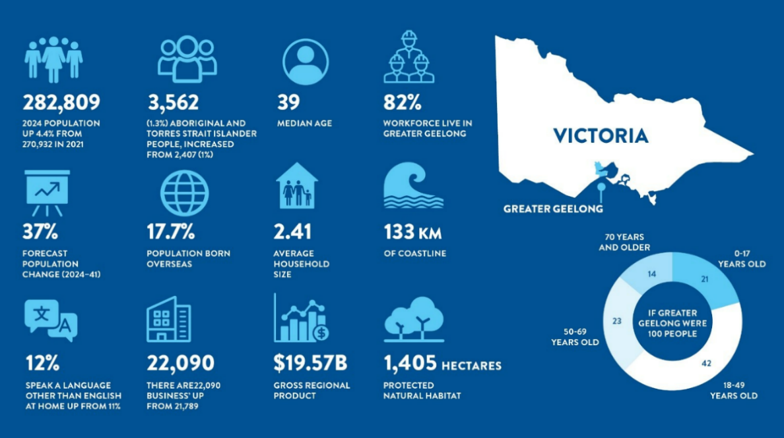
Our People
Graphic 1
Community engagement
In the second half of 2024, The City conducted a deliberative planning activity with the community, to understand the priorities and themes for the next iteration of the Council Plan. The asset management team contributed to that engagement and obtained the feedback below, relating to the asset portfolio.
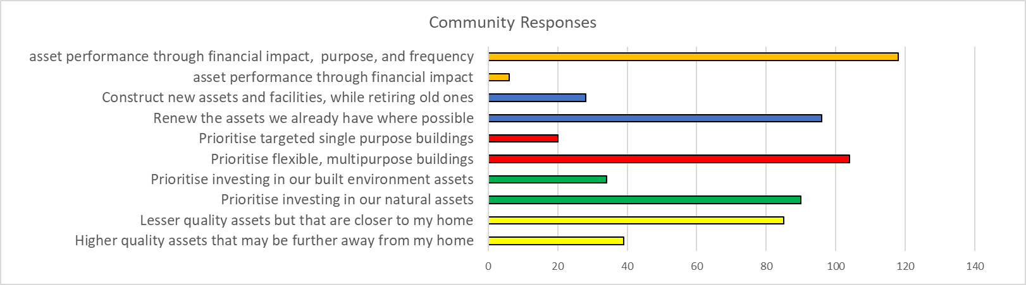
Table 2
The outcome from that engagement included asset management related themes that are now reflected in the Council Plan objectives.
OUR ASSET PLAN
This Asset Plan provides the community with:
- information about maintenance, renewal, acquisition, upgrade, and disposal in relation to each class of infrastructure asset under the control of the Council
- any other matters prescribed by the regulations.
The key outcomes of this Asset Plan are to:
- Identify the assets and their various attributes
- Understand how the assets support the delivery of community services
- Commit to maintaining assets aligned to funding within the Long-Term Financial Plan (LTFP)
- Commit to expending relevant capital to meet asset renewal, acquisition, upgrade and disposal planning requirements
- Measure the performance of the assets
- Report on the Plan.
City Planning
The City conducts planning in accordance with the graphic below. This Asset Plan aligns with our ten-year horizon and is linked to business and service planning that occurs on an annual cycle.
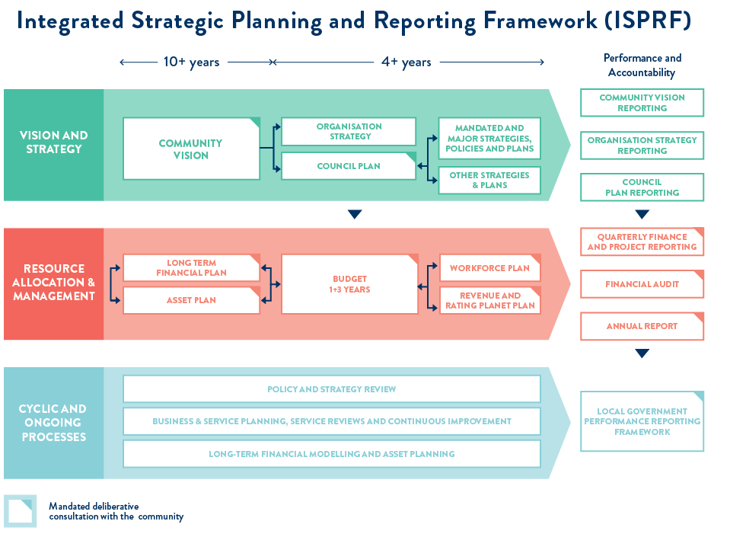
Graphic 2
The key elements of planning for asset management and the Asset Plan are:
- Council Plan
- Financial planning
- Organisation strategy
- departmental service planning.
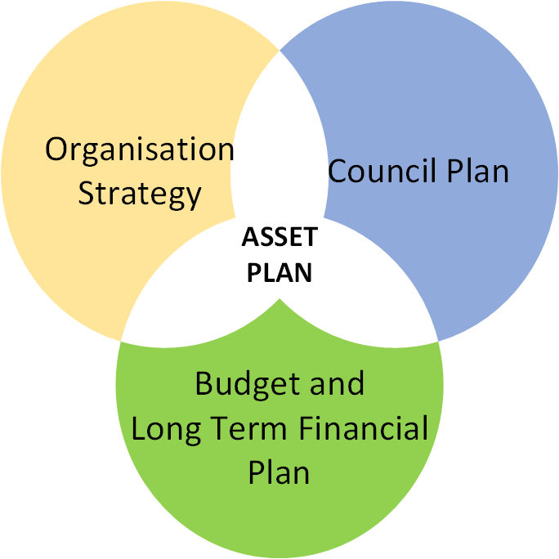
The graphic below identifies the importance of strategic guidance to enable the effective management of assets in delivering services to the community.
Graphic 3
Council Plan
A summary of our recently endorsed Council Plan commitment and high-level goals is detailed below:
- Commitment: We are committed to advancing community outcomes for a thriving Greater Geelong
  - Plan, deliver, manage and optimise core and critical infrastructure across the region
  - Identify, promote, advocate for, and deliver equitable health and wellbeing outcomes for our diverse communities
  - Lead efforts to strengthen our diverse economic precincts and workforce to enhance prosperity across our community
  - Champion our unique heritage and culture
  - Protect and enhance our unique natural environment and surrounds
  - Commit to the highest levels of leadership, integrity, financial stewardship and meaningful community engagement.
Financial Planning
The success of effective asset management relies on the financial commitment to the LTFP. Specifically, the renewal targets and allocation of renewal, upgrade and new asset funding across the asset portfolio.
Financial planning within the City incorporates, year one budgeting, budgeting in years two to four and long-term financial planning. Departments within the City develop annual budgets to cover the operational and maintenance costs of the assets that they are responsible for. Finance business partners work with the departments to budget year one and forecast years two to four.
The more strategic financial planning is coordinated between finance and asset management and is predominantly driven through the LTFP. The four key funding components are:
- New asset expenditure – expenditure that creates a new asset that provides a service that does not currently exist.
- Asset upgrade expenditure – expenditure that:
  - enhances an existing asset to provide a higher level of service
  - extends the life of an asset beyond its original life.
- Asset renewal expenditure – expenditure on an existing asset or on replacing an existing asset that returns the service capability of the asset to its original capability.
- Maintenance expenditure – recurrent expenditure which is periodically or regularly required as part of the anticipated schedule of works required to ensure that the asset achieves its useful life and provides the required level of service.
New asset and upgrade asset capital expenditure. A business case is required to be developed by the relevant service manager within the City to justify any new asset or upgrade to an existing asset. The business case is developed in consultation with the asset management team and requires the development of a life cycle cost model. This level of information informs any future capital and maintenance expenditure. Management and allocation of this type of funding sits outside this Asset Plan. Asset functionality and capacity is addressed with capital expenditure.
Asset renewal capital expenditure. Renewal planning is led by the asset management team and supported by the finance team. Using up-to-date asset data such as asset health and condition, the asset team develops a plan per asset class to improvement condition gradings.

Organisation Strategy
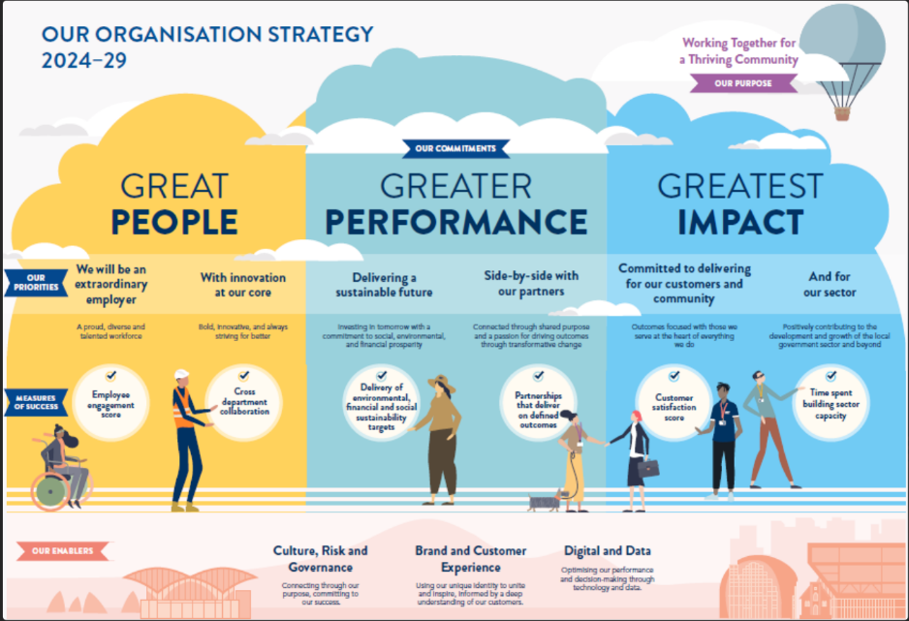
Our new Organisation Strategy 2024-2029 depicted in the graphic below, outlines how we will do our work. It identifies where we mut focus as an organisation to ensure the delivery of the Council Plan in the most effective and efficient way. Paving the path to achieve aspiration of becoming the highest performing and best local government to work for. The three key pillars are: Great People, Greater Performance and Greatest Impact.
Graphic 4
Service Planning
Asset management is one of 30 key services provide to the community by the City. It is an enabling service for many other community services. The graphic below shows the primary service and sub-services of asset management, including a detailed description of the sub-services.
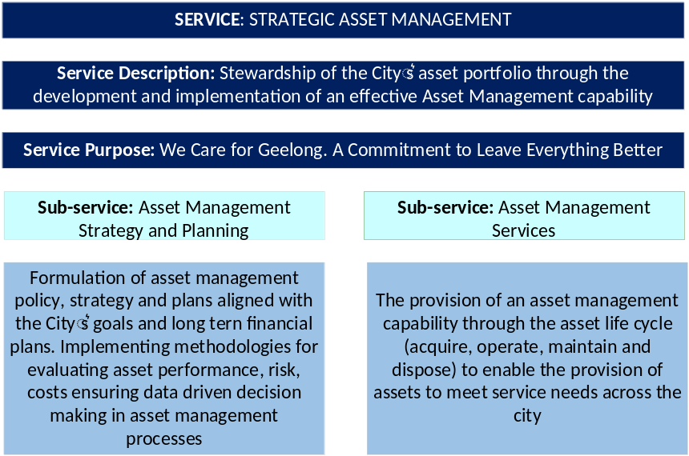
Graphic 5
With the inputs of the Council Plan, Organisation Strategy and the LTFP, asset management service planning is then conducted. This is a top-down approach ensuring that the outputs of asset management, as a service, align to the Council Plan outcomes. The graphic below depicts the outcomes of service planning and identifies the actions in which asset management will be assessed. Note the five actions that specifically relate to this Asset Plan.
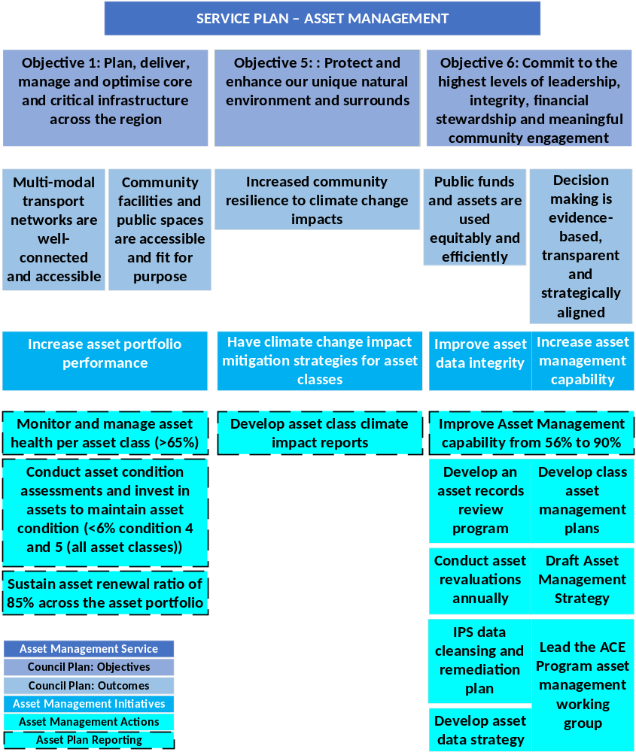
Graphic 6

OUR ASSETS
Our Asset Portfolio
The City’s asset portfolio’s fair value is $6.095b. There are three financial groups that arrange the financial categories of our assets to enable financial reporting in accordance with the Local Government Act 2020. The graph below shows a breakdown of fair value for the three groups.
Graphic 7
Asset attributes
The following are three key asset attributes to consider when determining asset value:
- Capacity – ability of the physical asset to meet service delivery needs
- Functionality – ability of the physical asset to meet program delivery needs
- Condition – condition of the physical asset that allows it to meet the intended service level.
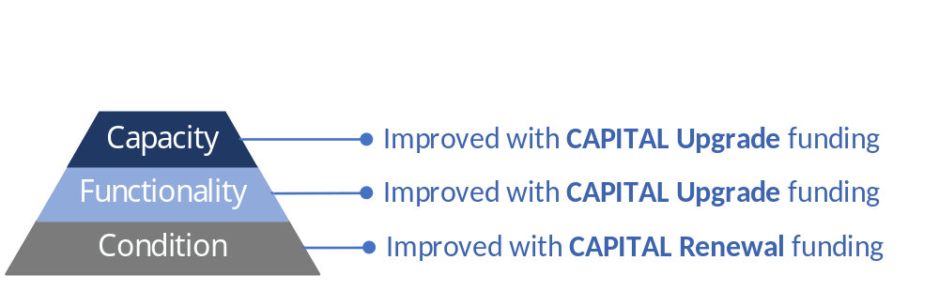
Graphic 8
Asset classes
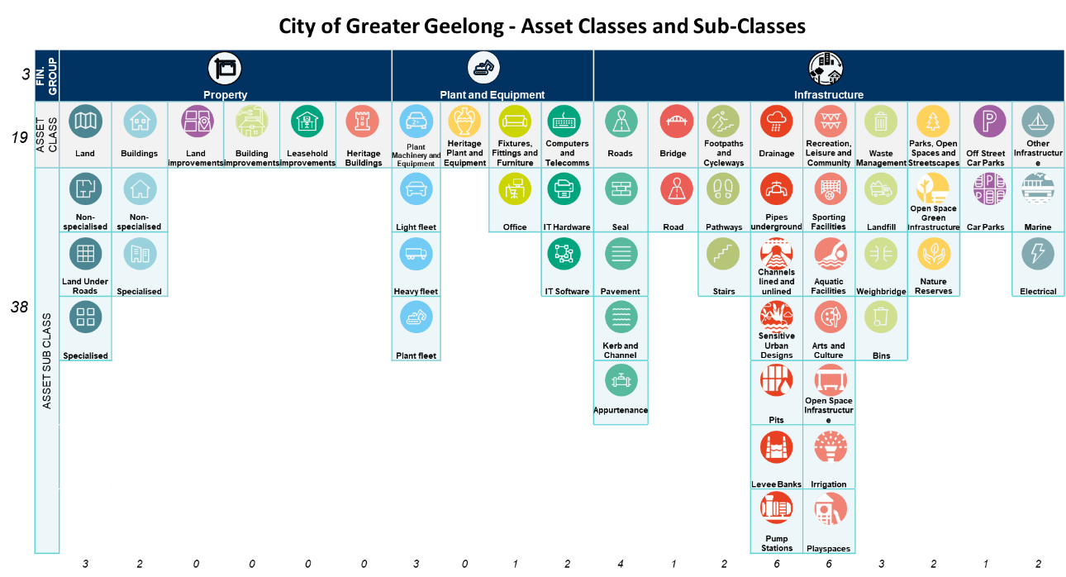
Our asset portfolio comprises of 19 asset classes, however not all asset classes are subject to detailed strategic asset management and renewal funding. Most of the assets are within seven primary assets classes, which will form the basis of this Asset Plan. This primary asset class list aligns with the major components of Part 2 of our Annual Report, the Financial Report. The table below shows a breakup of the 19 asset classes.
Graphic 9
Primary Asset Classes
The City comprises 30 services of which 12 predominantly rely on assets as a key component of the service delivery. Most of the community facing services are delivered utilising assets in the following asset classes:
Bridges | Buildings | Drainage | Footpaths and Cycleways | Open Spaces | Recreation, Leisure and Community | Roads
 |  |  |  |  | 
Table 2
Renewal funding is set aside to address asset condition. Where an asset is not meeting functional or capacity requirements, funding is raised from capital. The following sections relate to renewal funding, capital funding will be addressed towards the end of this section.
State of Assets
Our asset profile is best described through financial, age, health and condition lenses. The detail below reveals that the City has a very large asset portfolio, that has aged significantly, but remains generally, in good condition.
Asset Age Profile
The City’s asset portfolio age range varies significantly, and many of the asset classes have a high number of assets. For these reasons it is easier to view the age portfolio via a box and whisker plot. Below is an example of the box and whisker plot using the buildings asset class.

The green rectangular box represents 50% of the data. Hence, 50% of the buildings are aged between 14 and 55 years. The red line (whisker) to the left of the green box represents the bottom 25% of the data. So, 25% of the buildings are aged from 0-14 years. The blue whisker to the right of the green box represents the top 25% of the data. Therefore, 25% of the buildings are aged from 55-115 years. The median (middle) age of the asset class is 44 years (orange vertical line).
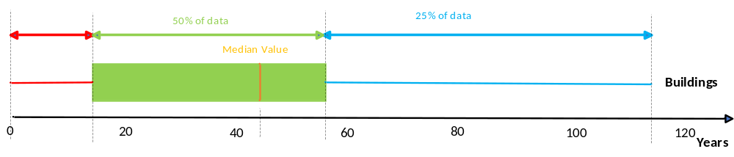Graphic 10
The City’s asset portfolio has a range of useful lives, ranging from 0 years to 120 years. The profile below is the age of six of the seven primary asset classes. asset groups including the median. The
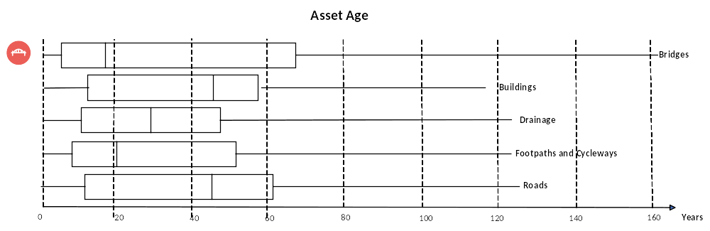
Graphic 11
Asset Health profile
The health of an asset class is defined as the average remaining useful life of the class. It is dependent on the asset type, the asset useful life and the asset condition. Institute of Public Works Engineering Australia (IPWEA) recommends a minimum of 50% life on all its asset classes for councils, whereas the National State of the Assets (NSoA) recommendation is 60%. The City of Greater Geelong proposes to ensure that all asset classes have a minimum of 65% remaining useful life. The current profile of the seven primary asset classes is below.

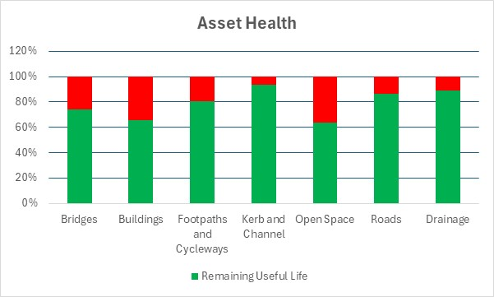
Graphic 12
Note that the health of six of seven of the City’s asset classes is above the minimum NSoA recommended levels as at 2025, however open space is below the City’s target of 65%. To ensure that all classes meet the 65% target, the City will use the asset management governance framework to allocate sufficient funding to maintain desired asset health levels. Prudent maintenance and ongoing renewal effort is required to sustain this over a ten-year period.
Asset Condition
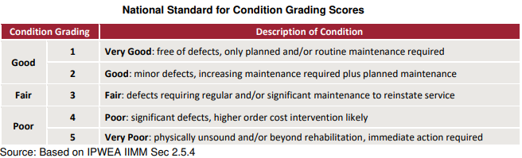
The above refers to general asset health. In addition to measuring asset health, we also conduct regular condition assessments. All assets are inspected and given a condition score ranging from 1-5. The Table below explains each of the condition grading.
Table 3
General maintenance funding providing from the recurrent budget will address ongoing asset maintenance, which includes addressing assets in good or fair condition. Renewal funding targets assets in poor condition, grades four and five. Renewal funding is allocated with the following considerations:
- Condition - The condition rating of the asset
- Capacity - The level of utilisation of the asset (where it can be measured)
- Functionality - The ongoing requirement for the asset to meet a service need (in consultation with the asset planner and the service manager)
- The deterioration rate of the asset.
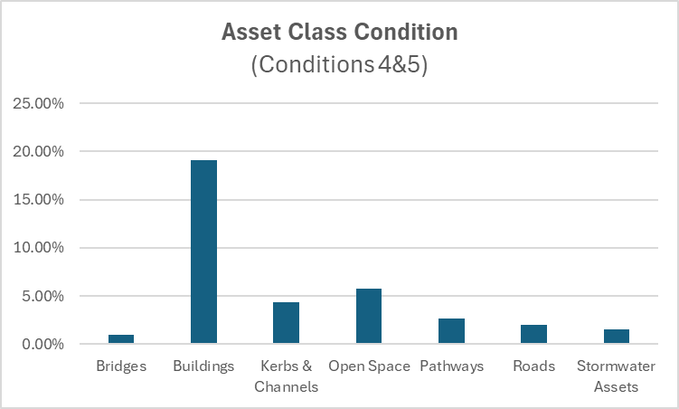
The City has set a target that all asset classes have no more than 6% assessed as condition grading four or five. The current profile of the seven prime asset classes is below.
Graphic 13
From the graph above, the buildings asset class will require additional renewal investment to meet the City’s targets, and this is reflected in the LTFP allocation of funding.
ASSET MANAGEMENT
We intend to deliver a high level of asset management services, aligned to the Council Plan, through
the application of our organisational strategy. We well ensure:
- Asset needs are determined through service planning
- Asset planning is supported by data driven insights
- Asset portfolio is managed through a set of realistic data measures
- Asset management knowledge uplift across the city from, councillors to asset users.
Asset performance and reporting
An important component of this Asset Plan is the identification of a series of performance measures, that reflect how well the assets are managed to deliver on the objectives within the Council Plan. The below KPIs will form part of the City’s annual reporting, which provides the community on the City’s progress in achieving the Council Plan outcomes.
- AM01 – Develop Asset Class Climate Impact Reports
- AM02 – Sustain asset renewal ratio of 85% across the asset portfolio
- AM03 – Maintain asset class health greater than 65%
- AM04 – Maintain asset class conditions four and five of less than 6%
- AM05 – Improve Asset Management capability from 56% to 90%.
Community value
The above metrics are only half the story when it comes to the City’s assets. They exist primarily to deliver a service to the community of the City of Greater Geelong. In addition to measuring the performance of the asset, we must also consider the following community value benefits when making decisions on the City’s assets:
- Social – access to services, community cohesion, inclusiveness, public safety
- Economic – Support to local businesses, job creation, property value uplift
- Environmental – Biodiversity, stormwater retention, tree canopy, CO2 reduction
- Cultural – Heritage protection, use of public space for events/traditions
- Health and wellbeing – physical activity opportunities, mental health support, accessibility
Balancing the physical asset performance with the needs and benefits to the community requires a holistic approach to asset management, and an integrated approach decision making within the City.
Ten-year forecast
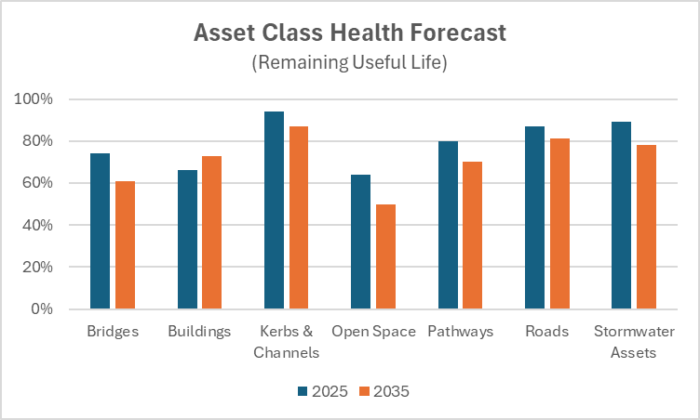
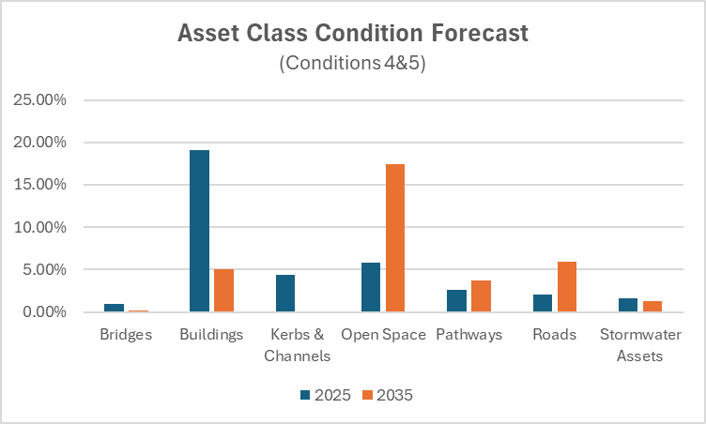
With the maintenance and renewal funding provided in the LTFP, the asset management team can forecast the asset health and asset condition for the seven primary asset classes, for the next ten years. The data in the graphs below is indicative of what can be achieved with the forecast level of funding.
Graphics 14 and 15
Throughout the ten-year period, the asset governance forum will authorise changes to funding to meet any change to asset performance requirements. Note that the above forecasts are aggregated to the asset class level. There are several asset sub-classes that may have different asset conditions and health, depending on the priorities of the City and the needs of the community.
Challenges
As a local government authority, the City has over 500,000 assets with a fair value of over $6b. We have a diverse geographical region that we manage and provide a broad range of services to our community. As we increase our community engagement, improve our relationships with the community and improve the understanding of asset management, the following is list of challenges and opportunities that must be addressed to meet the needs of the community:
- Financial sustainability – maintaining financial sustainability with rate caps, inflation, maintenance costs and availability of funding for asset upgrades and renewals
- Climate Change – The effects of climate change are being experienced in our community now, however we are only just starting to consider climate change impacts across our asset class over the long term. We need to understand how the impacts affect asset condition and functionality.
- Growing region – Our region is expected to grow by 38% by 2045. This will place considerable strain on our current asset base, so we need to be prepared for our assets to be upgraded and/or replaced over the next 20 years.
- Demographics – With the ever-changing demographics from one generation to another, there are different demands placed on our assets. Asset design must include a level of flexibility in asset functionality and capacity.
Opportunities
The following is a list of strategic improvement initiatives targeted at uplifting the AM capability within the City which will also significantly improve on the planning and delivery of asset management across our asset portfolio.
- Asset Management System – the investment in a modern enterprise asset management system, integrated with the financial system will significantly improve the storage and access to reliable data in a timely manner, easily linked to asset and financial classes
- Service Management approach to assets. The City should only ever have assets to meet a service need, and not develop a need to have an asset. As part of the strategic asset management planning function, assets will undergo a review and alignment to the 30 services that are delivered to the community. This is to ensure that the City only retains assets that deliver value by meeting the needs of the community through the Council plan. Where assets are deemed no longer required, they will be disposed of. As part of service management planning, we will be considering delivering multiple services from the same asset, where it is appropriate. This will increase asset utilisation and demonstrate improved value to meet the needs of the community.
- Asset utilisation. We intend to adopt several innovative approaches to measure the utilisation of our assets. This includes providing people counters for building and public spaces, graphic counters at some of our critical infrastructure assets, to enable us to measure the value these assets provide to the community. Where an asset is underutilised, then we will work with service managers to rationalise assets to gain better value to the community.
- Climate change. Understanding the impacts of climate change on our asset base. Whilst we are seeing the impacts of additional rainfall on our drainage assets, we are you to fully understand other elements of climate change such as increase heat, drought and rising sea level on our assets. One of our targets for this Asset Plan is to prioritise the assessment of climate change impacts on our critical asset classes and subclasses. That will enable us to be better prepared for the future.
- Asset Management Maturity. In 2024, the City’s asset management capability was externally assessed against the National Asset Management Assessment Framework. The results show clear opportunity for improvements in several areas. We have set an ambitious target to uplift the capability to 90% within this Asset Plan period. An organisational review conducted in 2023 restructured the asset management team and they are now better equipment and arranged to meet this ambitious target.
CONCLUSION
This asset plan provides the community with a high level of detail that relates to the large portfolio of assets owned and managed by the City of Greater Geelong. We have simplified the assets into ten primary classes and provided a range of profiles on the assets. We have aligned the assets to our services and then provided a direct link to the objectives of the Council Plan. A range of performance measures have been recommended that enable reporting on the outcomes of the plan.

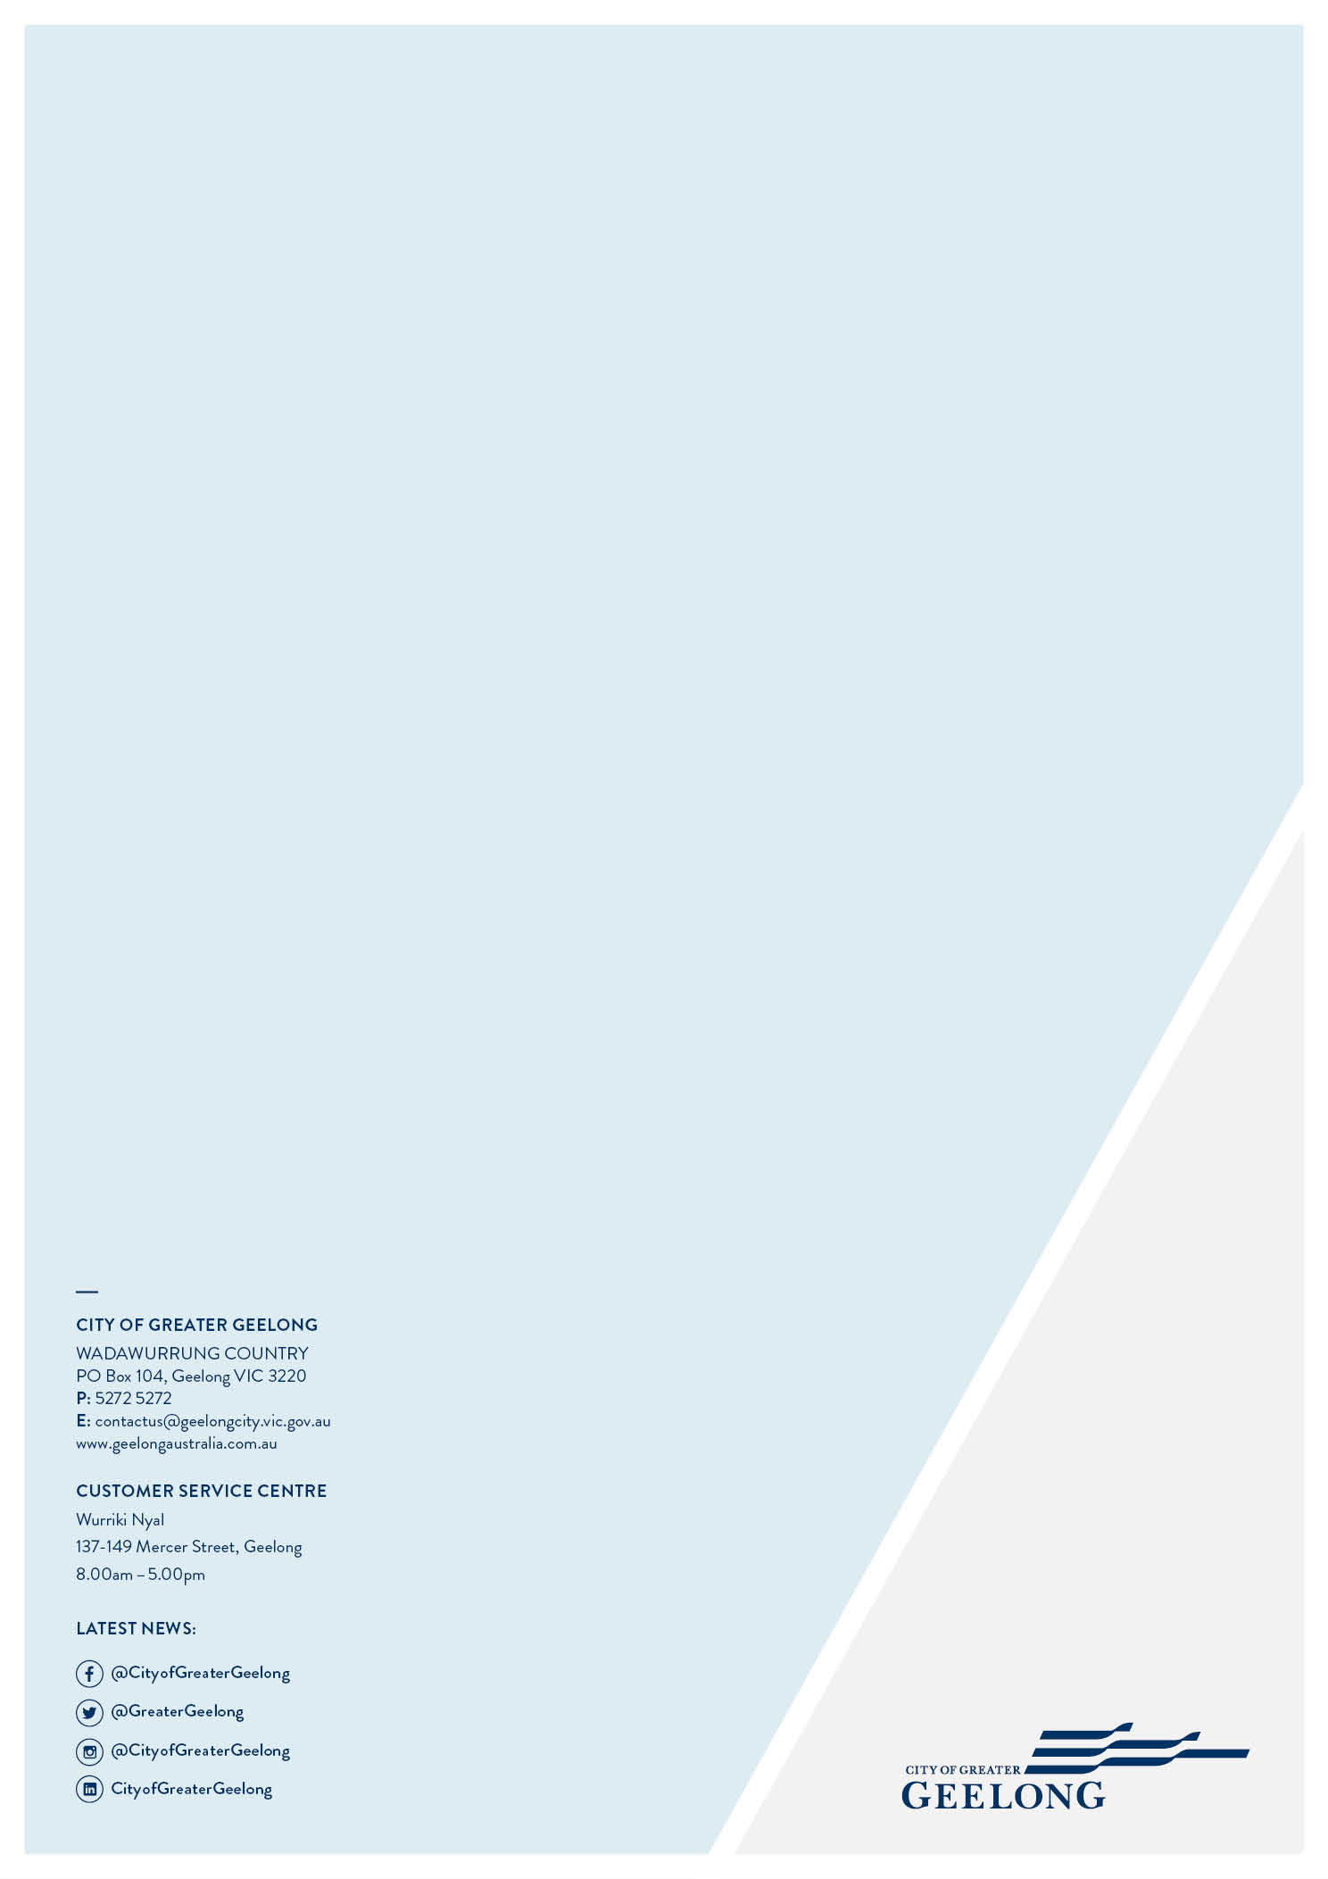

Note that all dollar values in this Asset Plan are drawn from the City of Greater Geelong Annual Report 2024
Note that many of these definitions are found in the documents: Local Government (Planning and Reporting) Regulations 2020 and Local Government Asset Management – Better Practice Guide 2015
We have also included details of other asset classes within the Property and Plant and Equipment financial groups
As defined by Institute of Public Works Engineering Australia
We are in the process of auditing Open Space and Kerb and Channel assets to verify asset age data
Note that Plant and Equipment Financial Group assets generally have short lives and are not assessed for asset health
The Table is an extract from the IPWEA Practice Note 3
Note that the Plant, Machinery and Equipment Financial Group assets generally have short lives and are not assessed for asset health or long-term condition management

