South Geelong –

Stormwater Management Strategy
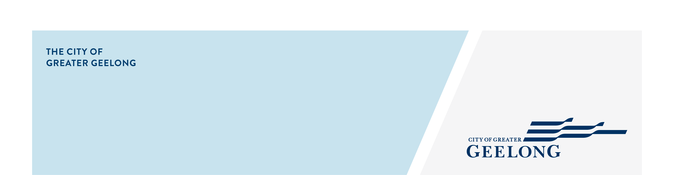

community engagement summary – STAGE 1

The City of Greater Geelong is undertaking a stormwater study in our South Geelong Catchment. This study will assist the City to:
- Better understand and manage flood risk.
- Better understand stormwater quality impacts on local waterways.
- Seek opportunities for alternate water supply to City managed facilities.
- Plan future drainage upgrades.
The study area takes in parts of South Geelong, Newtown, Breakwater, Thomson and St Albans Park. More information on this study can be found at https://yoursay.geelongaustralia.com.au/SGSMS.

We conducted community engagement in July and August 2024 to gather the experiences and feedback of residents, businesses, and stakeholders in the study area.
Thank you to members of the community who provided their feedback and shared their experiences. The feedback will be used to validate the catchment model to ensure it reflects their experiences.

.

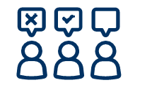
23 Flood experience were shared

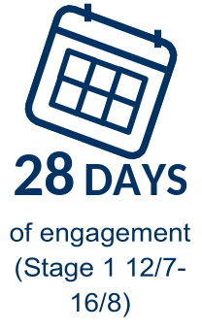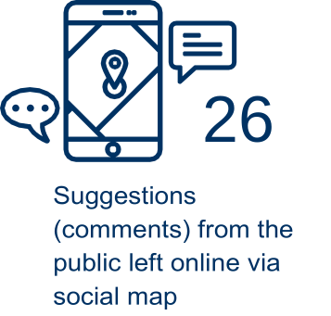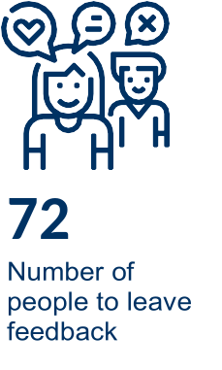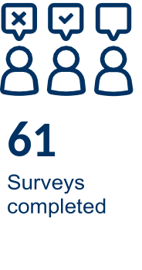

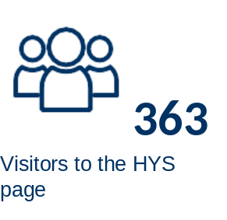

This engagement aimed to better understand the community’s experiences with flooding, the effectiveness of current flood management measures, and to gather insights on potential solutions to improve flood resilience in these areas.

This information will help to inform our South Geelong Stormwater Management Strategy, which will assist the City and relevant authorities to better understand and manage flood risk, stormwater quality impacts on local waterways, and alternate water supply options for the region. capture the community's experiences of flooding in South
HOW WE ENGAGED

Next Steps or any Verbatim comments and officers can remove which is not applicable.

A Have Your Say project page was designed to enable the community to share relevant information and provide their feedback. All community members were invited to respond to an online survey and an interactive map.

Feedback was invited over a 5-week period.

A total of 61 surveys were completed and 26 responses were left on the interactive map.

The community were asked to classify their responses into the four categories below:

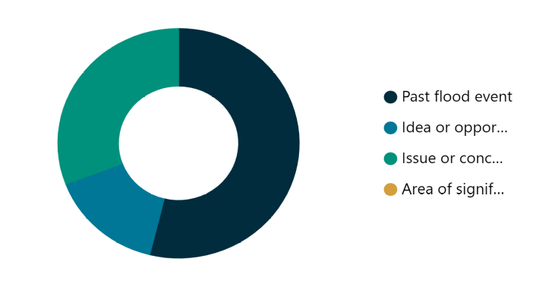

- Past flood event – 50% of responses
- Idea or opportunity – 15% of responses
- Issue or concern – 30% of responses
- Area of significance – no response received

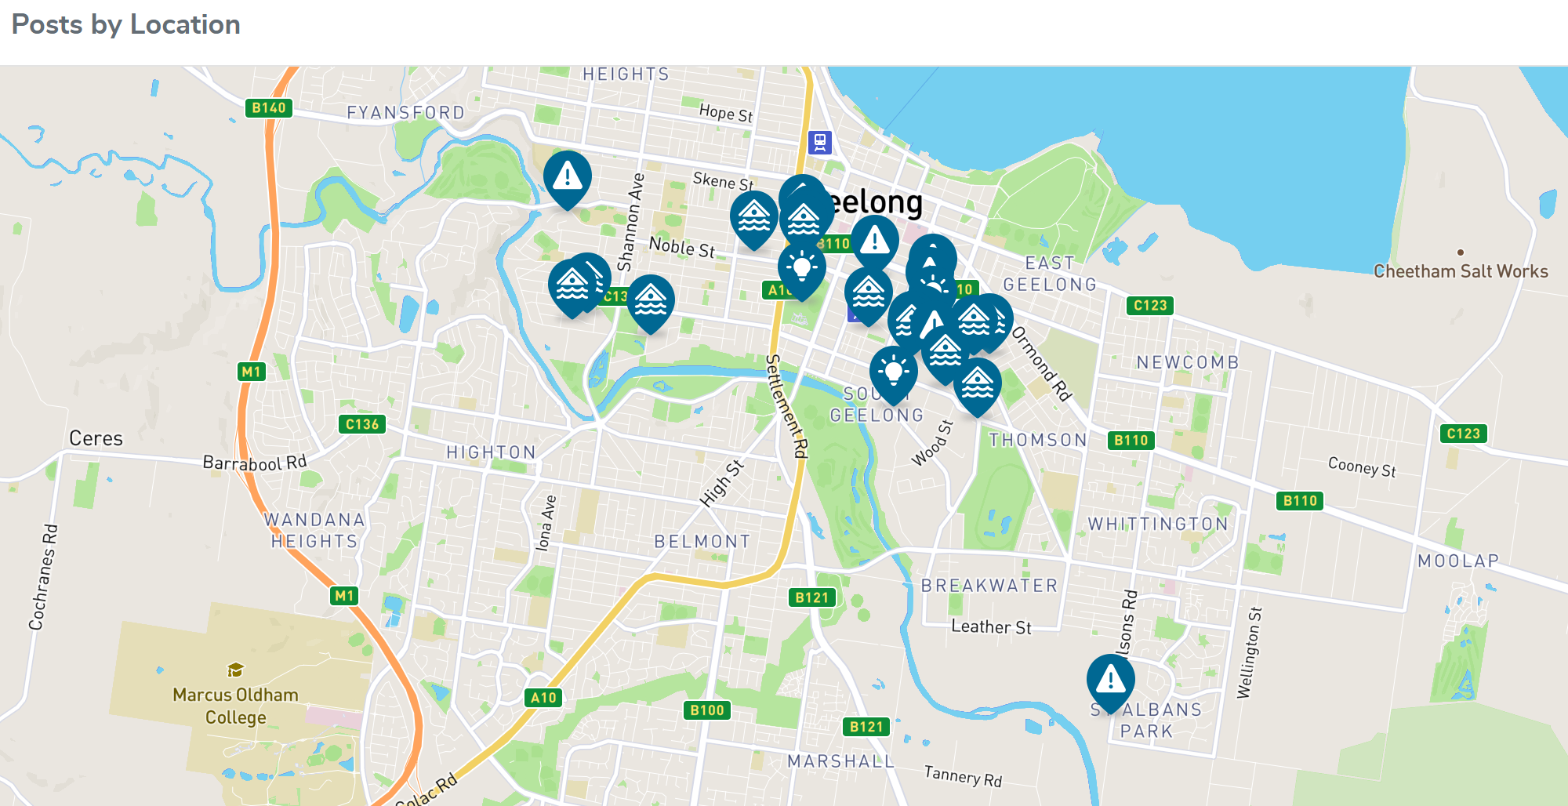

What we heard

Next Steps or any Verbatim comments and officers can remove which is not applicable.

Survey feedback
Of the residents who responded to the survey, 68% of them have experienced flooding on, or around their property, with 40% having experienced flooding within the previous year. Most respondents believe flooding has been caused by excess overland flow (48%) and blockage of underground drains (41%) and blockage of open drains (41%).

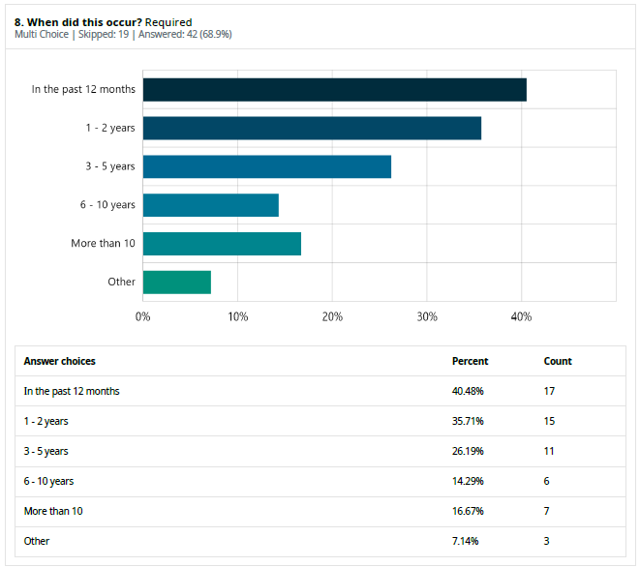
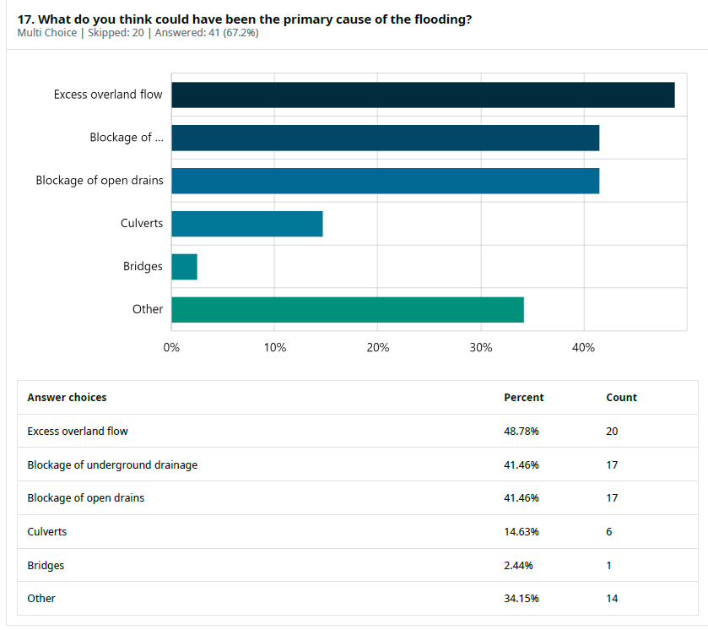

Map Feedback
- Identified flooding hotspots including Buckingham Rd, Bridge St, Clarke St and Kilgour St.
- Suggested locations where better infrastructure (stormwater drains, kerb and footpaths) could improve safety for motorists, cyclists and pedestrians.
- Identified opportunities for stormwater treatment infrastructure (litter traps, WSUD) to protect Barwon River environs.

Key Findings
- Most respondents come from the suburbs of Geelong, Newtown, East Geelong, and South Geelong.
- Most respondents are highly impacted and invested, in that they:
  - Almost exclusively represent residents and property/business owners.
  - Have first-hand experience of flooding (68%).
  - Over 75% of residents have experienced flooding in the last 2 years.
  - 55% of residents are concerned about future floods.
- Flooding most commonly affects streets, footpaths, gardens and driveways.
- Most respondents believe flooding occurred because of both excess overland flow and blocked drains.
- There is a clear feeling that the City’s stormwater drainage infrastructure is inadequate and poorly maintained.

Next Steps.

We are currently using the provided feedback, experiences, and digital resources (photos/videos) to validate our catchment model. We have also completed floor level survey of selected properties in the study area to assist with the accuracy of our results.

There will be two further rounds of community engagement during the life of the study.
- Stage 2 – This stage presents draft flood mapping and mitigation options and indicative costing to reduce the impact of flooding on impacted community members. Feedback and suggestions are welcome. This round of engagement is expected to be undertaken in April-May 2025.
- Stage 3 – This stage informs the community by presenting the draft final South Geelong Stormwater Management Strategy. This is anticipated to occur in July 2025.

