
Aldershot Reserve
Playground Renewal Feedback

community engagement summary
Report
The City of Greater Geelong invited the community to share their insights on the renewal of the playground at Aldershot Reserve, in St Albans Park. The purpose of this engagement was to gather feedback regarding the preferred play equipment for the playground.
This report presents the priorities, ideas and aspirations shared by community members during the engagement period of November to December 2023. The City would like to thank the participants who generously shared their time and ideas throughout this engagement process.

Background
Aldershot reserve is located at 41-55 Aldershot Road in St Albans Park. The reserve is a district level community park, and it has existing amenities including junior play equipment, a basketball half court, shelter, BBQ, and pedestrian path network. The reserve is landscaped with a few trees.
In 2020/21 the City worked with the community to develop a new masterplan for the reserve to better meet the needs of local residents. The masterplan was endorsed by Council in March 2021 after extensive community engagement. The masterplan includes planning for an entry garden, improved path network, new play space, pump track, fenced dog park, open spaces, and fitness equipment.
As part of the City's asset renewal program, and in line with the City's Play Strategy, the Aldershot Reserve play space has been identified for renewal to deliver a district level play experience for the surrounding community.

Key Outcomes

The top 5 pieces of equipment selected by participants were:
- Junior play tower with slides
- Flying fox
- Swing set
- Ninja warrior course
- Trampoline

Draft concept plan
Based on community’s feedback, the City has designed a draft concept plan which includes community’s preferred play equipment. The draft concept plan remains subject to further refinement during the detailed design phase. Our aim is to ensure that final design aligns closely with community’s preferences while also adhering to budgetary constraints.

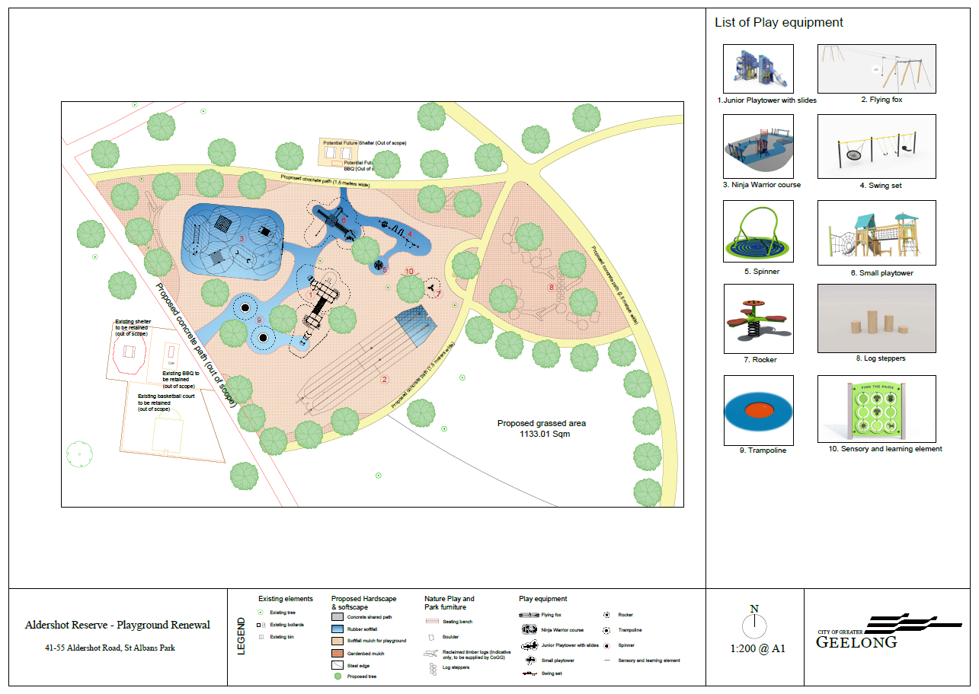

community engagement Data
HOW WE ENGAGED
WHAT DID WE DO?
On 13 November 2023, the City commenced community engagement for Aldershot Reserve Playground renewal for a period of 4 weeks. The emphasis of this engagement was to receive the community’s feedback and priorities for the new playground to be considered when developing the concept plan.
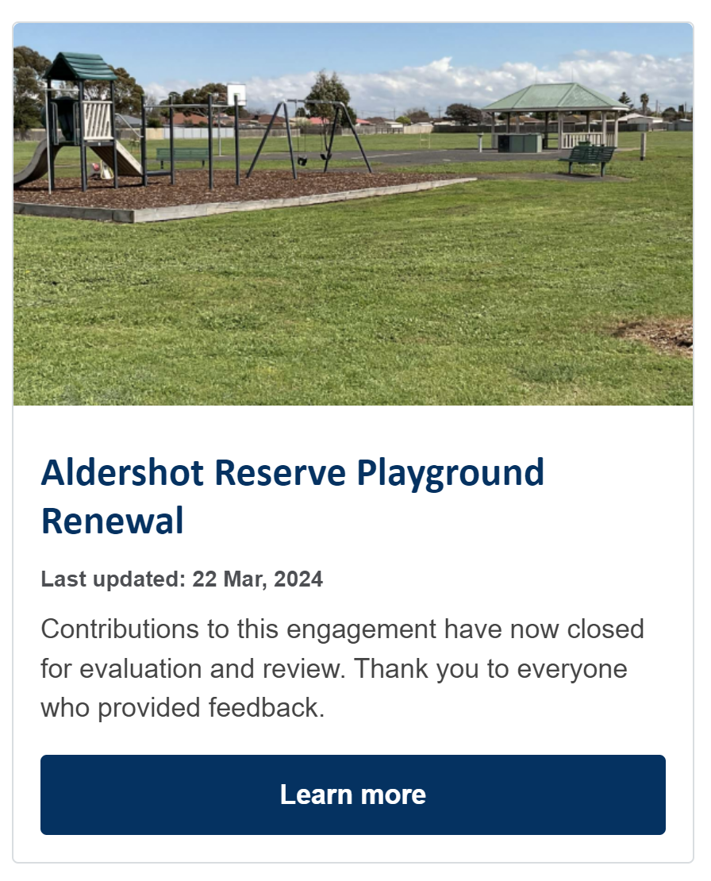 Figure: Project tile on the City’s HYS website
Feedback was collected through a dedicated online Have Your Say project page including a range of engagement tools and techniques to provide different types of opportunities for stakeholders and community to have their say. The main tools and techniques are explained in further detail below.
Two in-person onsite community consultations were held as well as a school workshop at Whittington Primary School. The school is approximately eight hundred metres from Aldershot Reserve.
A summary of the consultation process and feedback received:
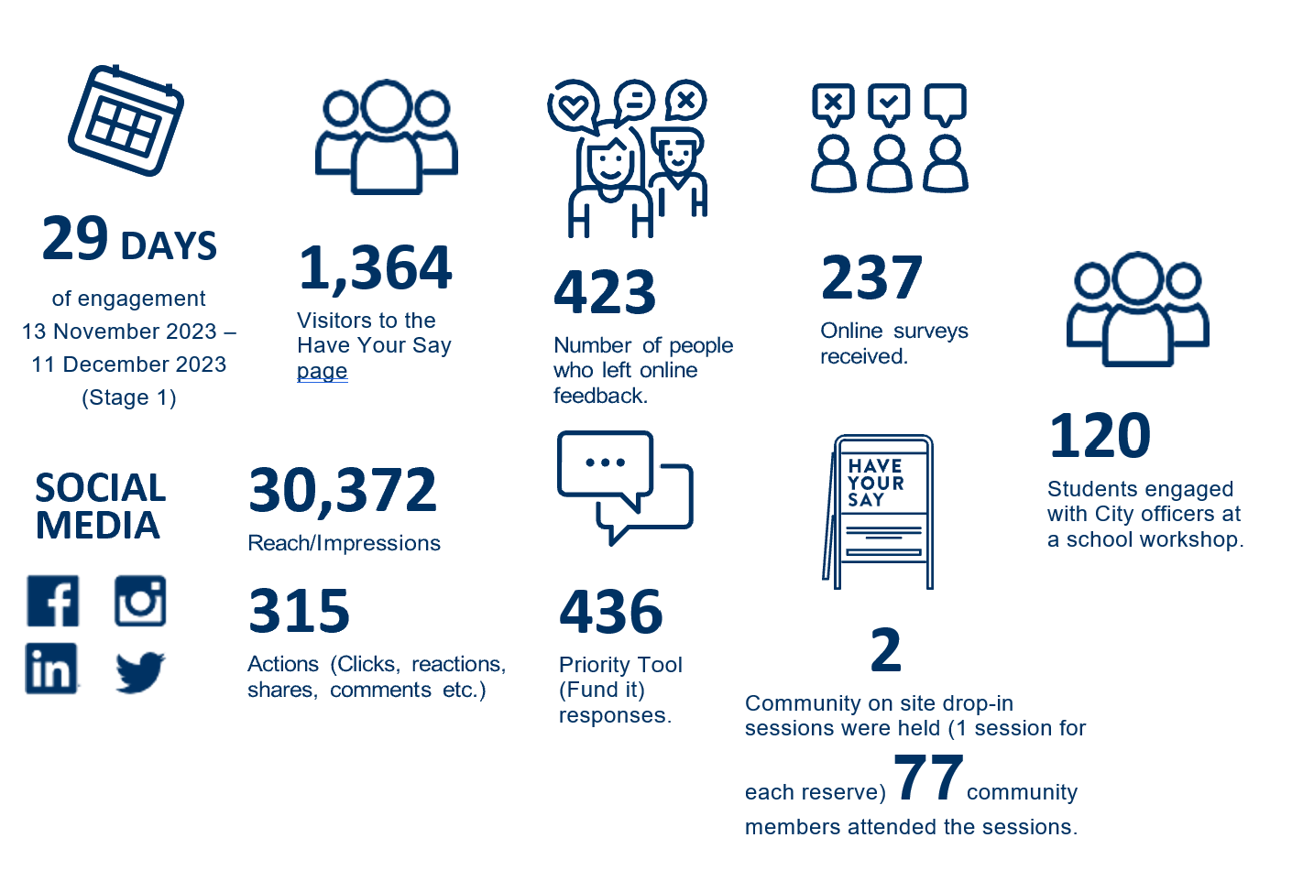

ENGAGEMENT TOOL AND TECHINQUES
Different levels of engagement methods were chosen to seek feedback from the community and stakeholders throughout the engagement period.

HOW WE ENGAGED
Have Your Say Online Portal  Yoursay.geelongaustralia.com.au | An online Have Your Say (HYS) project page was designed to share relevant information to encourage community feedback on what type of play equipment they would prefer in their new playground.
ONLINE SURVEY | A brief survey sought feedback on what type of playground design the community would prefer and the ages of people in the community that would use this playground. An open text question asked what type of play equipment the community like would to see in the new playground. These questions provided an opportunity for the community to expand on what other type of play equipment they would like which may not be listed on the priority tool (fund it survey).
PRIORITY TOOL (online) | This data collection method identified 17 types of play equipment options for the community to consider. The priority (fund it) tool allowed the community to allocate points per play equipment option with a ten-point maximum limit. Each piece of play equipment had been given a point value based on dollar value.
ON-SITE CONSULTATIOns | Two onsite conversations were held on Wednesday 22 November 2023 (3pm to 6pm) and Saturday 2 December 2023 (10am to 1pm).  The on-site consultation involved a dotmocracy activity (voting using dots) which was also used at a school workshop to complement the online priority tool. The activity involved the community prioritising what type of playground equipment they liked, by placing dots on a range of playground equipment images. Participants were allocated 5 dots per person.
SCHOOL Workshop | Approximately 120 school students from Grade 3 & 4 and 5 & 6 at Whittington Primary School were engaged via a workshop using the dotmocracy method.
online ideas board | We asked the young community for their thoughts “What playground equipment would you like to see in your new playground”.
Letterbox drop | Letters were distributed in the first week of the engagement to houses in close proximity to Aldershot Reserve to help inform local residents about the project.
Social Media | Facebook and Instagram campaign advising of Aldershot Reserve Playground renewal.
On-site signage | Three signs were installed ahead of engagement to inform the nearby community to be aware of the consultation, directing people to the City’s Have Your Say page to provide feedback.
Communications
The project and engagement activities were promoted and communicated via the City’s Have Your Say platform and social media through an Instagram post and targeted Facebook campaign. The engagement was also promoted via letters to surrounding residents, a media release within City News, and onsite signage.


SOCIAL MEDIA
30,372
Reach/Impressions
315
Actions (Clicks, reactions,
shares, comments etc.)
NEWS

1
print adverts in local newspapers.

Who we engaged with

PARTICIPATION
During November and December 2023 more than 1,300 people visited the City’s Have Your Say page, of those, 423 provided online responses, with the majority of those (94.92 per cent) being local residents. Note that some participants contributed to more than one of the consultation activities which accounts for the discrepancy in individual activity participant numbers and number of contributions.
77 people attended across the two on-site sessions and approximately 120 students attended a workshop at Whittington Primary School.
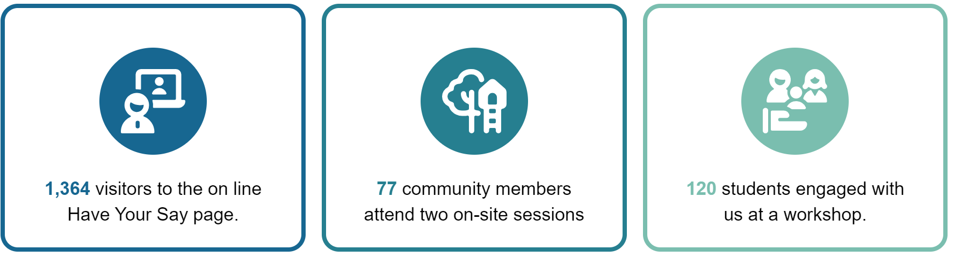
Demographics
Through the survey, the community were invited to share some demographic data with us, primarily through our Have Your Say page.
The age groups were well distributed, with the highest participant group aged 35-49 age group (38.14 per cent). The 25-34 age group were also high contributors (37.71 per cent).
More than 94 per cent of survey participants were from the suburb of St Albans Park, with the remaining participants spread out across other suburbs reflecting the utilisation of the reserve.
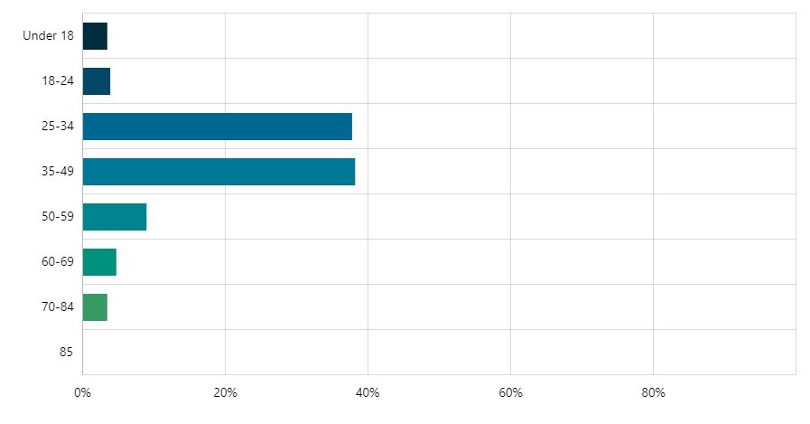
Figure 1 – Survey participation by age

WHAT WE HEARD

THE FEEDBACK
Feedback from the engagement was overall positive and constructive. A significant majority of participants across all engagement methods expressed their strong preference for a certain type of play equipment they would like to see in the playground and the type of playground.

Apart from playground renewal feedback, the footpath upgrade, reserve drainage and additional tree planting were also identified as other priorities beyond the scope of the play space project, but the City will pursue opportunities to address these issues though other projects.

The feedback will help shape the concept design for the playground. Feedback on social media reflected this sentiment and themes.

DATA METHODOLOGY

PRIORITY TOOL (FUND IT)

The City provided 17 different types of play equipment for the community to choose from. Each community member had 10 points to allocate to their favourite equipment. Each piece of equipment was allocated a point value based on dollar value.

The top 5 pieces of equipment as voted online were:
- Junior play tower with slides,
- Flying fox,
- Swing set
- Ninja warrior course
- Trampoline.
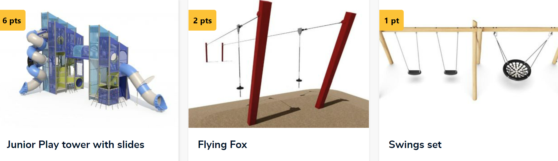
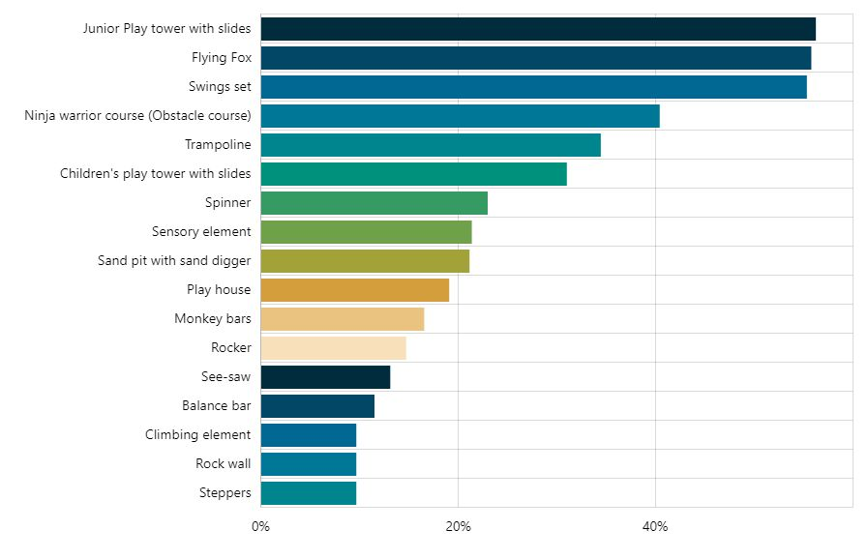
Figure 2 – Fund It results from City’s Have Your say page.
SURVEY
The survey aimed to capture a broad sense of what people really value about the reserve, what they would like to see changed or improved.
We asked the community to consider 3 types of playgrounds, and what type of play equipment they would like to see in the new playground?
The data told us that the preferred style of playground was a mixture of both natural and contemporary, and this was evident across all age groups as seen in the charts below.

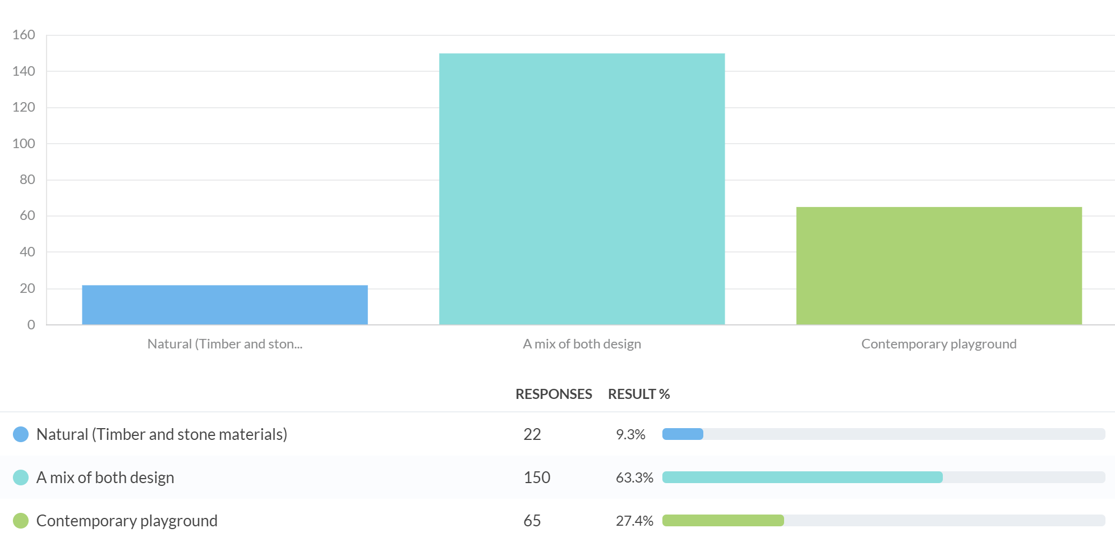

Type of playground selected via age groups.
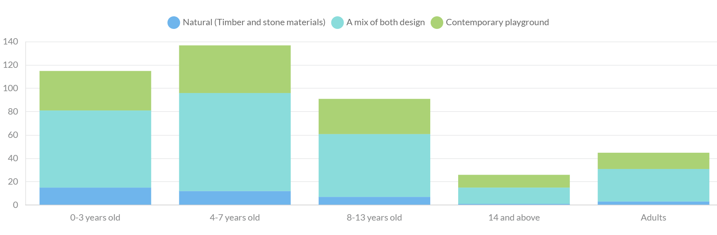
Community members were also given the opportunity to provide feedback about what type of play equipment would you like to see in the new playground.
The top themes emerged were:
- Variety of play equipment. There was a strong desire for a diverse range of play equipment, including swings, slides, climbing structures, flying foxes, trampolines, sensory equipment, water play features, obstacle courses, and natural play elements like sand pits and treehouses.
- Catering for all. Many respondents emphasised the importance of catering to different age groups and abilities. Community members highlighted the importance of inclusive and accessible design.
- Additional amenities. In addition to play equipment, shade structures, seating, toilets, dog park, walking tracks and improved landscaping were all mentioned.

Some verbatim comments:
A range of play spaces that can be used by kids big and small. The potential for the local Kinder to use the space as a meeting place for family events.

Mix of nature play and contemporary. Swings and a big climbing tower with slides. Balancing and climbing structures. Shade and seating areas.

A Mix of designs.
The current problem with the park is that the gravel paths need more topping and have bare clay sections. As a result, they cannot be used for walking or cycling after rain. This is a maintenance issue and not connected to the park upgrade project.

I would like the area to have a paved walkway, keep the area an off leash dog area outside of the playground. Lighting for safety. Slides, swings, climbing, see saw, flying fox, shade sail. Any other additional play equipment welcome.

ONLINE IDEAS BOARD

We asked our young people the same question from the survey - What playground equipment would you like to see in your new playground?
Our ideas board received 28 contributions reflecting a wide range of play equipment for us to consider. This feedback provides us an understanding of community preferences and concerns from a young person’s perspective, offering valuable insights that will be instrumental in shaping our concept plan.

In person consultation
Two onsite sessions and a school workshop were held to capture the community feedback in addition to online collection.

A dotmocracy activity (voting using dots) was used at both the pop-up consultation and school workshops. The activity involved the community prioritising what type of play equipment elements they liked by placing dots on a range of play equipment images.

Onsite
Two on-site sessions were held and attended by 77 community members. The sessions sought to engage with people who may have been unaware of the project or preferred to chat direct to a City officer. Community members were invited to share their feedback and select their preference of equipment using a dotmocracy method. The top 3 preferred play equipment were a swing set (29 dots), junior play tower (24 dots) and flying fox (20 dots).

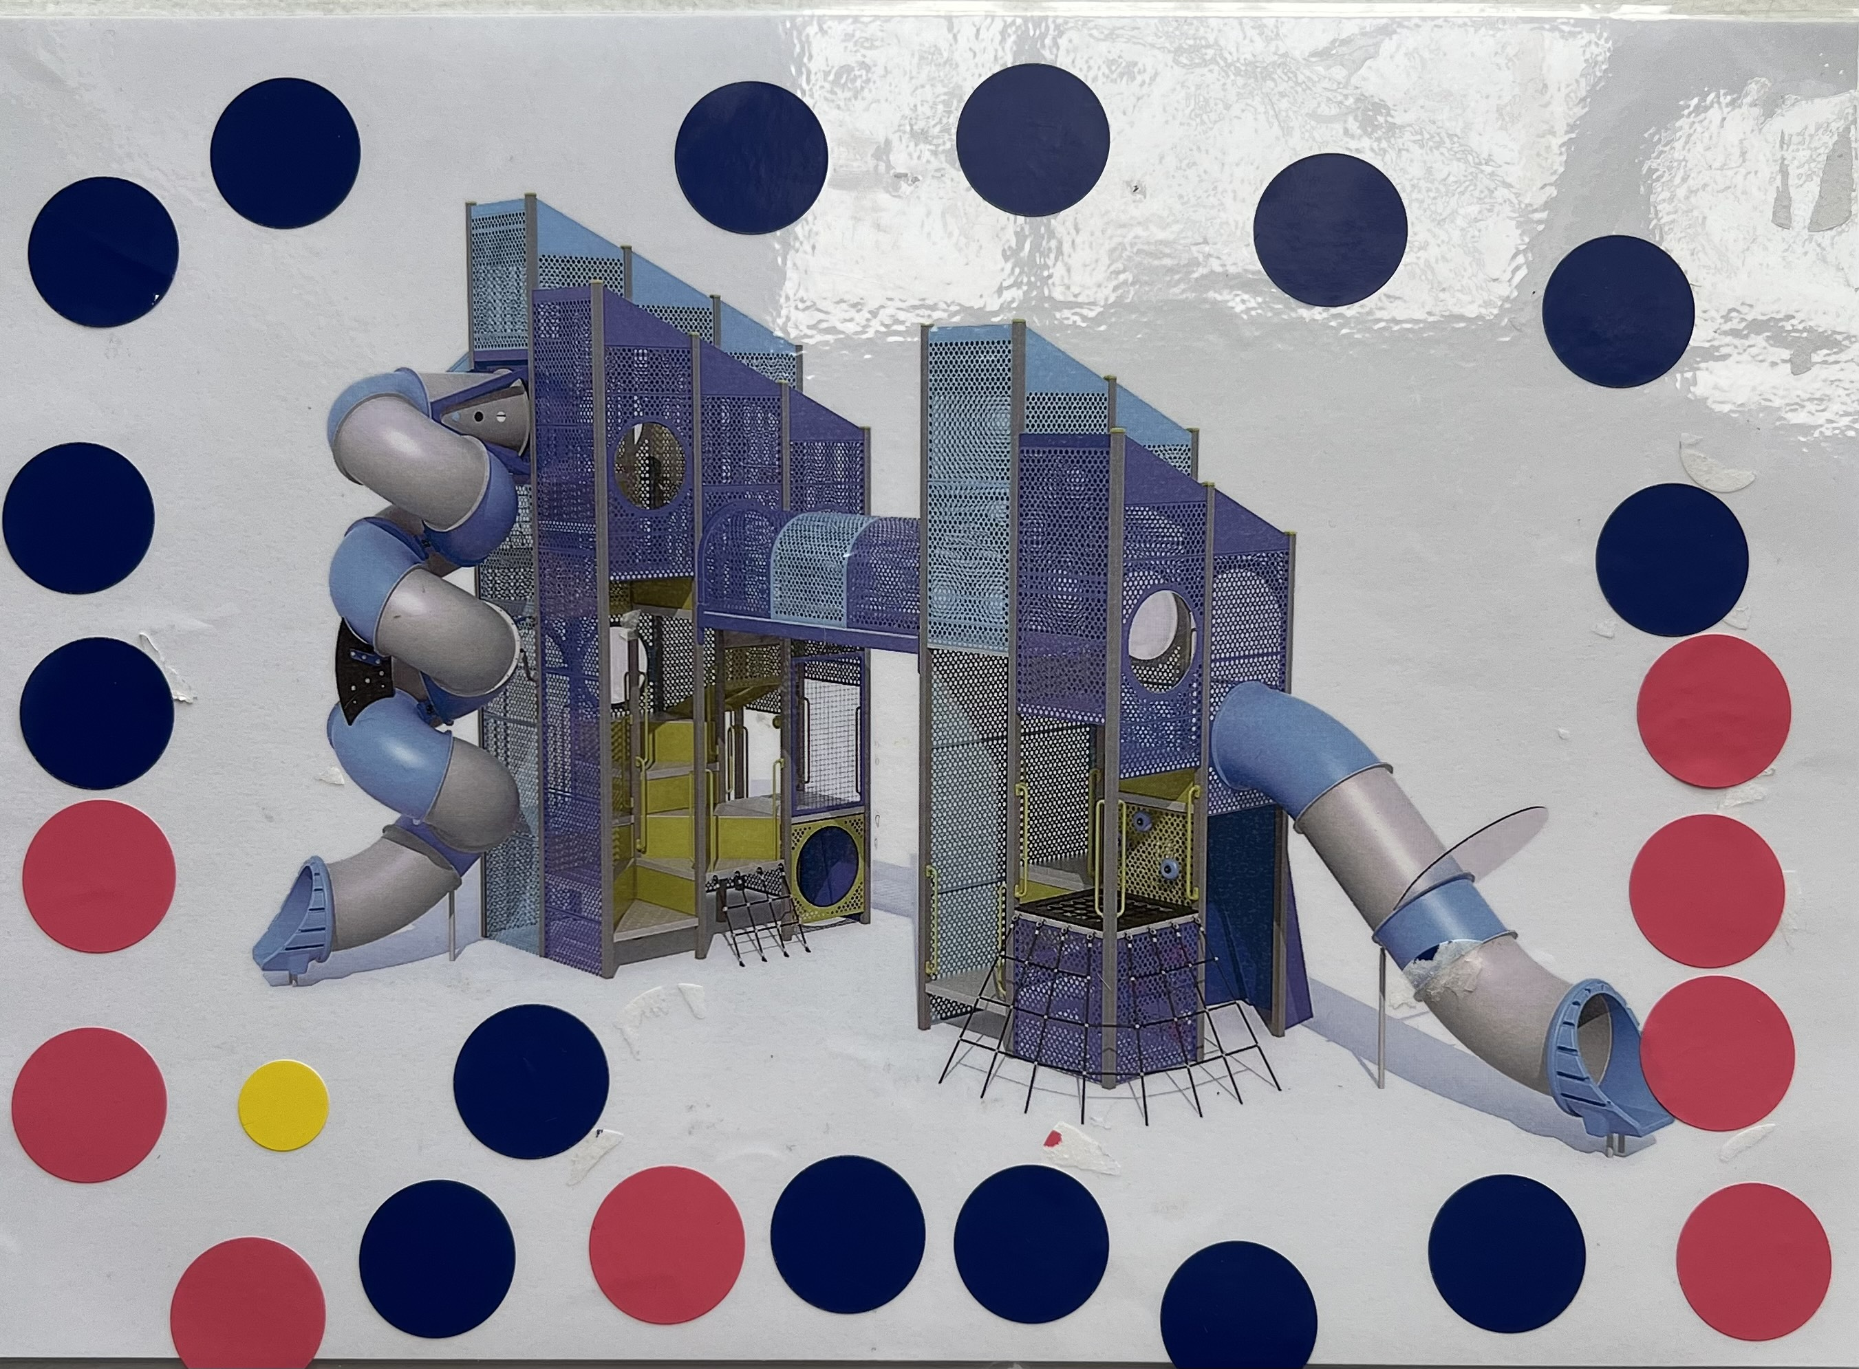
Different dots were given to different cohorts of the community onsite:
- Blue dots were given to male adults.
- Pink dots were given to female adults,
- Yellow dots were given to female kids and green dots were given to male kids.

Feedback from Whittington Primary School workshop

The City conducted a workshop with approximately 120 students from Grade 3 & 4 and 5 & 6 at Whittington Primary School, as the school is located approx. 800 metres from Aldershot Reserve. Many students use the reserve for recreational purposes.
Junior play tower with slides, flying fox, ninja warrior course, trampoline and swing set were the top five preferred play equipment chosen by the students.
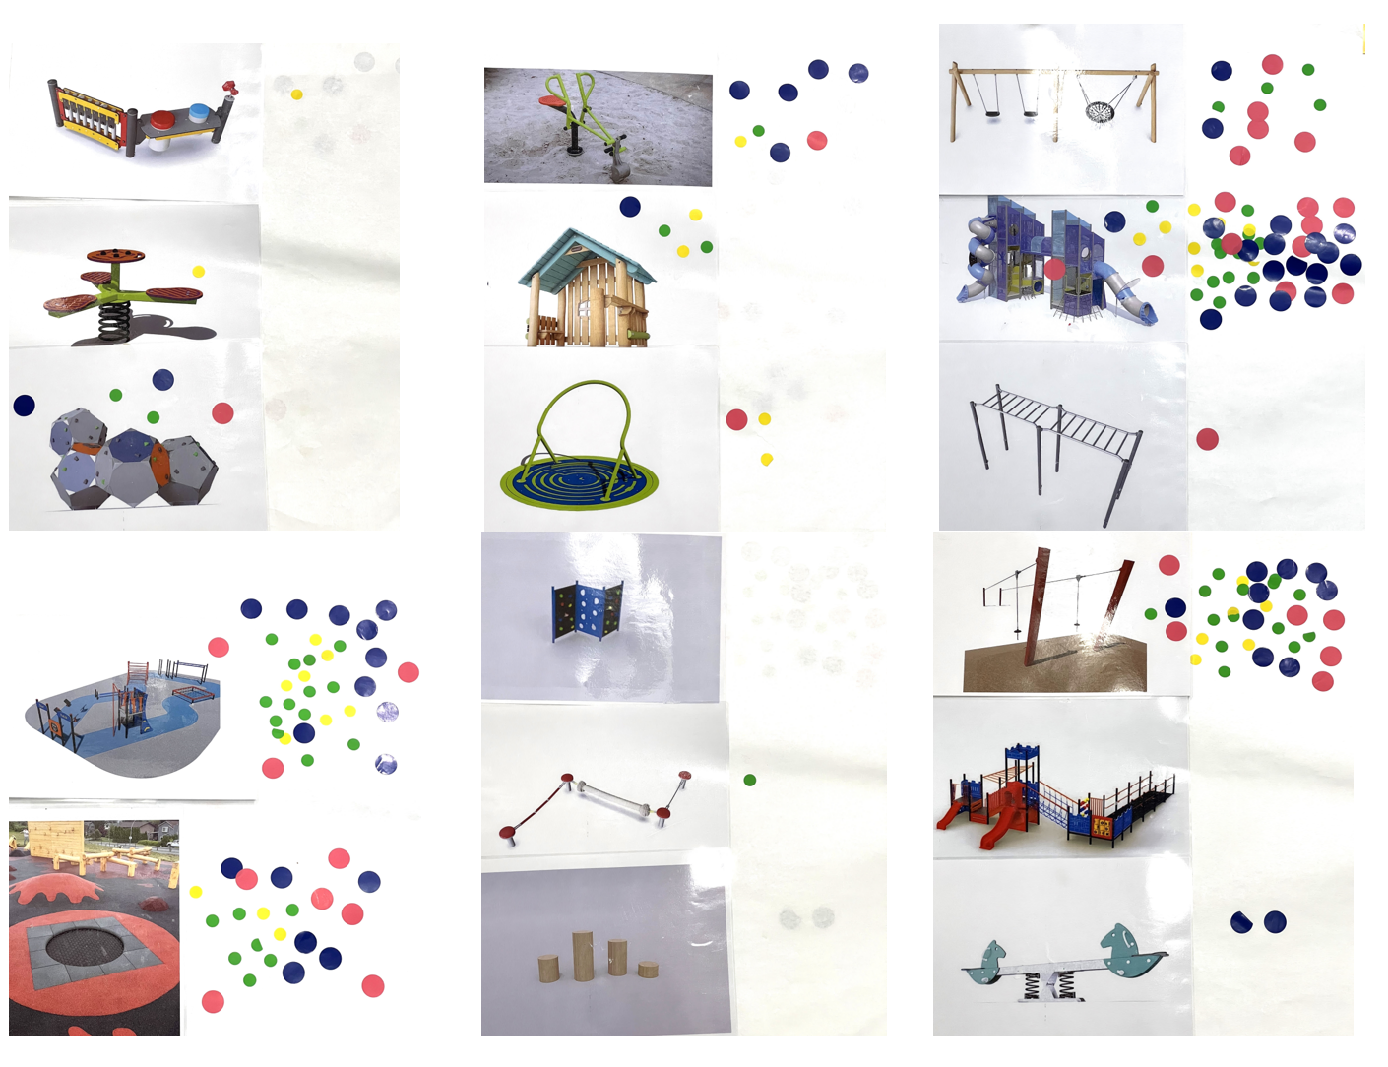
Figure 3 – Dotmocracy activity results from Whittington Primary School
Feedback Summary from onsite and school workshop
The feedback from all in person sessions resulted in the same top five play equipment:
- Junior play tower with slides
- Swing set
- Flying fox
- Ninja warrior course/ obstacle course
- Trampoline

NEXT STEPS

CONCLUSION/NEXT STEPS
This community engagement has closed. Engaging with the community to explore their perspectives on Aldershot Reserve was an enriching experience. The primary objective behind this community engagement was to foster a deeper understanding of diverse thoughts, opinions and expectations that residents hold regarding the reserve,
Feedback is a crucial part of planning and designing the reserve, ensuring it meets the needs of the local community. The input we gather during this consultation will guide the next stage of design. However, it's important to note that budget constraints may limit our ability to incorporate all suggestions. We will carefully evaluate all options within our financial means.
The City will proceed with the detailed design, but we are awaiting the outcome of a grant application. If successful, this grant will allow us to include additional elements in the master plan. We anticipate beginning the detailed design in the second half of 2024.

