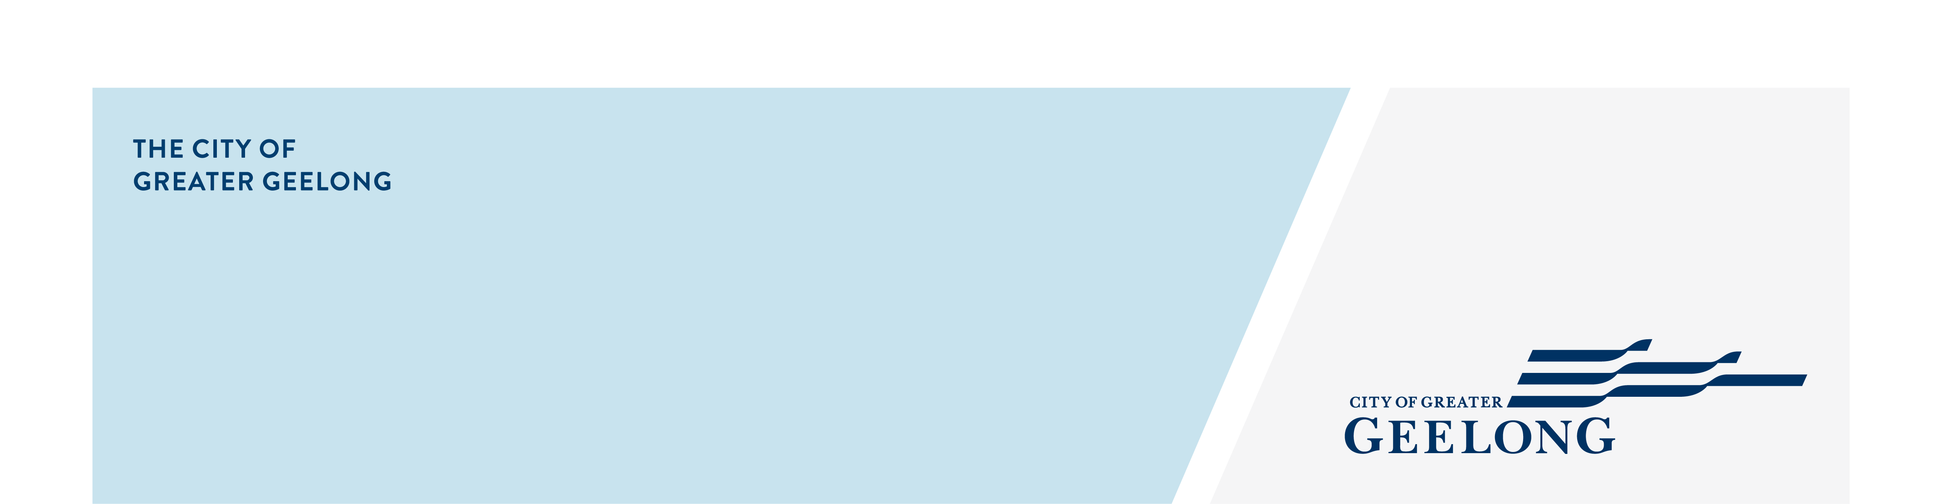
DIGITAL PARKING IN

CENTRAL GEelONG

community engagement sNAPSHOT REPORT
Feedback on the Digital Parking in Central Geelong consultation has now closed, thank you to everyone who provided feedback, your contribution is valued and appreciated.
Community engagement ran from 24 September to 15 October 2025 and sought feedback on the proposal to transition to digital parking. This change is being considered due to a steady decline in coin payments over the past seven years, with around 85% of drivers now choosing to pay by debit card, credit card, or through the EasyPark app.
Community feedback plays an important role in our planning process. The insights gathered will help guide decisions aimed at improving service efficiency and reducing costs for ratepayers.
Participation:


1 hard copy survey, 7 emails and 1 letter received.
910
Visitors to the Have Your Say page
21 DAYS
of engagement
Surveys completed
497


Stickers with QR code attached to all parking meters
2501
People following the project
16


SOCIAL MEDIA
35,428
Reach/Impressions
1,122
Actions (Clicks, reactions,
shares, comments etc.)

Next Steps
Community engagement is now closed for evaluation and review. Officers will analyse the feedback received and seek to resolve any identified community concerns in relation to the use of digital parking.
A detailed report is being prepared to summarise the engagement process, outlining the feedback received and explaining how community input has informed the project.

